## ISC/23/ANNEX/14

**ANNEX 14**

*23rd Meeting of the International Scientific Committee for Tuna*

*and Tuna-Like Species in the North Pacific Ocean Kanazawa, Japan*

*July 12-17, 2023*

**Stock Assessment Report for Striped Marlin (*Kajikia audax*) in the Western and Central North Pacific Ocean through 2020**

**July 2023**

Left Blank for Printing

Stock Assessment Report for Striped Marlin (*Kajikia audax*) in the Western and Central North Pacific Ocean through 2020

**ISC Billfish Working Group**

**June 1, 2023**

#### *Abstract*

We present the benchmark stock assessment for the Western and Central North Pacific Ocean striped marlin (*Kajikia audax*) stock conducted in 2022-2023 by the ISC Billfish Working Group (BILLWG). The 2023 assessment consisted of applying a Stock Synthesis model with the best- available life history parameters and catch, abundance index, and length composition data for 1977-2020. The results indicated that population biomass (age 1 and older) for the Western and Central North Pacific Ocean (WCNPO) striped marlin (MLS) stock fluctuated around an average of 11,300 mt during 1977-2020 and was estimated to be 7,300 mt in 2020. Estimated fishing mortality has generally increased from the 1970s to the late-1990s, peaked at 1.42 year-1 in 1998, or about three times FMSY and F20%SSB(F=0), and declined to average 0.68 year-1 in 2018-2020.

Fishing mortality has been above FMSY and the dynamic 20-year value of F20%SSB(F=0) for the entire assessment period, but has had a declining trend since 1998. The Western and Central

Pacific Fisheries Commission (WCPFC) requested the BILLWG to provide reference points based upon a dynamic B0 calculation, therefore potential reference points are reported as 20% of the SSBF=0, where SSBF=0 is the average of the dynamic B0 over the last 20 years (2001-2020). Compared to the dynamic B0 reference points, the current or recent 3-year average spawning biomass of 1,360 mt (average for 2018-2020) was 63% below 20%SSBF=0 and the current fishing mortality (average for ages 3 – 12 during 2018-2020) was 9% above F20%SSB(F=0). The base case model indicated that under current conditions the WCNPO MLS stock was very likely overfished (>99% probability) and was likely subject to overfishing (>66% probability) relative to the dynamic 20-year 20%SSBF=0-based reference points.

# Executive Summary: Western and Central North Pacific Ocean Striped Marlin Stock Assessment

**Stock Identification and Distribution:** The Western and Central North Pacific Ocean (WCNPO) striped marlin (MLS, *Kajikia audax*) stock area was defined to be the waters of the North Pacific Ocean contained in the Western and Central Pacific Fisheries Commission

Convention Area bounded by the equator and 150°W. All available fishery data from the stock area were used for the stock assessment. For the purpose of modeling observations of CPUE and size composition data, it was assumed that there was an instantaneous mixing of fish throughout the stock area on a quarterly basis.

**Catches:** The WCNPO MLS catches were high from the 1970’s to the 1990’s averaging about 7,200 mt per year during 1977-1999, and have decreased to an annual average of 2,500 mt during 2018-2020. Catches by Japanese fleets have decreased and catches from the US and Chinese Taipei have varied without trend, while minor catches by other WCPFC countries have generally increased (Figure S1). Overall, longline fishing gear has accounted for the vast majority of WCNPO MLS catches since the 1990’s while catches by the Japanese driftnet fleet were predominant during 1977 to 1993. It should be noted that the Japanese driftnet catch during this period is highly uncertain due to possible inaccurate reporting as well as possible inclusion of catch from southern hemisphere, both of which cannot be verified at this moment.

**Data and Assessment:** Catch and size composition data were collected from ISC countries (Chinese Taipei, Japan, and USA) and the WCPFC. Standardized catch-per-unit effort (CPUE) data used to measure trends in relative abundance were provided by Chinese Taipei, Japan, and USA. The WCNPO MLS stock was assessed using an age- and length-structured assessment Stock Synthesis (SS3) model fit to time series of standardized CPUE and size composition data. Life history parameters for growth and maturity were updated for this benchmark stock assessment. The value for stock-recruitment steepness used for the base case model was *h* = 0.87. The assessment model was fit to relative abundance indices and size composition data in a likelihood-based statistical framework. Maximum likelihood estimates of model parameters, derived outputs, and their variances were used to characterize stock status and to develop stock projections. Several sensitivity analyses were conducted to evaluate the effects of changes in model parameters, including natural mortality rate at age, stock-recruitment steepness, growth curve parameters, and female length at 50% maturity, as well as uncertainty in the input catch data and model structure.

**Status of Stock:** The WG agreed upon a base-case model for WCNPO MLS and is providing stock status information based upon this model. However, there was a concern if the base-case results are sufficiently reliable in order to provide specific conservation advice due to its uncertainty. At the 2022 ISC Plenary meeting, the WG was requested to continue working on the 2022 WCNPO MLS base-case model, with a focus on the growth parameters, particularly incorporating the Richard’s four-parameter growth curve directly into the SS3 model, for presentation to ISC23. The WG agreed that the growth curve used to produce the base-case model was the best information available at this time, while highlighting the suite of sensitivity runs to show how the model reacts to changes of the growth curve (Figure S6, see the list and description of the sensitivity runs in table 12). The WG noted a concern that the estimation of initial F and thus the virgin biomass scale is largely affected by the selection of the growth curve, as the initial catch remains uncertain.

Estimates of population biomass from the base-case fluctuated around an average of 11,300 mt during 1977-2020 and was estimated to be 7,300 mt in 2020 (Figure S2a). Initial estimates of female spawning stock biomass (SSB) averaged around 4,700 mt in 1977-1979. SSB was at its

highest level of 5,096 metric tons in 1977, and declined to 1,080 mt in 2011. The time-series of SSB during 2011-2020 averaged about 1,200 metric tons, or about 33% of the dynamic 20-year 20%SSB(F=0) and about 42% of SSBMSY. Overall, SSB exhibited a strong decline during 1992- 1998 and has stabilized to an average of about 1,400 mt since then (Figure 2b). Estimated fishing mortality (arithmetic average of F for ages 3 – 12) increased from 0.53 year-1 in 1977 to a peak of 1.42 year-1 in 1998, and subsequently declined to 0.58 year-1 in 2020 (Figure S2c). It averaged roughly F=0.68 during 2018-2020 or about 28% above F20%SSB(F=0) and 8% above FMSY, with a relative fishing mortality of F/F20%SSB(F=0) = 1.09 in 2020. Fishing mortality has been above F20%SSB(F=0) and FMSY since the beginning of the assessment time period, but has had a declining trend since 1998. Recruitment (numbers of age-0 fish) estimates averaged approximately 366,000 during 1977-2020. While the overall pattern of recruitment from 1977-2020 varied, there was an apparent declining trend in recruitment strength over time with higher recruitments observed during 1977-1992 and lower recruitments from 2000 to the present (Figure S2d).

Recruitment from 2001-2020 averaged about 225,000 age-0 fish, which was 60% of the 1977- 2020 average. The WCPFC has requested the BILLWG to provide estimates of stock status for WCNPO MLS relative to biological reference points based on 20% of a dynamic SSB0 estimate (SSB(F=0)), where SSB0 is the moving average of the last 20 years SSB0 estimates. Despite the relative large L50/Linf ratio for WCNPO MLS, the stock is expected to be highly productive due to its rapid growth and high resilience to reductions in spawning potential. Recent recruitments have been lower than expected and have been below the long-term average since 2000 (Figure S2d). Although fishing mortality has decreased since 2000, the two decades of low recruitment combined with consistent landings of immature fish have inhibited increases in spawning biomass since 2001. When the status of WCNPO MLS is evaluated relative to dynamic 20%SSBF=0-based reference points, the 2020 spawning stock biomass of 1,696 mt is 54% below 20%SSBF=0 (3,660 mt) and the 2018-2020 fishing mortality is about 28% above F20%SSB(F=0).

Therefore, relative to 20%SSBF=0-based reference points, the WCNPO MLS stock is very likely to be overfished (>99% probability) and is likely to be subject to overfishing (>66% probability, Figure S3).

**Table S1.** Reported catch (mt) used in the stock assessment along with annual estimates of population biomass (age-1 and older, mt), female spawning biomass (mt), relative female spawning biomass (SSB/20%SSBF=0), recruitment (thousands of age-0 fish), fishing mortality (average F, ages-3 – 12), relative fishing mortality (F/F20%SSB(F=0)), and spawning potential ratio of Western and Central North Pacific striped marlin.

|  |  |  |  |  |  |  |  |  |  |  |
| --- | --- | --- | --- | --- | --- | --- | --- | --- | --- | --- |
| **Year** | **2014** | **2015** | **2016** | **2017** | **2018** | **2019** | **2020** | **Mean1** | **Min1** | **Max1** |
| Reported Catch | 2,745 | 3,272 | 2,456 | 2,256 | 2,177 | 2,695 | 2,412 | 5,383 | 2,177 | 10,912 |
| Population Biomass | 7,142 | 6,476 | 5,944 | 5,506 | 5,316 | 6,831 | 7,339 | 11,283 | 5,316 | 19,463 |
| Spawning Biomass | 1,142 | 1,293 | 1,305 | 1,238 | 1,223 | 1,158 | 1,696 | 2,266 | 1,081 | 5,118 |
| Relative Spawning Biomass | 0.31 | 0.35 | 0.35 | 0.33 | 0.33 | 0.31 | 0.46 | 0.61 | 0.29 | 1.38 |
| Recruitment (age 0) | 102,169 | 196,286 | 138,584 | 150,045 | 299,538 | 215,884 | 263,519 | 366,217 | 89,526 | 711,480 |
| Fishing Mortality | 0.77 | 0.91 | 0.70 | 0.74 | 0.69 | 0.77 | 0.58 | 0.89 | 0.53 | 1.42 |
| Relative Fishing Mortality | 1.46 | 1.70 | 1.31 | 1.39 | 1.30 | 1.45 | 1.09 | 1.67 | 1.00 | 2.67 |
| Spawning Potential Ratio | 0.14 | 0.11 | 0.16 | 0.16 | 0.16 | 0.14 | 0.20 | 0.13 | 0.06 | 0.23 |

1 During 1977-2020

**Biological Reference Points:** Biological reference points were computed for the base case model with SS3 (Table S2). The reference points were based upon 20% of the dynamic B0 (SSB(F=0)) averaged over the last 20 years (2001-2020), which corresponds to about 4 mean generation times for WCNPO-MLS. The point estimate of equilibrium annual catch at the dynamic 20%SSB(F=0) was calculated to be 4,468 mt. The point estimate of the spawning biomass to produce 20%SSB(F=0) (adult female biomass) was 3,660 mt. The point estimate of F20%SSB(F=0), the fishing mortality rate to produce 20% of SSB(F=0) (average fishing mortality on ages 3 – 12) was 0.53 and the corresponding equilibrium value of spawning potential ratio at 20%SSB(F=0) was 22%.

**Projections:** Stock projections for WCNPO-MLS were conducted using SS3.30. No recruitment deviations nor log-bias adjustment were applied to the future projections. The absolute future recruitments were based on two deterministic scenarios: the expected stock-recruitment relationship and the average recruitment in the last 20 years (2001-2020). Projections started in 2021 and continued through 2040. The five levels of fishing mortality with the two recruitment scenarios and the ten catch levels with only the 20-year average recruitment scenario were applied for projections. The five fishing mortality scenarios were: F status quo (average F during 2018-2020), FMSY, F at 20%SSB(F=0), FHigh at the highest 3-year average during 1977-2017

(1998-2000), and FLow at F30%. The ten catch level scenarios were: No catch (F=0), 500 mt catch, 1,000 mt catch, 1,500 mt catch, 2,000 mt catch, 2,300 mt catch, 2,400 mt catch, 2,500 mt catch, 3,000 mt catch, and 3,500 mt catch. Twenty results show the projected female spawning stock and catch biomasses under each scenario (Tables S3, S4, Figures S4 and S5).

Note that the assumed recruitment levels for projection vary substantially for the two scenarios, with the average recruitment from the stock-recruitment curve around 350,000 individuals per year and the recruitment from the low-recruitment scenario around 225,000 individuals per year. In the past, the WG has recommended that management measures consider the low-recruitment scenarios as the projections using the stock-recruitment curve does not consider the long-term declining trend in recruitment (ISC21). If spawning biomass rebuilds to the target, which is about equal to the average spawning biomass observed during 1977-1989, then recruitment may be expected to return to the high levels observed during 1977-1989 or about 2-fold higher than current recruitment (Figure S2d).The WG intends to provide additional stochastic ensemble projection results taking into account model uncertainty, as requested by WCPFC16. One of the important axes of uncertainty with be the assumptions on future recruitment.

**Conservation information:** The WG recognized substantial uncertainties that have been discussed and documented in this stock assessment report. The high-seas drift net catch data is highly uncertain, life history parameters, such as growth, have been estimated from limited data, and stock is subject to mixing with other management areas, as revealed by genetic analyses. The WG evaluated the fit of several growth assumptions to the data and other diagnostics. The WG found that the stock assessment results showed large differences in estimated biomass among various growth curves. Future improvements of the growth curve are expected due to incoming data from the ongoing International Billfish Biological Sampling program, which will be followed by continued biological research and model development to address other sources of uncertainty. Due to these various uncertainties, the WG suggests that catch should be kept at or below the recent level (2018-2020 average catch = 2,428 mt) until the assessment is further

improved or additional projections are provided. Under the level of catch of around 2,400 t, the stock is projected to recover above SSBMSY and near the 20% of SSBF=0 reference level by 2040, assuming the low recruitment regime (3,660 mt).

**Table S2.** Estimates of biological reference points along with estimates of fishing mortality (F), spawning stock biomass (SSB), recent average yield (C), and spawning potential ratio (SPR) of Western and Central North Pacific striped marlin, derived from the base case model assessment model, where SSBF=0 indicates the average 20-year dynamic B0 estimate, 20%SSBF=0 is the associated reference point, and MSY indicates the maximum sustainable yield reference point.

|  |  |
| --- | --- |
| **Reference Point** | **Estimate** |
| F20%SSB(F=0) (age 3-12) | 0.53 |
| FMSY (age 3-12) | 0.63 |
| F2020 (age 3-12) | 0.58 |
| F2018-2020 | 0.68 |
| SSBF=0 | 18,300 mt |
| 20%SSBF=0 | 3,660 mt |
| SSBMSY | 2,920 mt |
| SSB2020 | 1,696 mt |
| SSB2018-2020 | 1,359 mt |
| C20%SSB(F=0) | 4,468 mt |
| MSY | 4,512 mt |
| C2018-2020 | 2,428 mt |
| SPR20%SSB(F=0) | 22% |
| SPRMSY | 18% |
| SPR2020 | 20% |
| SPR2018-2020 | 17% |

**Table S3.** Projected median values of Western and Central North Pacific striped marlin spawning stock biomass (SSB, mt) and catch (mt) under five constant fishing mortality rate (F) and two recruitment scenarios during 2021-2040. For scenarios which have a 50% probability of reaching the target of 20%SSBF=0, the year in which this occurs is provided; NA indicates projections that did not meet this criterion. Note that 20%SSBF=0 is 3,660 mt.

|  |  |  |  |  |  |  |  |  |
| --- | --- | --- | --- | --- | --- | --- | --- | --- |
| **Year** | **2021** | **2022** | **2023** | **2024** | **2025** | **2030** | **2040** | **Year when**  **target achieved** |
| **Scenario 1: F20%SSB(F=0), FBtgt; Stock – Recruitment Curve** | | | | | | | | |
| SSB | 2084 | 2412 | 2775 | 3071 | 3275 | 3620 | 3658 | NA |
| Catch | 2624 | 3041 | 3461 | 3803 | 4039 | 4426 | 4468 |  |
| **Scenario 2: Highest F (Average F1998-2000); Stock – Recruitment Curve** | | | | | | | | |
| SSB | 2032 | 2217 | 2464 | 2663 | 2796 | 3017 | 3043 | NA |
| Catch | 3080 | 3386 | 3729 | 3997 | 4174 | 4461 | 4494 |  |
| **Scenario 3: Low F (F30%); Stock – Recruitment Curve** | | | | | | | | |
| SSB | 2390 | 3059 | 3758 | 4367 | 4825 | 5675 | 5783 | 2024 |
| Catch | 1807 | 2293 | 2770 | 3177 | 3477 | 4009 | 4072 |  |
| **Scenario 4: FMSY; Stock – Recruitment Curve** | | | | | | | | |
| SSB | 2062 | 2369 | 2712 | 2991 | 3182 | 3504 | 3540 | NA |
| Catch | 2685 | 3090 | 3502 | 3836 | 4064 | 4439 | 4481 |  |
| **Scenario 5: FStatus Quo (Average F2018-2020); Stock – Recruitment Curve** | | | | | | | | |
| SSB | 2026 | 2291 | 2593 | 2837 | 3005 | 3289 | 3322 | NA |
| Catch | 2795 | 3170 | 3550 | 3854 | 4062 | 4406 | 4445 |  |
| **Scenario 6: F20%SSB(F=0), Fbtgt; 20-year Average Recruitment** | | | | | | | | |
| SSB | 2084 | 2343 | 2411 | 2392 | 2371 | 2351 | 2351 | NA |
| Catch | 2623 | 2886 | 2952 | 2924 | 2896 | 2871 | 2871 |  |
| **Scenario 7: Highest F (Average F1998-2000); 20-year Average Recruitment** | | | | | | | | |
| SSB | 2032 | 2149 | 2130 | 2077 | 2046 | 2023 | 2022 | NA |
| Catch | 3080 | 3182 | 3131 | 3056 | 3014 | 2986 | 2986 |  |
| **Scenario 8: Low F (F30%); 20-year Average Recruitment** | | | | | | | | |
| SSB | 2390 | 2979 | 3296 | 3414 | 3456 | 3483 | 3484 | NA |
| Catch | 1806 | 2177 | 2368 | 2430 | 2447 | 2453 | 2454 |  |
| **Scenario 9: FMSY; 20-year Average Recruitment** | | | | | | | | |
| SSB | 2062 | 2301 | 2355 | 2331 | 2308 | 2287 | 2287 | NA |
| Catch | 2684 | 2932 | 2987 | 2952 | 2921 | 2895 | 2895 |  |
| **Scenario 10: FStatus Quo (Average F2018-2020); 20-year Average Recruitment** | | | | | | | | |
| SSB | 2026 | 2225 | 2254 | 2220 | 2194 | 2171 | 2171 | NA |
| Catch | 2794 | 2996 | 3016 | 2968 | 2932 | 2905 | 2905 |  |

Table S4. Projected median values of Western and Central North Pacific striped marlin spawning stock biomass (SSB, mt) under ten constant catches with low recruitment scenarios during 2021- 2040. For scenarios that have a 50% probability of reaching the target of 20%SSBF=0, the year in which this occurs is provided; NA indicates projections that did not meet this criterion. Note that 20%SSBF=0 is 3,660 mt.

|  |  |  |  |  |  |  |  |  |
| --- | --- | --- | --- | --- | --- | --- | --- | --- |
| **Year** | **2021** | **2022** | **2023** | **2024** | **2025** | **2030** | **2040** | **Year when**  **target achieved** |
| **Scenario 11: No catch; 20-year Average Recruitment** | | | | | | | | |
| SSB | 3097 | 4809 | 6370 | 7587 | 8486 | 10304 | 10644 | 2022 |
| **Scenario 12: 500 mt catch; 20-year Average Recruitment** | | | | | | | | |
| SSB | 2907 | 4350 | 5639 | 6629 | 7358 | 8858 | 9159 | 2022 |
| **Scenario 13: 1,000 mt catch; 20-year Average Recruitment** | | | | | | | | |
| SSB | 2719 | 3892 | 4915 | 5679 | 6236 | 7405 | 7660 | 2022 |
| **Scenario 14: 1,500 mt catch; 20-year Average Recruitment** | | | | | | | | |
| SSB | 2537 | 3454 | 4213 | 4771 | 5160 | 5986 | 6182 | 2023 |
| **Scenario 15: 2,000 mt catch; 20-year Average Recruitment** | | | | | | | | |
| SSB | 2361 | 3030 | 3540 | 3874 | 4106 | 4607 | 4738 | 2024 |
| **Scenario 16: 2,300 mt catch; 20-year Average Recruitment** | | | | | | | | |
| SSB | 2258 | 2783 | 3152 | 3368 | 3509 | 3809 | 3895 | 2026 |
| **Scenario 17: 2,400 mt catch; 20-year Average Recruitment** | | | | | | | | |
| SSB | 2224 | 2703 | 3026 | 3204 | 3316 | 3551 | 3619 | NA |
| **Scenario 18: 2,500 mt catch; 20-year Average Recruitment** | | | | | | | | |
| SSB | 2190 | 2623 | 2901 | 3042 | 3126 | 3297 | 3347 | NA |
| **Scenario 19: 3,000 mt catch; 20-year Average Recruitment** | | | | | | | | |
| SSB | 2026 | 2238 | 2303 | 2274 | 2230 | 2104 | 2058 | NA |
| **Scenario 20: 3,500 mt catch; 20-year Average Recruitment** | | | | | | | | |
| SSB | 1868 | 1881 | 1779 | 1631 | 1505 | 1202 | 1083 | NA |

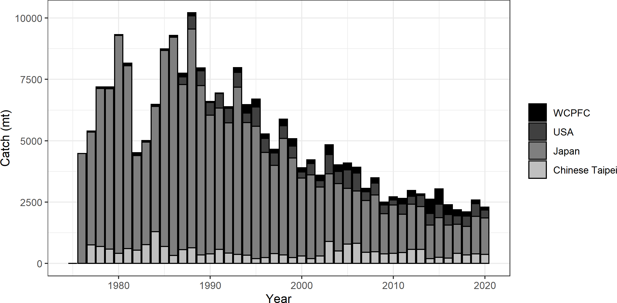

**Figure S1.** Annual catch biomass (mt) of Western and Central North Pacific striped marlin (*Kajikia audax*) by country for Japan, Chinese Taipei, the U.S.A., and all other countries during 1977-2020.

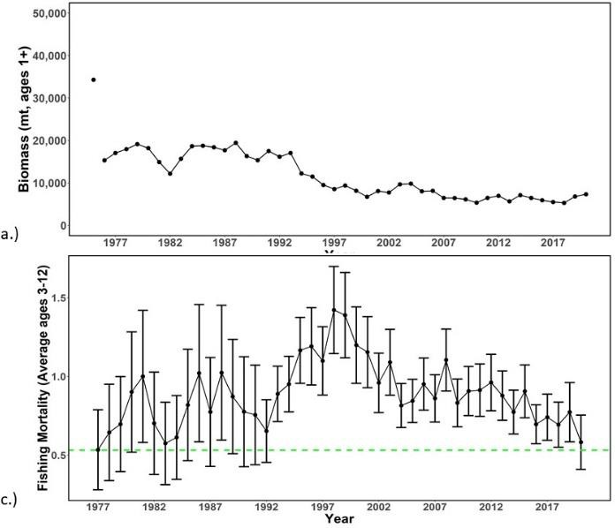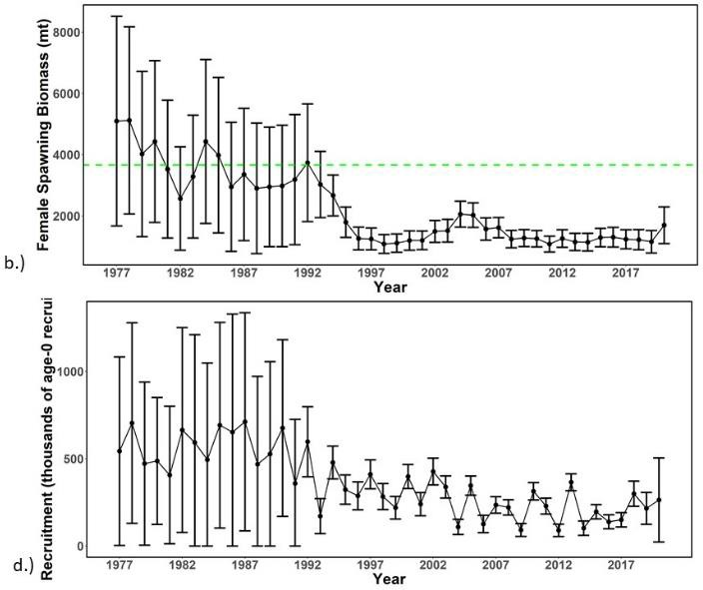

**Figure S2.** Time series of estimates of (a) population biomass (age 1+), (b) spawning biomass,

(c) instantaneous fishing mortality (average for age 3-12, year-1), and (d) recruitment (age-0 fish) for Western and Central North Pacific striped marlin (*Kajikia audax*) derived from the 2023 stock assessment. The circles represents the maximum likelihood estimates by year for each quantity and the error bars represent the uncertainty of the estimates (95% confidence intervals), green dashed lines indicate the dynamic 20%SSBF=0 and F20%SSBF=0 reference point.

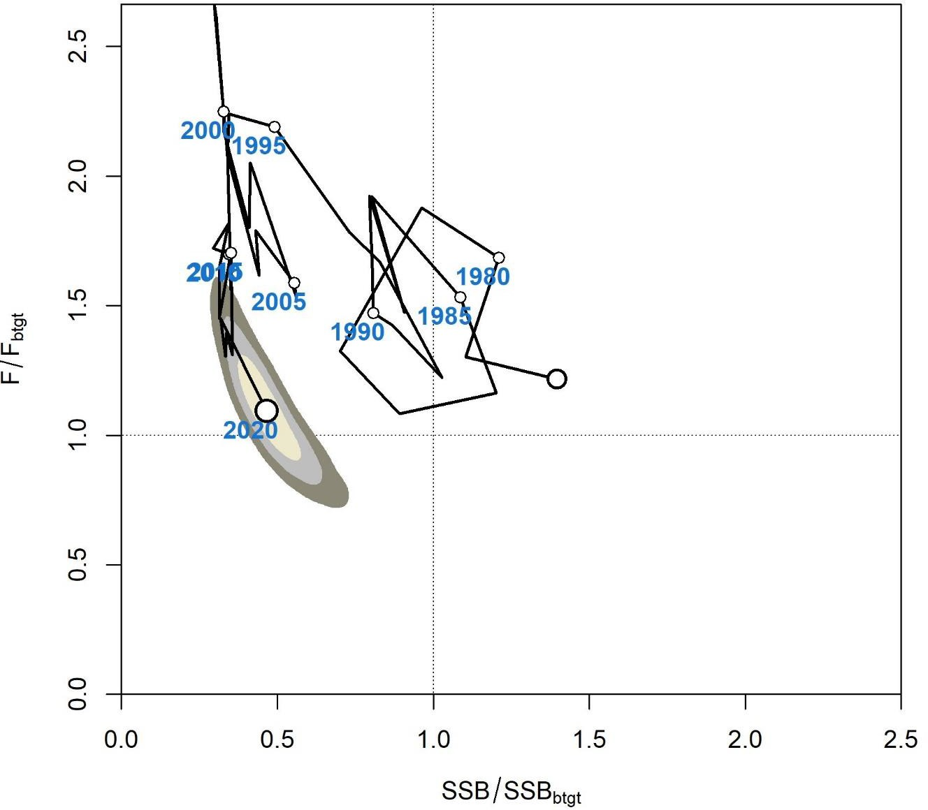

**Figure S3.** Majuro plot of the time series of estimates of relative fishing mortality (average of age 3-12) and relative spawning stock biomass of Western and Central North Pacific striped marlin (*Kajikia audax*) during 1977-2020. Fbtgt and SSBbtgt refer to F20%SSBF=0 and 20%SSBF=0, respectively. The large, un-labeled open circle indicates 1977, subsequent open circles are in 5- year increments. Shading indicates 50%, 80%, and 95% confidence intervals, respectively.

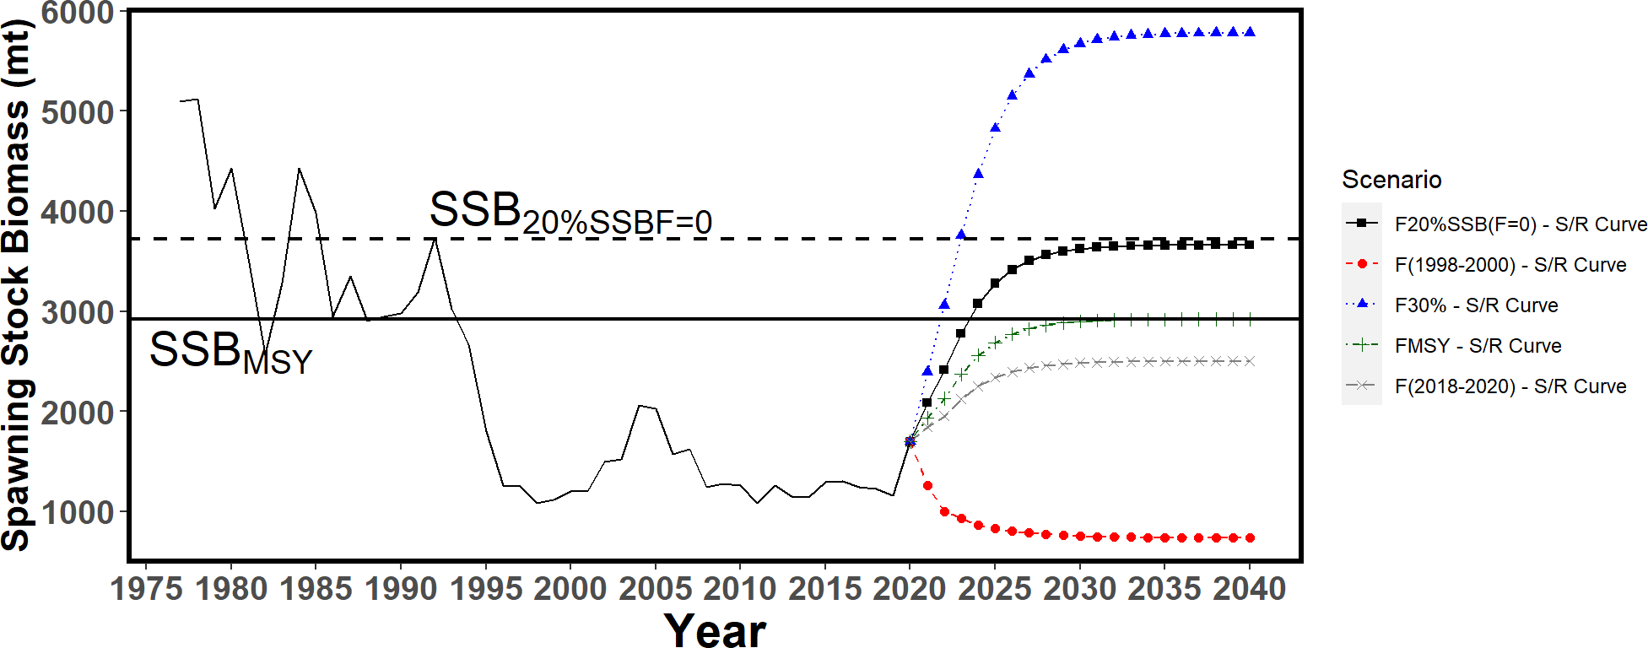a.)

b.)

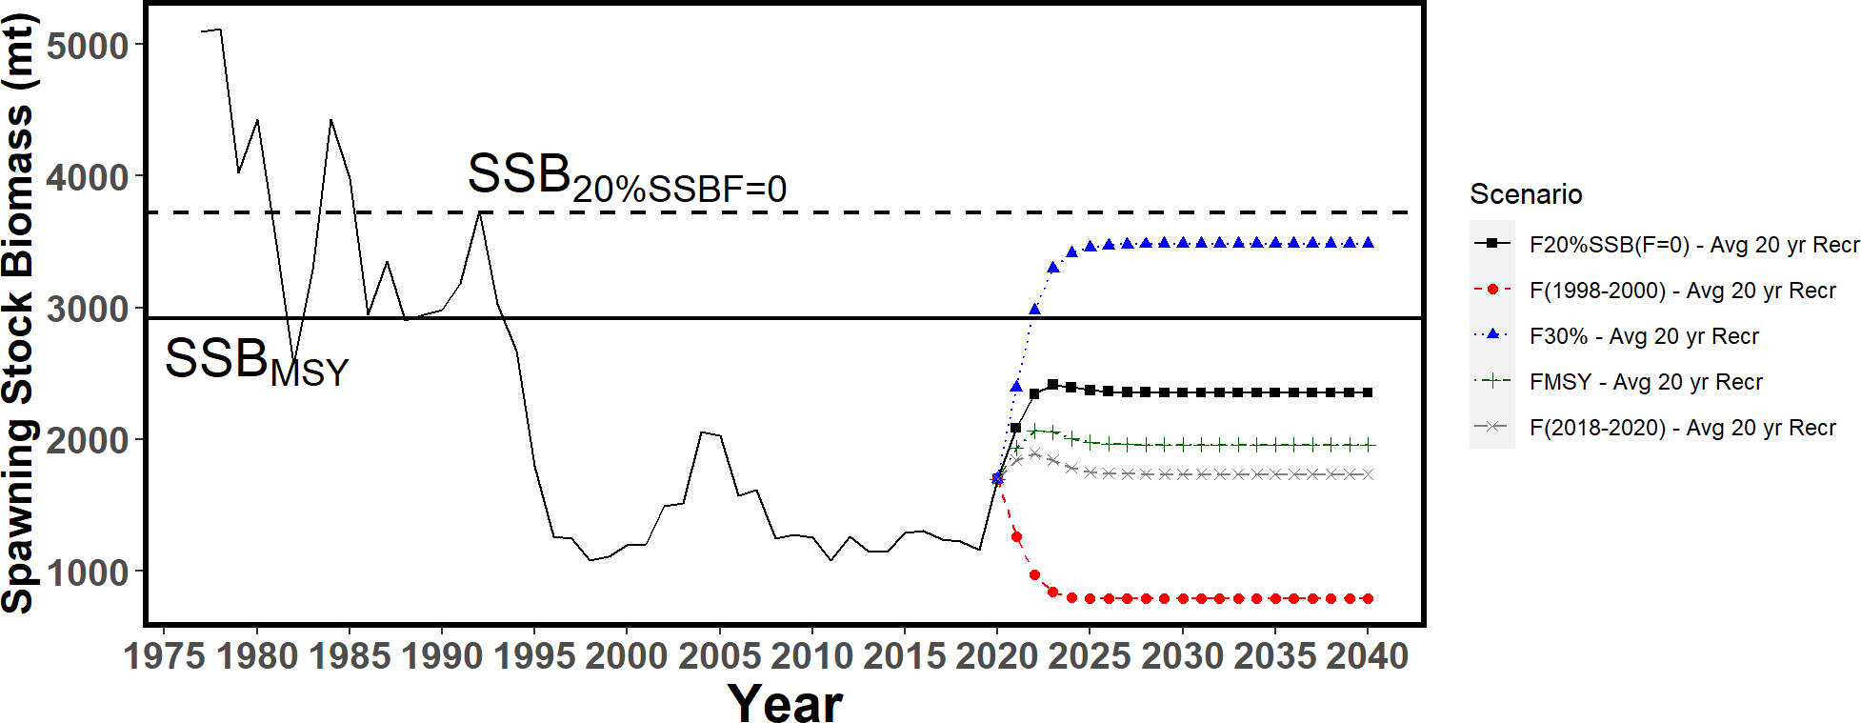

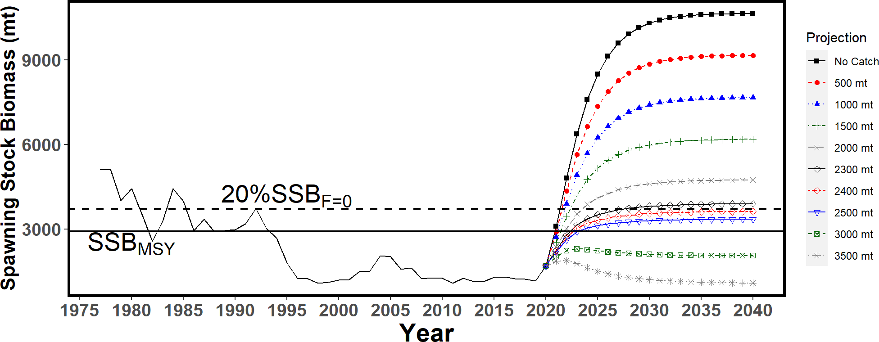c.)

**Figure S4.** Historical and projected trajectories of spawning biomass from the Western and Central North Pacific striped marlin base case model based upon F scenarios: (a) F scenarios projected spawning biomass using recruitment estimated from the stock-recruitment curve; (b) F scenarios projected spawning biomass using average recruitment from 2001-2020. (c) Catch scenarios projected spawning biomass using average recruitment from 2001-2020. Dashed line indicates the spawning stock biomass at the dynamic 20%SSBF=0 reference point. Solid line indicates the spawning stock biomass at SSBMSY. The list of projection scenarios can be found in Table S3 and S4.

a.)

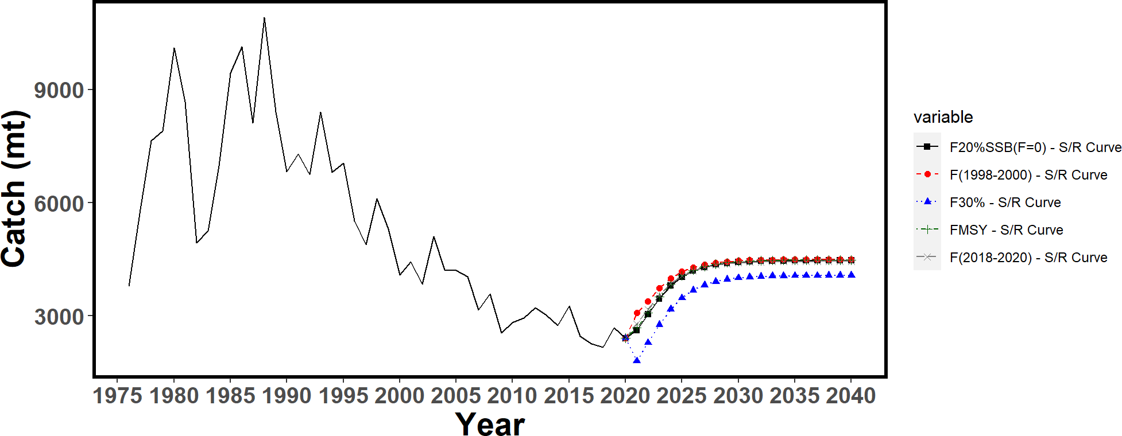

b.)

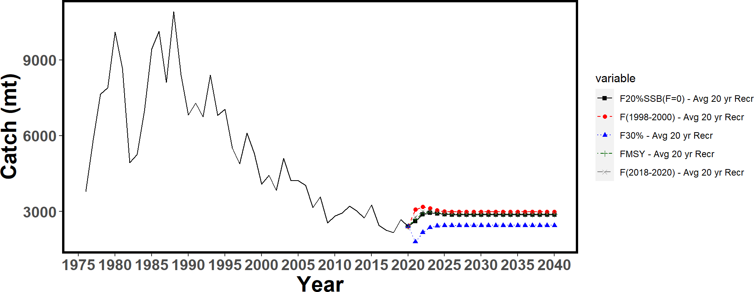

**Figure S5.** Historical and projected trajectories of catch from the Western and Central North Pacific striped marlin base case model based upon F scenarios: (a) F scenarios projected catch using recruitment estimated from the stock-recruitment curve; (b) F scenarios projected catch using recruitment estimated from 2001-2020 average. The list of projection scenarios can be found in Table S3.

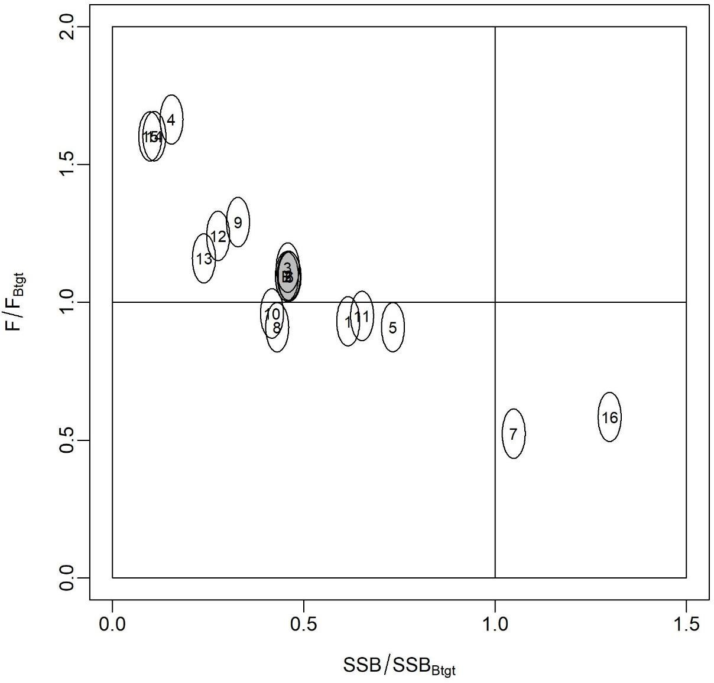

**Figure S6**. Majuro plot showing the terminal year stock status for the base-case model (gray circle, B) and the 16 sensitivity runs used to evaluate the sensitivity of the model to various model assumptions (circled numbers, circles are used as a visual aid). Models 12, 13, 15, and 16 are all sensitivity runs on assumptions on growth. See Table 12 in the stock assessment report for the full list and description of the sensitivity runs.

# Introduction

The Billfish Working Group (BILLWG or WG) of the International Scientific Committee for Tuna and Tuna-like Species in the North Pacific Ocean (ISC) completed a benchmark stock assessment for Western and Central Pacific Ocean (WCNPO) striped marlin (MLS, *Kajikia audax*) in 2019 (ISC, 2019). The assessment results indicated that the stock status was overfished and the overfishing was occurring relative to MSY-based reference points. The BILLWG raised several concerns for the modelling, and the Western and Central Pacific Fisheries Commission (WCPFC) requested that the BILLWG to provide rebuilding targets based upon a 20%SSBF=0 reference point where the SSBF=0 is the dynamic B0 averaged over the last 20 years (2001-2020). The WCPFC also requested the BILLWG to provide the best timeframe for the calculation of these reference points. Therefore, the BILLWG agreed to conduct a new benchmark stock assessment in 2022 for providing stock status based upon the reference points. The BILLWG held the data preparatory meeting virtually in December 2021 to evaluate new stock structure, updated life history parameters and fishery data (ISC, 2022). Then the BILLWG conducted the stock assessment at a virtual meeting in April 2022. However, after the assessment meeting, the BILLWG raised a concern about the updated growth curve used in the assessment. As a result, the BILLWG agreed not to put forward the 2022 assessment for management advice, but to revisit the issue of the growth curve and, if necessary, revise the assessment model based upon the results of the growth curve analysis. Between August 2022 and November 2022, a series of virtual meetings were held between members of the modeling team to discuss the growth curve. During this meeting, a new growth curve was developed using a Bayesian analysis using the original length at age data contained in the Sun *et al.*, 2011 paper. The BILLWG agreed that this growth curve was the best information available and should be used in the 2023 WCNPO-MLS stock assessment. In December 2022, a hybrid virtual and in-person assessment meeting was held where the base-case model was determined, and diagnostics, sensitivity runs, and future projections were completed.

This report will contain two sections: one describing the development of the 2023 WCNPO-MLS growth curve and one describing the 2023 stock assessment for the WCNPO MLS stock. The best available scientific information including the up-to-date catch, catch-per-unit-effort (CPUE), and size composition data from 1975-2020 were provided by individual ISC countries and the WCPFC, however, the start year was changed from 1975 to 1977 due to the large uncertainty in the catch statistics before 1977. The 2023 assessment was conducted using the integrated age- structured assessment model SS3 version 3.30.18 (Methot and Wetzel 2013).

# Growth Curve Development

In the 2019 WCNPO MLS stock assessment, the BILLWG noted that one of the important sources of uncertainty pertained to the use of the growth curve. The BILLWG used the growth curve produced by Sun *et al.* (2011), as this was the most up-to-date information available about growth for WCNPO MLS. However, the growth curve had some disadvantages. First, the length- at-age data that the growth curve was estimated from only covers the apparent ages of 0.5 to 6 (Figure 1). However, it is believed that striped marlin can live in excess of 15 years of age based upon the size of the largest fish caught in the fishery, which suggests that the Sun *et al.* (2011)

growth curve does not contain information to estimate accurately the growth of the fish older than 7 years and the maximum size (Linf). Second, the fish aged in this study were sampled from the Chinese Taipei offshore longline, gillnet, and harpoon fleets, which operate near Chinese Taipei. The WCNPO MLS stock, however, extends to 150°W, which means that the growth curve may not be representative of the growth of the entire stock. Therefore, the BILLWG agreed that the question of the growth should be the primary focus for the next benchmark assessment. The BILLWG has spent almost two years discussing and developing the growth curve that was used in the 2023 WCNPO MLS stock assessment. The path to reaching this growth model will be described below. The BILLWG is confident that this is the best growth curve option using the data and information currently available on the growth of WCNPO MLS.

### March 2021 – BILLWG intercessional meeting

During the March 2021intercessional BILLWG meeting, a working paper was presented that showed the estimated size at age output from the r4ss SS3 analysis package in R (Taylor, *et al.*, 2021) which suggested that the growth curve used in the 2019 base-case model did not match with the original growth curve provided by Sun *et al.* (2011), that had been used in the assessments for WCNPO MLS since 2011 (hereafter 2019 growth model, Figure 2, Ijima, 2021a). The BILLWG expressed a concern about this issue and requested further research to evaluate whether the input growth curve of SS matched the expected size at age from the Sun et al. 2011 growth curve (ISC BILLWG, 2021). The BILLWG also agreed to advance the schedule of WCNPO MLS benchmark assessment planned in 2023 to 2022 in order to address the concerns over the growth curve and other uncertainties outlined in the 2019 stock assessment report.

The BILLWG re-estimated the parameters of the best-fitting Sun *et al.* (2011) Richards growth curve, using non-linear least squares to the Schnute (i.e. L1-L2) Von Bertalanffy formulation (Figure 3, ISC BILLWG, 2011) because SS3 did not support a Schnute (L1-L2) Richards curve in 2011. Since then, the BILLWG had used this Von Bertalanffy growth parameterization in the 2015 update assessment and the 2019 benchmark assessment.

### December 2021 BILLWG MLS data preparatory meeting

Between the March and December BILLWG meetings in 2021, the BILLWG explored new growth parameters using the Von Bertalanffy growth curve from the Sun *et al.* (2011) paper based upon Linf and t0 (Figure 4). The BILLWG proposed to use the Linf-t0 Von Bertalanffy growth curve, which was then converted into the L1-L2 Von Bertalanffy curve (hereafter 2022 growth model, Ijima, 2021c) to use in the assessment. In addition, the BILLWG noted that the growth curve used in the assessment is a key uncertainty. The BILLWG also noted that the original length-at-age data (Sun *et al.*, 2011) covers only apparent ages 0.5-6, though WCNPO- MLS are believed to live in excess of 15 years. Therefore, the BILLWG agreed to use not only the L1-L2 Von Bertalanffy growth curve, but also the growth curves from other regions in the Pacific from the Southwest Pacific Ocean (SWPO, Kopf *et al.,* 2011) and the Eastern Pacific Ocean (EPO, Mel-Barrerra *et al.,* 2003, ISC BILLWG, 2022a).

### April 2022 BILLWG MLS assessment meeting

In the interim between the data preparatory meeting in 2021 and the stock assessment meeting in 2022, the BILLWG modeling team developed three potential base-case models based on the 2022 growth model, the SWPO growth model, and the EPO growth model. At the assessment meeting, the BILLWG agreed not to continue developing the EPO growth model as it was biologically inconsistent with the observed catch and size composition data from the WCNPO. The BILLWG continued refining both the SWPO growth model and the 2022 growth model (i.e., L1-L2 Von Bertalanffy growth curve), and the BILLWG finally agreed to use only the 2022 growth model to provide stock status and management advice, as the SWPO growth model showed poor performance in many diagnostic tests. This was likely driven by the difference in the Brody growth coefficient *k*, which was almost twice as large in the SWPO as the 2022 growth model. This means that juveniles in the SWPO model grew more quickly than those in the 2022 growth model, which was not well supported from the available data (ISC BILLWG, 2022b). The BILLWG decided to include the SWPO growth model as a sensitivity run (see Figure 31 in the sensitivity analyses section below).

### July 2022 ISC plenary meeting

Prior to the ISC plenary meeting in July 2022, the BILLWG reviewed the process of the decision on changing the growth curve from the 2019 growth model to the 2022 growth model. The BILLWG discovered that the premise for changing the growth curve —that SS3 was not producing accurate length-at-age estimates— was incorrect. The r4ss package reported length-at- age in quarter one, however, most WCNPO MLS are believed to be born in quarter two, and then recruit and start growing according to the growth in quarter three of the model. This means that the length-at-age output from r4ss is offset by size months, i.e. the length-at-age six months is smaller than expected. When the BILLWG added the extra half-year of growth to age-0 fish, the estimated length-at-age from the 2019 stock assessment matched the predicted length-at-age from the 2019 growth model. This meant that the 2019 growth curve should not have been changed in the 2022 assessment as it was the best fit curve from Sun *et al.* (2011) and no new growth information was available at the time of the assessment in 2022. ISC 2022 plenary decided not to put forward the 2022 base-case model for management advice, but proposed to continue exploring the growth question and complete the WCNPO MLS assessment in December 2022 (ISC, 2022). Recognizing that the Schnute (L1-L2) Richards curve is directly available in SS3 at this time, the BILLWG agreed to explore the use of the Richards parameterization of growth estimated by Sun *et al.* (2011) in the 2023 assessment. Should those efforts not be successful, the WG committed finding the best growth curve to use for the new assessment.

### October – November 2022 Modeling Team Meetings

Over the course of three meetings with the modeling team, representing Chinese Taipei, Japan, and USA, a new growth curve was developed to use in the 2023 WCNPO MLS assessment. The BILLWG proposed a series of growth models: the BILLWG attempted to convert the Richards growth curve from Sun *et al.* (2011) into the Schnute L1-L2 Richards formulation in SS3 (SS3-

Richards, Brodziak, 2022). A non-linear least squares approach was used to estimate the new growth parameters with the predicted length-at-age data from the Sun *et al.* (2011) growth curve. This was the same method used to produce the Von Bertalanffy growth curve (SS3-Von Bertalanffy) used in the 2011-2019 assessments (i.e., 2019 growth curve). The BILLWG also decided to estimate the growth parameters using the original length-at-age data (Sun et al., 2011).

After initial efforts which produced parameters inconsistent with the observed data (estimating an Linf = 190cm EFL while fish are observed in the catch up to 300 cm EFL), the BILLWG adopted a Bayesian method, placing priors on the input parameters. Most parameters were given a vaguely uninformative priors, and three different priors were used for the two maximum length-at-age parameters (Linf or L2, depending on the formulation). Six models were ultimately presented for consideration (Figure 5). Three growth curves were the SS3-Richards curve formulation using L1 and L2, and three growth curves were the SS3-Von Bertalanffy curve formulation using L1 and Linf, which is equivalent to the SS3-Richards curve when the shape parameter *a* is equal to one. For these models, L1 was set to age 0.5, which is the age of the

youngest fish in the original dataset, and L2 was set to age 15, which is the maximum age used in the assessment model.

Prior one was vaguely informative with a mean length at age 15 from the 2019 growth model (212 cm EFL) and a standard deviation of 24 cm EFL. Prior two was also vaguely informative with a standard deviation of 25 cm EFL (11% CV), however, the Linf was set at the mean value of SWPO growth model (220.5 cm EFL). Prior three was strongly informative with the same mean as prior 2 and the standard deviation of Linf was 2.2 cm EFL (1% CV). This prior was based upon the expert opinion that the true maximum length-at-age (either Linf or L2) was larger than 190 cm EFL because a number of MLS caught in the WCNPO were greater than 220 cm EFL. In addition, the growth curve used in the SWPO-MLS stock assessment (Kopf *et al.,* 2011) seems more accurate than that in the WCNPO-MLS because observed mean length data contains ages up to 9 years of apparent age (Chang, *et al.*, 2023). All growth curves predicated lengths-at- age for ages 0.5-6 were compared to the observed mean lengths-at-age from the original data, and the SS-Von Bertalanffy growth curve using the highly informative prior (prior three) provided the best fit to the observed data (Figure 6). The BILLWG agreed to move forward with this growth curve (2023 growth model) for the assessment meeting in December 2022 (Figure 7).

### December 2022 BILLWG MLS assessment

At the December 2022 WCNPO-MLS assessment meeting, the BILLWG used the 2023 growth model and evaluated the model diagnostics of the proposed base-case model. The BILLWG indicated that the model diagnostics did not show any issues about the model fitting to the data, although the sensitivity analysis showed that the model outputs were highly sensitive to the growth parameters. The WG finally agreed that the SS model with the 2023 growth curve should be used as the best available scientific information at this moment. However, the BILLWG has a plan to replace the growth curve if the progressing International Billfish Biological Sampling program could provide a reasonable growth curve for WCNPO-MLS (ISC BILLWG, 2022c).

# 2023 WCNPO-MLS Assessment

### Materials and Methods

#### *Spatial and Temporal Stratification*

The geographic area encompassed in the assessment for MLS was the WCNPO bounded by the equator and the WCPFC management boundary at 150°W. Three types of data were used: fishery-specific catches, relative abundance indices, and length measurements. The fishery data were compiled for 1975-2020, noting that the catch data and length composition data were compiled and modeled on a quarterly basis and only data from 1977-2020 were ultimately used in the model. Several CPUE indices were also modeled as a quarterly index from the Japanese longline fleet. Available data, sources of data, and temporal coverage of the datasets used in the stock assessment are summarized in Figure 8. Further details are presented below.

#### *Definition of Fisheries*

A total of 25 fisheries that caught WCNPO-MLS were defined on the basis of country, gear type, location, and time period, where each fishery was assumed to target a distinct component of the stock. Descriptions and data sources to characterize the twenty-five fisheries that catch WCNPO- MLS are summarized in Table 1. These fisheries included fourteen longline fisheries (F1-F14) from Japan which are consistent with the fleets used in the 2019 assessment. Thirteen of these fleets are the results of the flexmix model applied to the Japanese offshore and distant-water longline data, which divided the data into areas and quarters based upon mean weight and CPUE (Ijima and Kanaiwa, 2019b). Nine quarter-area combinations were identified and two of these, Japan quarter 1 area 1 and quarter 3 area 1 were divided into the early and late periods (F1, F5, F22, and F23). An additional longline fleet (F12: JPNLL_Others) accounted for any other MLS longline catches. Five additional fleets from Japan included the driftnet catches as four fleets (F13, F14, F24, and F25) divided by time-period and quarter: quarters one and four and quarters two and three (JPNDF_Q14 and JPNDF_Q23) for two time periods: 1977-1993 (Mid) and 1975- 1976 and 1994-2020 (EarlyLate) and a fleet to encompass all other Japanese MLS catches (F15: JPN_Others). The change in the fleet definition for Japanese driftnet fisheries was implemented to reflect the re-estimated catch for the Japanese driftnet fisheries from 1977-1993 where the new catch data were reported in numbers. There were also three fleets from Chinese Taipei: one for their distant water longline fleet (F18: TWN_DWLL), one for their small-scale tuna longline fleet (F19: TWN_STLL) and one other fleet for any additional catches (F20: TWN_Others).

There were two fleets from the United States: a single fleet for the Hawaii-based longline fleet (F16: US_LL) and one other fleet (F17: US_Others) which included handline and troll catches. Finally, there was one fleet for the various flags contained in the WCPFC management region not otherwise accounted for (F21: WCPFC_Others).

#### *Catch*

Catch was input into the model on a quarterly basis (i.e., by calendar year and quarter) from 1977 to 2020 for the 23 individual fisheries. Catch was reported in terms of catch biomass (metric

tons: mt) for all fisheries, with the exception of the Japanese offshore and distant water longline fleets (JPNLL F1-13) and the Japanese driftnet mid fisheries (F24 and F25) for which catch was reported as numbers of fish caught.

Three countries (i.e., Chinese Taipei, Japan, and the USA) provided national catch data (Hirotaka Ijima, NRIFSF, personal communication; Yi-Jay Chang, NTU, personal communication; Russell Ito, NOAA NMFS, personal communication). The WCNPO-MLS catches for all other fishing countries were collected from WCPFC category I and II data (WCPFC Yearbook 2021).

The resulting best available data on WCNPO-MLS catch by fishery from 1977-2020 were tabulated and are shown in Figure 9 and Table 2. The historical maximum and minimum annual WCNPO-MLS catches were 10,912 mt in 1988 and 2,177 mt in 2018, respectively. From 1975 to 1993, the Japanese driftnet fishery harvested approximately half of the total annual catch.

However, these catches are likely to have large uncertainties due to incomplete logbook records and limited port sampling. Overall, annual catch of WCNPO-MLS generally declined since 1988. The recent mean annual catch of WCNPO-MLS during 2018-2020 was 2,430 mt.

#### *Abundance Indices*

Relative abundance indices for WCNPO-MLS based on standardized CPUE were prepared for this assessment and are shown in Figure 10 and Tables 3 and 4. A finite mixture model analysis was used to identify nine different area-quarter combinations based upon the weight and CPUE data of WCNPO-MLS caught in the Japanese offshore and distant water longline fleets. Japanese CPUE data were standardized in two area-quarters (Q1A1 and Q3A1) as well as two-time periods (Early:1975-1993 and Late:1994-2020) due to the change of Japanese logbook reporting requirements (Ijima and Kanaiwa, 2019a; Ijima and Kanaiwa, 2019b; Ijima and Koike, 2022).

Operational fishing data collected by observers in the Hawaiian longline fishery during 1995- 2020 were used in the CPUE standardization for US longline fleets (Sculley, 2022). The fishery operates in two sectors: a shallow-set sector targeting swordfish and a deep-set sector targeting tunas. The WCNPO-MLS are caught as bycatch in both sectors. These data were standardized into a single CPUE time series including factors that accounted for much of the variability between sectors.

The distant-water longline fleet from Chinese Taipei was standardized from 1995-2020 using a spatio-temporal model (Lee *et al.,* 2022).

Visual inspection of three indices of late period (S1, S2, and S3) showed an overall decreasing trend in 1990s and 2000s with the last 10-20 years showing a relatively flat trend. Both of the early Japanese LL indices and the Chinese Taipei LL index are relatively variable without trend (Figure 10). However, S3 (US HI LL) and S6 (JPNLL Q3A1 Early) were ultimately excluded from the model likelihood due to conflicts in the indices identified when profiling the likelihood based upon R0.

#### *Size Composition Data*

Quarterly fish length composition data from 1977–2020 for seventeen fisheries were used for the assessment and are summarized in Table 3. Length frequency data were compiled using 5-cm length bins from 50 to 230 cm. The lower boundary of each bin was used to define each bin for all length-composition data, and each observation consisted of the actual number of MLS measured. The length composition data were agreed upon at the BILLWG data preparatory meeting as the best available scientific information for the 2023 stock assessment.

Figure 11 shows the quarterly length compositions. Most of the fisheries caught small (mean size caught 153 cm EFL) individuals. The longline fleets caught fish with a mean of 154 cm EFL while the driftnet fleets caught slightly larger fish, mean 163 cm EFL. The US longline fleet (US_LL) caught smaller fish on average than any of the other fleets (mean size 143cm EFL).

The aggregate length composition distributions were relatively consistent between fleets, with the exception of the US Longline fleet (Figure 12). Most longline length composition distributions had a single mode around 150-160cm EFL, while the US longline fleet was bimodal with peaks around 110cm and 140cm EFL.

#### *Model Description*

The stock assessment for WCNPO-MLS was conducted using SS version 3.30.18.00-SAFE released 09/30/2021 programed via Otter Research ADMB 12.3 (Methot and Wetzel 2013). The model was set up as a single area model with a single sex and four seasons (quarters). Spawning was assumed to occur in quarter two while recruitment was assumed to occur in July (month 7). Age at recruitment was calculated based upon the model estimated average selectivity at age based upon the quarterly selectivity at length. The maximum age of WCNPO-MLS was set to 15 years. Age-specific natural mortality was used (Table 5) as agreed upon in the BILLWG data preparatory meeting (ISC, 2022). The age at length L1 was set to age 0.5, the CV of the growth curve was set to 0.14 for young fish and 0.10 for old fish, and the sex ratio at birth was assumed to be 1:1. The growth curve used a von Bertalanffy growth curve for ages 0.5-15 with a K = 0.26 and a length at age 15 (*L2*) = 215.5 cm EFL with the size at age 0.5 (*L1*) = 110.9 cm EFL. A Beverton-Holt spawner-recruit relationship was used with steepness (h) set at 0.87 and sigmaR (σr) set at 0.6.

#### *Data Observation Models*

The assessment model fit three data components: 1) total catch; 2) relative abundance indices; and 3) length composition data. The observed total catches were assumed to be unbiased and relatively precise, and were fitted assuming a lognormal error distribution with standard error (SE) of 0.05. The relative abundance indices were assumed to have log-normally distributed errors with SE in log-space (log(SE)) which was log(SE)=sqrt(log(1+CV2)), where CV is the standard error of the observation divided by the mean value of the observation and sqrt is the square root function.

Two CPUEs (S3 and S4) were assigned to quarter one. The other CPUEs for Japanese longline fleets (S1, S2, S5, and S6) were quarterly indices representing quarters one and three. Of these, four fleets (S1, S2, S4, and S5) were used in the base-case model. The other two CPUE indices (S3 and S6) were excluded from the base-case model because they had conflicts with the other input data based upon the R0 likelihood profile. The CPUE indices were assumed to be linearly proportional to biomass where catchability (*q*) was assumed to be constant and occur in the first month of the quarter assigned.

The CVs for each CPUE index were assumed to be equal to their respective calculated SEs on the log scale (Table 6). The minimum CV was scaled to a minimum of 0.2 and then reweighted if the suggested variance was greater than the input variance based upon the Francis method using the root-mean-square error (RMSE, i.e., square root of the residual variance, Francis 2011).

The length composition data were assumed to have multinomial error distributions with the error variances determined by the effective sample sizes. Measurements of fish are usually not random samples from the entire population. Rather, they tend to be highly correlated within a set or trip (Pennington *et al.*, 2002). The effective sample size is usually substantially lower than the actual number of fish measured because the variance within each set or trip is substantially lower than the variance within a population. The effective sample size for all fleets was set equal to 1/10 of the total number of samples in each quarter, in alignment with previous assessments (ISC 2019). In addition, quarters with fewer than 15 total samples were removed from the time series due to limited sample size and the maximum number of samples was set to 50, as agreed upon by the modeling sub-group.

#### *Estimation of Fishery Selectivity*

Selectivity was estimated as a double-normal curve for all fleets, except for F13 and F14, the Japan drift gillnet fisheries, and F18, the Chinese Taipei longline fishery and were assumed as asymptotic lognormal (Figure 13). All other fleets were mirrored to the fleet that was believed to have the most similar selectivity pattern (Table 7).

#### *Data Weighting*

Index data were prioritized in this assessment based on the principles that relative abundance indices should be fitted well because abundance indices are a direct measure of population trends and scale, and that other data components such as composition data should not induce poor fits to the abundance indices (Francis, 2011).

It is common practice to re-weight some or all data sets in two stages (Francis, 2011). Input length composition sample sizes and CPUE data iteratively re-weighted in stage 2, but only if the re-weighting decreased the sample size or increased the CV of the CPUE index.

#### *Model Diagnostics*

Several diagnostics have been evaluated for their utility to identify data conflicts and model misspecification within integrated stock assessment models (Carvalho *et al.* 2017). However, Carvalho *et al.* (2017) determined that there was no single diagnostic that worked well in all of the cases they evaluated. Instead, they recommend the use of a carefully selected range of diagnostics that proved to increase the ability to detect model misspecification.

Key stock assessments diagnostics identified by Carvalho *et al.* (2017) and Carvalho *et al.*

(2021) were implemented to evaluate the base case model.

*Retrospective analysis*

Retrospective analysis is a way to detect bias and model misspecification (Hurtado-Ferro *et al.* 2014). A retrospective analysis was applied to the base-case model results. The diagnostic was implemented here by sequentially eliminating the five most recent years of data from the full stock assessment base case model (a 5 year “peel”) and then re-estimating all stock assessment model parameters from each peel and from the full model. Then Mohn’s rho was calculated for the biomass and fishing mortality peels, which measures the severity of the retrospective pattern (Hurtado-Ferro *et al.* 2014). Values higher than 0.20 and lower than -0.15 can indicate problematic retrospective patterns and may point to model misspecification, data conflicts, or poor fits to the data.

*R0 likelihood profile*

An R0 likelihood component profile (Lee *et al.* 2014) was applied to the base-case model results.

The diagnostic was implemented here by sequentially fixing the equilibrium recruitment parameter, R0, on the natural log scale, log(R0), to a range of values. The relative change in negative log-likelihood units over the range of fixed values for log(R0) (the R0 profile) was compared among the SS model likelihood components for CPUE, length-composition, and recruitment deviations using two diagnostic tests. First, a relatively large change in negative log- likelihood units along the R0 profile was diagnostic of a relatively informative data source for that particular model. Second, a difference in the location of the minimum negative log- likelihood along the R0 profile among data sources was diagnostic of either conflict in the data or model misspecification (or both).

*Age-structured production model*

An age-structured production model (ASPM; Maunder and Piner 2015; Carvalho *et al.* 2017) was applied to the base-case model results.

The diagnostic was implemented here by fixing selectivity to its estimated values in the fully integrated stock assessment model, fixing recruitment equal to the stock recruitment curve obtained from the fully integrated stock assessment model, and then estimating the remaining parameters of the stock assessment model. Trends in relative spawning stock size were compared from the fully integrated stock assessment model and the ASPM.

Carvalho *et al.* (2017) suggest that if the ASPM is able to fit well to the indices of abundance that have good contrast (i.e. those that have declining and/or increasing trends), then this is evidence of the existence of a production function, and the indices will likely provide information about absolute abundance. On the other hand, Carvalho *et al.* (2017) suggest that if there is not a good fit to the indices, then the catch data alone cannot explain the trajectories depicted in the indices of relative abundance. This can have several causes: (i) the stock is recruitment-driven; (ii) the stock has not yet declined to the point at which catch is a major factor influencing abundance; (iii) the base-case model is incorrect; or (iv) the indices of relative abundance are not proportional to abundance.

*Goodness-of-Fit Indices of Abundance*

Residuals are examined for patterns to evaluate whether the model assumptions have been met. Many statistics exist to evaluate the residuals for desirable properties. One way is to calculate, for each abundance index, the root-mean-square-error (RSME) was used as a goodness-of-fit diagnostic, with relatively low RMSE values (i.e., RMSE < 0.3) being indicative of a good fit.

*Goodness-of-Fit Size Composition Data*

Comparisons between the observed and expected mean values of composition data from Francis (2011) were used for model diagnostics. Pearson residuals for size composition data fits were also used as a model diagnostic.

*Runs Test*

The runs test evaluates the residuals of the CPUE indices and size composition mean length trends. This is a nonparametric test for randomness in the sequence of residuals (Carvalho *et al.* 2021, Wald and Wolfowitz 1940). In other words, this test uses a 2-sided p-value to estimate the number of positive or negative residuals in a row (a “run”). CPUE or size composition data that fail the runs test indicate that there may be a pattern in the residuals and the model is unable to fit the data well or is mis-specified.

#### *Future Projections*

Deterministic future projections were conducted in SS to evaluate the impact of various levels of fishing mortality on future SSB and yield. No recruitment deviations and log-bias adjustment were applied to the future projections in this study. Instead, the absolute future recruitments were based on two recruitment scenarios: the expected stock-recruitment relationship and the average recruitment in the last 20 years. The future projection routine calculated the future SSB and yield that would occur while the specific fishing mortality, selectivity patterns, and relative fishing mortality proportions depended on the specific harvest scenarios. The last three model years’ (2018-2020) selectivity patterns and relative fishing mortality rates were used in the population future projections. The projections started in 2021 and continued through 2040 under five different harvest scenarios:

1. **High F Scenario (FHigh)**: Select the 3 years with the highest average F (age 3-12) and apply this fishing mortality rate to the stock estimates beginning in 2021; this corresponds to 1998-2000;
2. **FMSY Scenario (FMSY)**: Apply the estimate of the FMSY fishing mortality rate to the stock estimates beginning in 2021;
3. **Status Quo F Scenario (FStatus Quo)**: This will be the average F (age 3-12) during 2018- 2020;
4. **Low F Scenario (FLow)**: Apply an F30% fishing mortality rate to the stock estimates beginning in 2021;
5. **F20%SSB(F=0) Scenario (FBtgt):** Apply the estimate of F which produces 20%SSBF=0 based upon the dynamic B0, which roughly corresponds to F15%.

Recruitment for the projections was based on two hypotheses about future recruitment. The first hypothesis was that future recruitment would be similar to recent short-term recruitment (Avg 20 Yr Recr). This hypothesis was based on the observation that recruitment estimates had remained relatively low in recent years and one may not expect this to change in the future. The time period chosen to average the recruitment was 20 years, consistent with the time-period from which the dynamic B0 was calculated. The second hypothesis was that future recruitment would be similar to the stock recruitment curve (S/R Curve).

In addition, 10 constant catch scenarios were projected from 2021-2040 under the low recruitment assumption. Catch was set from zero catch (F=0) through 3500 mt in 500 mt increments, with the addition of runs at 2300 mt and 2400 mt to provide higher resolution of recovery probabilities.

### Results

#### *Base Case Model*

Results for the base case model provided estimates of biological reference points for WCNPO striped marlin and included trends in estimates of total stock biomass, spawning stock biomass, recruitment, and fishing mortality, along with a Majuro plot indicating stock status over time.

#### *Model Convergence*

All estimated parameters in the base case model were within the set bounds, and the final gradient of the model was approximately 0.02 and the hessian matrix for the parameter estimates was positive definite, which indicated that the model had converged to a local or global minimum. Results from 100 model runs with different random initial starting values for estimated parameters using the internal “jitter” routine in SS supported the result that a global minimum was obtained (i.e., there was no evidence of a lack of convergence to a global minimum, Figure 14).

#### *Model Diagnostics*

Figure 15 showed the results of the likelihood profile on virgin recruitment (ln(R0))for each data component. Detailed information on changes in negative log-likelihoods among the various fishery data sources are shown in Tables 8 and 9 and Figure 16 and 17.

Changes in the likelihood of each data component indicated how informative that data component was to the overall estimated model fit. Ideally, relative abundance indices should be the primary sources of information on the population scale in a model (Francis, 2011).

There was a relatively large change in the R0 profile for estimated recruitment deviations (Recruitment) and length composition data relative to the likelihood components for survey (CPUE, Figure 15). This result indicated that the estimation of the recruitment deviations was relatively informative within the likelihood for R0’s sizes below the MLE and the length composition data was relatively informative for R0’s above the MLE. The change in negative log-likelihood of abundance indices was relatively flat and the local minimum value was consistent with the total likelihood ln(𝑅0) = 6.01, though the contribution to the likelihood for all CPUE indices was minimal (Table 8, Figure 16).

The local minimum from the length composition data (5.8) was smaller than the minimum of the total likelihood (Figure 15). The U.S. longline fleet (F16) showed the largest changes in negative log-likelihood values (max 91.5) across values of R0 among the nine length composition data (Table 9, Figure 17). This fleet had the largest influence on the likelihood among the length composition fleets, and the local minimum was larger than 6.5.

There were differences in the location of the minimum negative log-likelihood along the R0 profile observed among data likelihood components for the base case model. The two-stage Francis approach seemed to have reduced the conflict, but did not eliminate it. Attempts to reduce the conflict of the US LL length composition data were unsuccessful, likely due to the challenge of fitting a bimodal selectivity distribution for the fleet. The BILLWG recommends continuing research to address this problem.

*Goodness-of-Fit Indices of Abundance*

Goodness-of-fit diagnostics were presented in Table 6, and plots of predicted and observed CPUE by fishery for the base case model were shown in Figure 18.

The fit to the CPUE indices can be summarized into two groups by the contribution to the total likelihood (contributed group of S1, S2, S4, and S5; uncontributed group of S3 and S6). Table 6 showed that RMSE was smaller than 0.3 for all indices except for S4. This result indicates that the model fit to these CPUE indices were good.

*Residuals Analysis of Size Composition Data*

Comparisons between the observed and expected mean values of length composition data from Francis (2011) were used for model diagnostics. Figure 19 shows the 95% credible intervals for

mean value for the nine length composition data sets. The model fit passed through almost all of the credible intervals.

Fits to the annual length compositions by fleet could be improved (Figure 20), with few obvious systematic patterns observed in the residuals (e.g., patterns of positive or negative residuals) making it difficult to objectively determine how to improve the fits. This is an important area for future model development. For example, more flexible selectivity curves (or time blocks) in combination with alternative binning of length composition data could be examined in the future to account for the jagged distributions observed in seasonal length compositions. Alternatively, different area stratification of fleets could be explored in the future to either increase sample size or smooth the length-frequency distributions. In this assessment both of these options were explored for several of the fleets, including the F1 Japanese LL Q1A1 data and the F16 US LL data, however the BILLWG ultimately selected a simpler model as improving the fit to the size data often required additional parameters, while accepting a slightly degraded fit to the data allowed the focus to remain on improving the CPUE fit and maintaining as many degrees of freedom in the model as possible.

Assuming standardized residuals were normally distributed, 95% of the measurements would fall within 2 standard deviations of the mean. The majority of Pearson residuals did not meet this criteria for F16 U.S. longline and F18 Chinese Taipei distant water longline, which showed stronger residual patterns when compared to the other fleets (Figure 20)**.**

Overall, the model fit the length modes in length composition data aggregated by fishery fairly well using the input effective sample sizes (Figure 21). However, F13, F14, and F16 all showed some misfit.

*Runs test*

The CPUE indices for all fleets passed runs test (Figure 22) that indicated the model fitted well. The length composition data for eight fleets passed the runs test (Figure 23). The length- composition data for F01 Japanese LL Q1A1 could pass the runs test if an additional time block is included in the selectivity estimates. However, this also increased the number of parameters estimated and degraded the fit to the S1 Japanese LL Q1A1 CPUE index. The BILLWG agreed that the priority was to fit the CPUE data and therefore estimated the F01 size data without a time block. Overall, additional work must be done to improve the fit to the size data, while ensuring that the fit to the CPUE data are prioritized.

*Retrospective Analysis*

A retrospective analysis was conducted for the last 5 years of the assessment time horizon to evaluate whether there were any strong changes in parameter estimates through time. The results of the retrospective analysis are shown in Figure 24. The trajectories of estimated SSB and F showed that there was a slight tendency of overestimation for SSB in recent years and underestimation for F. In addition, the Mohn’s rho for SSB (-0.13) and F (0.15) fell within the range of acceptable values (-0.15 to 0.20), suggesting that the retrospective pattern is not substantial.

*Age-structured production model*

ASPM results showed a different trend in SSB after around 1992 (Figure 25). The ASPM SSB gradually declined from 1977 to the 1980s, and then showed a sharp and consistent increase towards virgin SSB. The asymptotic 95% confidence interval from the fully integrated stock assessment did not overlap with the SSB trend from the ASPM for any of the modeled years. This indicates that either the CPUE indices do not represent relative abundance of this stock, or the stock is recruitment driven. Since the majority of the catch are below the length at 50% maturity, it is reasonable to hypothesize that the productivity of the stock is driven by recruitment, and the low SSB is due to juvenile fish being removed from the population before they have a chance to spawn.

#### *Stock Assessment Results*

Estimates of population biomass (estimated biomass of age 1 and older fish at the beginning of the year) declined from a high of 19,462 mt in 1988 to 5,349 mt in 2010, fluctuated between 5,000 and 7,000 metric tons through 2020 (Table 10 and Figure 26). In the last three years of the assessment the stock has averaged 6,500 mt (2018-2020). Overall, population biomass declined from an average of roughly 18,000 mt in the mid-1980s to an average of roughly 6,000 mt in the 2010s (Figure 26).

Female spawning stock biomass (SSB) estimates exhibited an initial oscillation around 4,700 mt in the late 1970s. The SSB was at its highest level of 5,096 mt in 1977, and declined to 1,083 mt in 1998 (Table 10 and Figure 27). The time-series of SSB during the past decade averaged 1,200 mt, or 6.7% of SSBF=0. Overall, SSB exhibited a strong decline during the early 1990s and has stabilized since. SSB has been below 20%SSBF=0 since 1993.

Recruitment (age-0 fish) estimates indicated a long-term fluctuation around a mean of approximately 366,000 (Table 10 and Figures 28). While the overall pattern of recruitment from 1977-2020 was variable, there was an apparent declining trend in recruitment strength over time with average recruitment higher in the 1970s and1980s than after around 1990s (Table 10 and Figure 28).

Over the course of the assessment time horizon, estimated fishing mortality (arithmetic average of F for ages 3 – 12) increased from 0.53 year-1 in 1977 to an all-time high of 1.42 year-1 in 1998, and afterward declined to a low of 0.58 year-1 in 2020 (Table 10 and Figure 29). Fishing mortality was above F20%SSBF=0 for all years in the assessment.

#### *Biological Reference Points*

Biological reference points were computed from the SS base case model. Based upon a request from WCPFC18, dynamic B0 reference points (SSBF=0) were used to assess relative stock status (Table 11). This value is 20% of the 20-year (2001-2020) average SSBF=0. The point estimate of 20%SSBF=0 was 3,660 mt with a SSBF=0 point estimate of 18,300 mt. The point estimate of F20%SSB(F=0), the fishing mortality rate to produce 20% of SSBF=0 on ages 3-12 fish was F = 0.53.

#### *Stock Status*

The WG agreed upon a base-case model for WCNPO MLS and is providing stock status information based upon this model. However, there was a concern if the base-case results are sufficiently reliable in order to provide specific conservation advice due to its uncertainty. At the 2022 ISC Plenary meeting, the WG was requested to continue working on the 2022 WCNPO MLS base-case model, with a focus on the growth parameters, particularly incorporating the Richard’s four-parameter growth curve directly into the SS3 model, for presentation to ISC23.

The WG agreed that the growth curve used to produce the base-case model was the best information available at this time, while highlighting the suite of sensitivity runs to show how the model reacts to changes of the growth curve (Figure 32, see the list and description of the sensitivity runs in table 12). The WG noted a concern that the estimation of initial F and thus the virgin biomass scale is largely affected by the selection of the growth curve, as the initial catch remains uncertain.

Compared to 20%SSBF=0-based reference points, the current SSB (average of 2018-2020) was 63% below 20%SSBF=0 and the current fishing mortality (average for ages 3-12 in 2018-2020) was 28% above FMSY. The Majuro plot indicates that the Western and Central North Pacific striped marlin stock is very likely currently overfished and is likely subject to overfishing relative to 20%SSBF=0-based reference points (Figure 30). Based upon 10,000 draws of a multinomial log-normal distribution, the probability that the stock is undergoing overfishing is 71.2% and the probability of the stock being overfished is >99%.

#### *Sensitivity Analyses*

In the December 2022 BILLWG workshop, the BILLWG agreed to conduct a series of sensitivity analyses (Table 12) to examine the effects of plausible alternative model assumptions and data input to the stock status. These analyses were:

1. **Sensitivity analysis on growth**: Although the BILLWG agreed to fully explore alternative growth curves from the EPO and SWPO stocks in the development of this assessment, the BILLWG finally determined not to use both growth curves as the base- case model because the biological parameters were incompatible with the WCNPO data and biologically unrealistic results were produced. Four sensitivity analyses were implemented: 1) the SWPO growth model was used as a sensitivity run because the model diagnostics indicated a model misspecification; 2) the 2019 growth model from the base-case model in the 2019 stock assessment was used as a sensitivity run; 3) the 2022 growth model from the base-case model in the 2022 stock assessment was used as a sensitivity run; 4) the 2022 growth model from the base-case model in the 2022 stock assessment with recruitment deviations to sum to zero was used as a sensitivity run and thereby reduced the number of parameters estimated and improved model convergence.
2. **Sensitivity analysis on natural mortality**: The BILLWG conducted two sensitivity analyses for natural mortality (M)-at-age. These were a low M scenario where Ms-at-ages were 10% lower than those of the base-case model and a high M scenario where Ms-at- ages were 10% higher than those of the base case model.
3. **Sensitivity analysis on recruitment variability**: The BILLWG conducted a sensitivity run on recruitment variability by assuming a larger SigmaR (σR = 0.9).
4. **Sensitivity analysis on steepness**: The BILLWG conducted three additional sensitivity runs on steepness (h). Steepness was fixed at higher value (h=0.95), lower value (h=0.79), and much lower value (h=0.70) compared to the base-case value (h=0.87).
5. **Sensitivity analysis on maturity**: The BILLWG conducted two sensitivity runs on the maturity ogive. The maturity ogive was fixed at the value (L50=177 cm EFL) used in the 2015 assessment and an alternative value (L50 = 181cm EFL) from Chang *et al.* (2018).
6. **Sensitivity analysis on assessment model time frame**: The BILLWG conducted two sensitivity analyses on the time frame of stock assessment. The same parameters of the base-case model was used with the starting year of the model in 1975 or 1994. The shorter time period was assumed to examine the impact of removing early data on the stock assessment results.
7. **Sensitivity analysis on modeling structure:** The BILLWG conducted three additional sensitivity runs to explore the effects of changes in the model structures from the 2019 model to the 2022 model: 1) a model with excluding newly added catch data from China and Vietnam to the 2022 model; 2) a model with the same biological parameters as the base-case model used in the 2019 stock assessment; 3) a model with the same selectivity patterns for Japanese driftnet catch prior to 1994 as those used in the base-case model in the 2019 stock assessment.

During the April 2022 BILLWG workshop, all 16 sensitivity analyses were completed and the results were presented and reviewed.

The BILLWG completed all 16 sensitivity runs and compared the SSB and the F trajectories to those of the base-case model (Figure 31). The BILLWG also produced a Majuro plot to compare the stock status of the recent years among 16 sensitivity runs. The result showed that there was clear pattern of the stock status (improvement or deterioration, Figure 32).

The stock status was estimated to be overfished except for two sensitivity runs (7 and 16) and overfishing is occurring for nine sensitivity runs (2, 3, 4, 6, 9, 12, 13, 14, and 15, Figure 32). Those nine sensitivity-runs indicated that the stock status was overfished and overfishing is occurring. For runs 1 (high mortality), 3 (large σR), 4 (steepness = 0.70), 13 (2019 growth parameters), and 16 (2022 growth with recruitment deviations summing to zero), the stock status was in the yellow zone of the Majuro plot, indicating stock was overfished but not experiencing overfishing, although F/F20%SSB(F=0) was very close to 1 (Figure 32). The two runs in the green zone was run 9 (SWPO MLS growth parameters) and run 15 (2022 growth parameters). The variability between the sensitivity runs with alternative assumptions about growth curve showed that the stock status was highly sensitive, therefore care should be taken when interpreting the model results. Additionally, the stock status was moderately sensitive to the assumption about

the stock recruitment curve. This is consistent with the results of the ASPM diagnostic, which suggested that the stock was at least partially driven by recruitment.

Overall, most of the sensitivity runs indicated the stock was overfished and almost half indicated that it was undergoing overfishing. Additionally, the results of the sensitivity analyses confirmed that growth is a key uncertainty in the current model.

#### *Stock Projections*

Future projection showed the trajectories of SSB and catch as well as those mean values during 2021-2040 for ten scenarios (Table 13 and 14, Figures 33 and 34). The recruitment assumption had a large impact on the recovery of the stock to the reference point (20%SSBF=0), though only one scenario reached the reference point by 2040. Under the stock-recruitment curve assumption, the scenario of low F (F30%) resulted in the recovery of the stock by 2023, and the scenario of F20%SSB(F=0) recovered the stock to nearly the reference point by 2040. Continuing to fishing at FMSY, Fstatusquo, and Fhigh would not allow the stock to recover by 2040. The BILLWG noted that recruitment has been much lower than average since the 1990s, and therefore recruitment scenario was set at the level of the average of the last 20 years to be consistent with the time frame used for the dynamic SSB0 calculation. Under this scenario, annual recruitment (age-0 fish) was 225,000, approximately 2/3 of the 314,000 from the S/R curve (Figure 35).

Unsurprisingly, these projections indicated more pessimistic results. None of the future projection scenarios reached the reference point by 2040, and only the F30% scenario reached alternative reference point (SSBMSY). Overall, the differences between the two recruitment scenarios highlighted that a long-term low recruitment had a large effect on the future stock levels, emphasizing the importance of considering non-stationarity when evaluating the future stock status. Under the similar recruitment levels to those observed in the last 20 years, even if fishing is at the lowest F, F30% could not prevent the stock from recovering to the 20%SSBF=0 level in the next 20 years. Thus, the constant harvest projections suggested that the stock rebuilding was unlikely to occur unless recruitment increased from recent low level or fishing mortality on juvenile fish is reduced.

The constant catch projections under the low recruitment scenario indicated that fishing at or below current harvest levels (2018-2020 average catch = 2,428 mt) would allow the stock to rebuild to 20%SSB(F=0) by 2026.

### Assessment Challenges

The BILLWG identified several challenges in developing the 2019 base-case stock assessment model that contributed to several uncertainties in the assessment results. The BILLWG attempted to address these issues in the 2023 stock assessment, although some uncertainties still remain.

The following six major sources of uncertainties were detailed by the BILLWG.

#### *Stock structure*

The 2019 BILLWG noted that there is a considerable uncertainty in the stock structure for WCNPO- MLS. This key uncertainty is therefore unlikely to be resolved without substantial resource dedicated to research (ISC, 2019). Several genetic studies in the Pacific Ocean suggested that there are at least three genetically distinct populations, one including Japan, Hawaii, and California, one including Ecuador and Peru, and one including Australia and New Zealand (Graves and McDowell 1994, Sipple *et al.* 2007, McDowell and Graves 2008, Purcell and Edmands 2011, Sipple *et al.* 2011). Evidence from Purcell and Edmands (2011) and more recently Mamoozadeh *et al.* (2018, 2020) also suggested a fourth genetically distinct group, which separates adults in Hawaii into a distinct group indicating that adults caught around Hawaii may not be from the same genetic stock as juveniles caught around Hawaii. Lam *et al.* (2022) also indicated there is mixing between the NPO, EPO, and SWPO based upon conventional, pop-up satellite archival tags (PSAT), and data archival storage tagging. There also appears to be differences in life history parameters of MLS between EPO and western Pacific Ocean (WPO) (see below, Chang *et al.,* 2018; Humphreys and Brodziak, 2019). In addition, previous analyses of the CPUE patterns for longline fleets suggested alternative eastern stock boundaries (ISC 2019). The flexmix analysis provided by Japan also suggested seasonal changes in the spatio-temporal patterns for CPUE and size composition data (Ijima and Kanaiwa, 2019b). Overall, the BILLWG elected to assess the WCNPO-MLS stock management unit based upon the boundaries of the convention area of the RFMO in this stock assessment; however, the BILLWG noted that tag-recovery data indicated that there was some mixing of MLS stocks between the WCPFC and IATTC convention areas. Population dynamics may be more complex than can be modeled in this stock assessment (e.g., a meta-population model could be considered in the future). This uncertainty remains a concern for the 2023 stock assessment.

#### *Driftnet catch*

The 2019 BILLWG noted that the Japanese driftnet catch before the moratorium on gillnets in the high seas (i.e., before 1993) may be larger than the catch reported for the stock assessment (ISC, 2019). Sensitivity runs in the 2019 assessment evaluated how changing the driftnet catch may influence the assessment results. In the 2022 stock assessment, the Japanese driftnet catch from 1977 to 1993 were revised by Japanese scientists, although the BILLWG noted that the estimated catch still has a large uncertainty (Figure 36). Paper-based landing notebooks on the six major ports (Choshi, Kamaishi, Kesennuma, Miyako, Nagasaki, and Shiogama) reported by the prefecture government and logbook data of high seas driftnet fishery were used to estimate Japanese driftnet catch. Fisheries research institute of Japan has no information about the landing notebook other than the catch collected from the six major ports. In the notebook, the billfish species have been reported with the catch in number and weight. Since the logbook data can be collected from the other fishing ports, the current reporting rate of the catch is not 100%. Both data sets have been available since 1977, however, there was no catch in the first and second quarters of 1977 and 1978. It was assumed that the total catch number at six major ports was correct to estimate the other port's landings. Specifically, the logbook data was used to calculate the catch ratio between six ports and the other ports. The total catch number was then estimated by the catch number in six ports and the catch ratio of the other ports. In addition, catches from the southern hemisphere were excluded using the catch rate of MLS in the North and South Pacific Ocean. In the 2019 stock assessment, the BILLWG noted that the catches in 1977 and 1978 were larger than the estimated catches for the six-major ports (Figure 36). The BILLWG

considered that the prefecture government might not survey the ports in these two years and the catch estimation in the first and second quarters of the two years was attempted by someone using some method. The BILLWG also noted that the catches in 1980 and 1981 used in the 2019 stock assessment were smaller than total catch of six major ports (Figure 36). The BILLWG hypothesized that the total catch during this period was affected by the catch ratio of MLS between the North and South Pacific.

#### *Life History Parameters*

The BILLWG noted that there were substantially different estimates for growth, maturity, and subsequently natural mortality for the three stocks of MLS in the Pacific Ocean. The BILLWG agreed to explore using a model ensemble with biological parameters from each of the three Pacific stocks for the 2023 stock assessment. The model ensemble included the updated life history parameters for growth curve and maturity-at-age used in the benchmark stock assessment for the WCNPO-MLS in December 2022, the process of derivation for these parameters was explained in the first half of this report (Table 5). The assessment model indicated that the life history parameters from the EPO stock were biologically incompatible with the input data from the WCNPO stock. Therefore, the life history parameters of EPO stocks were removed from the consideration of the base-case settings. The BILLWG also fully explored the effect of the life history parameters of SWPO stock during the April 2022 assessment meeting. The BILLWG noted the substantial problems in the model fit highlighted by the diagnostics and decided not to use the SS outputs based on the life history parameters of SWPO stock for management advice. The life history parameters for the WCNPO stock were also revised during December 2021 data prep. meeting (ISC, 2022) as detailed above. Although the model outputs largely differed by settings of growth curves (Figure 31k-l), the BILLWG notes that the life history parameters used for this assessment are the best available scientific information at this moment. The BILLWG had started to collect the biological samples to estimate the key life history parameters such as growth and maturity through the collaborative biological sampling program for billfish among three countries (IBBS) since 2020. The BILLWG is therefore expecting to improve the stock assessment for WCNPO-MLS if the project is completed.

#### *Initial equilibrium catch*

Initial equilibrium catch for the 2019 assessment were fixed in the base-case model to estimate the initial F. At the 2023 stock assessment, initial equilibrium catch was able to be estimated and removed a substantial source of uncertainty and a strong assumption about the WCNPO stock prior to 1977. Through the exploration of the estimation for the initial F, the BILLWG recognized that the model has very little information about the initial conditions, though the early Japanese LL CPUE indices (S5 and S6) are the primary drivers of the estimate of initial F. If the BILLWG can obtain the size composition data from the early period of the assessment model, the estimate of initial F could be significantly improved.

#### *ASPM diagnostic*

The results of ASPM for the 2023 base-case model were consistent with those for the 2019 base- case model. The BILLWG expressed concerns because the estimated SSB does not follow the trend from the fully integrated stock assessment model and it appeared to rebound quickly toward the virgin SSB level compared to the SSB of base-case model after 1995. In addition, several sensitivity runs on the recruitment assumptions indicated that changing these assumptions would result in large changes in the stock status (runs 3 and 4). These results suggested that abundance trends cannot be interpreted without accounting for the fluctuations in recruitment.

### Comparison to the 2019 base-case model

The BILLWG noted that the 2023 stock status, biomass trend, and fishing mortality trend were similar to the 2019 assessment model, with some important differences, especially at the beginning of the assessment (1975-1985, Figures 37 and 38). In light of this result, the BILLWG undertook to better understand how the changes in the 2023 assessment model affected the results compared to the 2019 model. Four major changes to this assessment from the 2019 assessment were implemented by improving the biological parameters, the Japanese driftnet catch, the Japanese driftnet selectivity, and the estimation of initial F.

The selectivity of Japanese driftnet fleet during 1977-1993 was changed from mirroring the Japanese driftnet fleet during 1994-2020 to mirroring the Japanese longline area 1 fleet (Table 7). This change in the selectivity was done to reflect the fact that the fishing area of Japanese driftnet fleet during the 1977-1993 overlapped with the Japanese longline fleet in the high seas during the same period, while the Japanese driftnet fleet in 1994-2020 operated in the coastal waters within the Japanese economic exclusive zone (EEZ). Changing the selectivity of the Japanese driftnet fleet had largely affected the SSB trend during 1977-1993 and decreased the estimated F during this time period compared to those of the 2019 assessment (Figure 39).

Changing the Japanese driftnet catch has a small impact on the SSB and F during 1977-1993. Changing the biological parameters (Table 5) caused the SSB in the 2023 model to be lower than that in the 2019 model, but virgin SSB to be higher. The fishing mortality was also higher for the entire time series with the biggest change observed during 1994-2020. This is primarily driven by the change in length at A15 (L2) which is 12 cm larger (203 vs 215) in the 2023 assessment which means the fish grow to larger sizes. The change in SSB was primarily driven by the size at 50% maturity, which was 9 cm smaller in the 2023 assessment, which means that smaller fish mature earlier than in the 2019 assessment.

### Conclusions

#### *Conservation information*

The WG recognized substantial uncertainties that have been discussed and documented in this stock assessment report. The high-seas drift net catch data is highly uncertain, life history parameters, such as growth, have been estimated from limited data, and stock is subject to mixing with other management areas, as revealed by genetic analyses. The WG evaluated the fit

of several growth assumptions to the data and other diagnostics. The WG found that the stock assessment results showed large differences in estimated biomass among various growth curves. Future improvements of the growth curve are expected due to incoming data from the ongoing International Billfish Biological Sampling program, which will be followed by continued biological research and model development to address other sources of uncertainty. Due to these various uncertainties, the WG suggests that catch should be kept at or below the recent level (2018-2020 average catch = 2,428 mt) until the assessment is further improved or additional projections are provided. Under the level of catch of around 2,400 t, the stock is projected to recover above SSBMSY and near the 20% of SSBF=0 reference level by 2040, assuming the low recruitment regime (3,660 mt).

### Acknowledgments

We thank the fishery stakeholders, data providers, and participants in the ISC Billfish Working Group meetings for their help in preparing and providing information for this assessment of Western and Central North Pacific Striped Marlin.

### Citiation

Please cite this document as:

International Scientific Committee for Tuna and Tuna-Like Species in the North Pacific [ISC]. (2023). Stock assessment of striped marlin in the Western and Central North Pacific Ocean through 2020, Report of theTwenty-second Meeting of the International Scientific Committee for Tuna and Tuna-like Species in the North Pacific Ocean, Annex 14. Kanazawa, Japan. 11-18 July, 2023.

# References

Brodziak, J. (2022). Conversion of Richards growth curve parameters for Western and Central North Pacific Ocean striped marlin. ISC/22/BILLWG-03/02.

Carvalho, F., Punt, A. E., Chang, Y.-J., Maunder, M. N., and Piner, K. R. (2017). Can diagnostic tests help identify model misspecification in integrated stock assessments? Fisheries Research, 192: 28-40.

Carvalho, F., Winker, H., Courtney, D., Kapur, M., Kell, L., Cardinale, M. Schirripa, M., Kitakado, T., Yemane, D., Piner, K.R., Maunder, M.N., Taylor, I., Wetzel C.R., Doering, K. Johnson, K.F. and Methot, R.D. (2021). A cookbook for using model diagnostics in integrated stock assessments. Doi: 10.1016/j.fishres.2021.105959

Chang, H.-Y., Sun, C.-L., Yeh, S.-Z., Chang, Y.-J., Su, N.-J., and DiNardo, G. (2018).

Reproductive biology of female striped marlin *Kajikia audax* in the western Pacific Ocean. Journal of Fish Biology, 92:105–130.

Chang, Y-J., Brodziak, J., Jusup, M., Ijima, H. and Sun, C-L. (2022). Updated estimate of the growth curve of the western and central North Pacific Ocean striped marlin: a Bayesian approach. Presentation. ISC/23/BILLWG-01/P01.

Francis, R.I.C.C. (2011). Data weighting in statistical fisheries stock assessment models. Canadian Journal of Fisheries and Aquatic Sciences, 68:1124-1138.

Graves, J.E., and McDowell, J.R. (1994). Genetic analysis of striped marlin (*Tetrapturus audax*) population structure in the Pacific Ocean. Canadian Journal of Fisheries and Aquatic Sciences, 51:1762-1968.

Humphreys, R. and Brodziak, J. (2019). Reproductive maturity of striped marlin, (*Kajikia audax*), in the central North Pacific off Hawaii. ISC/19/BILLWG-2/2.

Hurtado-Ferro, F., Szuwalski, C. S., Valero, J. L., Anderson, S. C., Cunningham, C. J., Johnson,

K. F., Licandeo, R., McGilliard, C.R., Monnahan, C.C., Muradian, M.L., Ono, K., Vert-Pre,

K.A. Whitten, A.R., and Punt, A.E. (2015). Looking in the rear-view mirror: bias and retrospective patterns in integrated, age-structured stock assessment models. ICES Journal of Marine Science, 72: 99-110.

Ijima, H., (2021a). The quality of Japanese catch statistics and reports of mistake in the SS3 model for the Western and Central North Pacific striped marlin. ISC/21/BILLWG-01/05.

Ijima H., (2021b). Update Japanese data set for striped marlin stock assessment in the Western and Central North Pacific Ocean. ISC/21/BILLWG-02/04.

Ijima, H., (2021c). Candidate biological parameters for the Western and Central Northern Pacific Ocean striped marlin stock assessment. ISC/21/BILLWG-03/08.

Ijima, H., and Kanaiwa, M. (2019a). Japanese longline CPUE of striped marlin (*Kajika audax*) in the WCNPO. ISC/19/BILLWG-1/7.

Ijima, H., and Kanaiwa, M. (2019b). Size-dependent distribution of Pacific striped marlin (*Kajikia audax*): The analysis of Japanese longline fishery data using the finite mixture model. ISC/19/BILLWG-1/9.

Ijima, H. and Koike, H. (2022). CPUE Standardization for Striped Marlin (Kajikia audax) using Spatio-Temporal Model using INLA. (ISC/21/BILLWG-02/01).

International Scientific Committee for Tuna and Tuna-Like Species in the North Pacific [ISC]. (2011). Stock assessment of striped marlin in the Western and Central North Pacific Ocean in 2011, Report of the Billfish Working Group Stock Assessment Workshop.

International Scientific Committee for Tuna and Tuna-Like Species in the North Pacific [ISC]. (2019). Stock assessment of striped marlin in the Western and Central North Pacific Ocean in 2019, Report of the Billfish Working Group Stock Assessment Workshop.

International Scientific Committee for Tuna and Tuna-Like Species in the North Pacific [ISC]. (2022). Report of the thwenty-second meeting of the International Scientific Committee for Tuna and Tuna-like Species in the North Pacific Ocean: Plenary Session, 12-18 July, 2022.

International Scientific Committee for Tuna and Tuna-Like Species in the North Pacific [ISC Billfish WG]. (2021). Report of the Billfish Working Group Workshop, 14-17 December 2021.

International Scientific Committee for Tuna and Tuna-Like Species in the North Pacific [ISC Billfish WG]. (2022a). Report of the Billfish Working Group Workshop, 9-16 March, 2022.

International Scientific Committee for Tuna and Tuna-Like Species in the North Pacific [ISC Billfish WG]. (2022b). Report of the Billfish Working Group Workshop, 28 March and 1-6 April, 2022.

International Scientific Committee for Tuna and Tuna-Like Species in the North Pacific [ISC Billfish WG]. (2022c). Report of the Billfish Working Group Workshop, 2-5 December, 2022.

Kopf, R.K., Davie, P.S., Bromhead, D., and Pepperell, J.G. (2011). Age and growth of striped marlin (*Kajikia audax*) in the Southwest Pacific Ocean. ICES Journal of Marine Science, 68(9), 1884-1895.

Lam, C.-H., Tam, C., and Lutcavage, M.E. (2022) Connectivity of striped marlin from the Central North Pacific Ocean. Front. Mar. Sci. 9:879463. doi: 10.3389/fmars.2022.879463

Lee, K., Yi, C-H., Wang, W-J., Lu, C-Y., and Chang, Y-J. (2021a). Catch and size data of striped marlin (*Kajikia audax*) by the Taiwanese fisheries in the Western and Central North Pacific Ocean during 1958-2020. ISC/21/BILLWG-02/05.

Lee, K., Hsu, J., Chang, Y-J. (2021b). CPUE standardization of stripe marlin caught by Taiwanese distant-water longline fishery in the Western and Central North Pacific Ocean during 1995 – 2020. ISC/21/BILLWG-02/02.

Lee, H.-H., Piner, K. R., Methot Jr., R. D., and Maunder, M. N. (2014). Use of likelihood profiling over a global scaling parameter to structure the population dynamics model: An example using blue marlin in the Pacific Ocean. Fisheries Research 158: 138-146.

Mamoozadeh, N., McDowell, J., and Graves, J. 2018. Genetic population structure of striped marlin (*Kajikia audax*) in the Indian Ocean, with relationship to Pacific Ocean populations. Indian Ocean Tuna Commission, 16th Working Party on Billfish, IOTC-2018-WPB16-20, 23 p.

Mamoozadeh, N., Graves, J., and McDowell, J. 2020. Genome‐wide SNPs resolve spatiotemporal patterns of connectivity within striped marlin (Kajikia audax), a broadly distributed and highly migratory pelagic species. Evolutionary applications, 13(4): 677-698.

Maunder, M. N., and Piner, K. R. (2015). Contemporary fisheries stock assessment: many issues still remain. ICES Journal of Marine Science, 72: 7-18.

McDowell, J.R., and Graves, J.E. (2008). Population structure of striped marlin (*Kajikia audax*) in the Pacific Ocean based on analysis of microsatellite and mitochondrial DNA. Canadian Journal of Fisheries and Aquatic Sciences, 65:1307–1320.

Melo-Barrera, F.N., Félix-Uraga, R., Quinonez-Velazquez, C. (2003) Growth and length-weight relationship of the striped marlin, Tetrapturus audax (Pisces: Istiophoridae), in Cabo San lucas, Baja California Sur, Mexico. Ceinc. Mar. 29(3): 305-313.

Methot, R.D. and Wetzel, C.R. (2013). Stock Synthesis: a biological and statistical framework for fish stock assessment and fishery management. Fisheries Research, 142, 86–99.

Pennington, M., Burmeister, L. M., and Hjellvik, V. (2002). Assessing the precision of frequency distributions estimated from trawl-survey samples. Fishery Bulletin, US, 100: 74–81.

Piner, K.R. and Lee, H.H. 2011. Correction to meta-analysis of striped marlin natural mortality. ISC/11/BILLWG-2/08. Available at: <http://isc.ac.affrc.go.jp/pdf/BILL/ISC11_BILL_2/ISC11BILLWG2_WP08.pdf>

Purcell, C.M., and Edmands, S. (2011). Resolving the genetic structure of striped marlin, *Kajikia audax*, in the Pacific Ocean through spatial and temporal sampling of adult and immature fish.

Canadian Journal of Fisheries and Aquatic Sciences, 68:1861–1875.

Sculley M. (2022). Standardization of the Striped Marlin (Kajikia audax) Catch per Unit Effort Data Caught by the Hawaii-based Longline Fishery from 1994-2020 Using Generalized Linear Models ISC/21/BILLWG-02/03.

Sippel, T.J., Davie, P.S., Holdsworth, J.C., and Block, B.A. (2007). Striped marlin (*Tetrapturus audax*) movements and habitat utilization during a summer and autumn in the Southwest Pacific Ocean. Fisheries Oceanography, 16:459–472.

Sippel, T., Holdsworth, J., Dennis, T., and Montgomery, J. (2011). Investigating behavior and population dynamics of striped marlin (*Kajikia audax*) from the southwest Pacific Ocean with satellite tags. PLoS One 6, e21087.

Taylor, I.G., Doering, K.L, Johnson, K.F., Wetzel, C.R., and Stewart, I.J., (2021). Beyond visualizing catch-at-age models: Lessons learned from the r4ss package about software to support stock assessments, Fisheries Research,

39:105924. <https://doi.org/10.1016/j.fishres.2021.105924>.

Wald, A., and Wolfowitz, J. (1940). On a test whether two samples are from the same population. Annals of Mathematical Statistics, Institute of Mathematical Statistics11: 147-162.

# Tables

Table 1. Descriptions of fisheries catch and abundance indices included in the base case model for the stock assessment including fishing countries, time-period, and reference sources for CPUE standardizations.

|  |  |  |  |  |
| --- | --- | --- | --- | --- |
| **Catch Index** | **Abundance Index** | **Fleet Name** | **Time Period** | **Source** |
| F1 | S1 | JPNLL_Q1A1_Late | 1994-2020 | Ijima and Koike 2021 |
| F2 | - | JPNLL_Q1A2 | 1975-2020 |  |
| F3 | - | JPNLL_Q1A3 | 1975-2020 |  |
| F4 | - | JPNLL_Q2A1 | 1975-2020 |  |
| F5 | S2 | JPNLL_Q3A1_Late | 1994-2020 | Ijima and Koike 2021 |
| F6 | - | JPNLL_Q4A1 | 1975-2020 |  |
| F7 | - | JPNLL_Q1A4 | 1975-2020 |  |
| F8 | - | JPNLL_Q2A2 | 1975-2020 |  |
| F9 | - | JPNLL_Q3A2 | 1975-2020 |  |
| F10 | - | JPNLL_Q4A2 | 1975-2020 |  |
| F11 | - | JPNLL_Q4A3 | 1975-2020 |  |
| F12 | - | JPNLL_Others | 1975-2020 |  |
| F13 | - | JPNDF_Q14_EarlyLate | 1975-1976, 1994-2020 |  |
| F14 | - | JPNDF_Q23_EarlyLate | 1975-1976, 1994-2020 |  |
| F15 | - | JPN_Others | 1975-2020 |  |
| F16 | S3 | US_LL | 1987-2020 | Sculley 2021 |
| F17 | - | US_Others | 1987-2020 |  |
| F18 | S4 | TWN_DWLL | 1967-2020 | Lee *et al.*, 2021a; Lee *et al.*, 2021b |
| F19 | - | TWN_STLL | 1958-2020 |  |
| F20 | - | TWN_Others | 1958-2020 |  |
| F21 | - | WCPFC_Others | 1975-2020 |  |
| F22 | S5 | JPNLL_Q1A1_Early | 1975-1993 | Ijima and Koike 2021 |
| F23 | S6 | JPNLL_Q3A1_Early | 1975-1993 | Ijima and Koike 2021 |
| F24 | - | JPNDF_Q14_Mid | 1977-1993 |  |
| F25 | - | JPNDF_Q23_Mid | 1977-1993 |  |

Table 2. Time series of catch by fleet submitted for the 2022 North Pacific striped marlin stock assessment Fleets 1-11 and 22-25 are in numbers of fish, fleets 12-21 are in metric tons. See Table 1 for and explanation of fleet numbers.

|  |  |  |  |  |  |  |  |  |  |  |  |  |  |  |
| --- | --- | --- | --- | --- | --- | --- | --- | --- | --- | --- | --- | --- | --- | --- |
|  |  |  |  |  |  |  |  | **Fleet** |  |  |  |  |  |  |
| **Year** | **Quarter** | **1** | **2** | **3** | **4** | **5** | **6** | **7** | **8** | **9** | **10** | **11** | **12** | **13** |
| 1975 | 1 | - | 8097 | 8628 | - | - | - | 195 | - | - | - | - | 81 | 1058.09 |
| 1975 | 2 | - | - | - | 12336 | - | - | - | 388 | - | - | - | 81 | - |
| 1975 | 3 | - | - | - | - | - | - | - | - | 297 | - | - | 81 | - |
| 1975 | 4 | - | - | - | - | - | 11118 | - | - | - | 570 | 264 | 81 | 1481.62 |
| 1976 | 1 | - | 10441 | 6635 | - | - | - | 260 | - | - | - | - | 69.5 | 576.65 |
| 1976 | 2 | - | - | - | 11136 | - | - | - | 970 | - | - | - | 69.5 | - |
| 1976 | 3 | - | - | - | - | - | - | - | - | 374 | - | - | 69.5 | - |
| 1976 | 4 | - | - | - | - | - | 12556 | - | - | - | 1562 | 347 | 69.5 | 807.48 |
| 1977 | 1 | - | 7997 | 4006 | - | - | - | 58 | - | - | - | - | 67.75 | - |
| 1977 | 2 | - | - | - | 8704 | - | - | - | 556 | - | - | - | 67.75 | - |
| 1977 | 3 | - | - | - | - | - | - | - | - | 124 | - | - | 67.75 | - |
| 1977 | 4 | - | - | - | - | - | 7610 | - | - | - | 1941 | 168 | 67.75 | - |
| 1978 | 1 | - | 6689 | 3309 | - | - | - | 81 | - | - | - | - | 67.5 | - |
| 1978 | 2 | - | - | - | 13236 | - | - | - | 1093 | - | - | - | 67.5 | - |
| 1978 | 3 | - | - | - | - | - | - | - | - | 191 | - | - | 67.5 | - |
| 1978 | 4 | - | - | - | - | - | 11649 | - | - | - | 3868 | 156 | 67.5 | - |
| 1979 | 1 | - | 11680 | 11827 | - | - | - | 360 | - | - | - | - | 96.75 | - |
| 1979 | 2 | - | - | - | 32828 | - | - | - | 1017 | - | - | - | 96.75 | - |
| 1979 | 3 | - | - | - | - | - | - | - | - | 378 | - | - | 96.75 | - |
| 1979 | 4 | - | - | - | - | - | 13987 | - | - | - | 2916 | 265 | 96.75 | - |
| 1980 | 1 | - | 14348 | 21479 | - | - | - | 594 | - | - | - | - | 153 | - |
| 1980 | 2 | - | - | - | 22550 | - | - | - | 690 | - | - | - | 153 | - |
| 1980 | 3 | - | - | - | - | - | - | - | - | 149 | - | - | 153 | - |
| 1980 | 4 | - | - | - | - | - | 13116 | - | - | - | 395 | 164 | 153 | - |
| 1981 | 1 | - | 10271 | 10837 | - | - | - | 171 | - | - | - | - | 67.75 | - |
| 1981 | 2 | - | - | - | 14692 | - | - | - | 476 | - | - | - | 67.75 | - |
| 1981 | 3 | - | - | - | - | - | - | - | - | 418 | - | - | 67.75 | - |

|  |  |  |  |  |  |  |  |  |  |  |  |  |  |  |
| --- | --- | --- | --- | --- | --- | --- | --- | --- | --- | --- | --- | --- | --- | --- |
|  |  |  |  |  |  |  |  | **Fleet** |  |  |  |  |  |  |
| **Year** | **Quarter** | **1** | **2** | **3** | **4** | **5** | **6** | **7** | **8** | **9** | **10** | **11** | **12** | **13** |
| 1981 | 4 | - | - | - | - | - | 11920 | - | - | - | 134 | 95 | 67.75 | - |
| 1982 | 1 | - | 8458 | 10546 | - | - | - | 147 | - | - | - | - | 70.75 | - |
| 1982 | 2 | - | - | - | 12404 | - | - | - | 479 | - | - | - | 70.75 | - |
| 1982 | 3 | - | - | - | - | - | - | - | - | 117 | - | - | 70.75 | - |
| 1982 | 4 | - | - | - | - | - | 5454 | - | - | - | 175 | 89 | 70.75 | - |
| 1983 | 1 | - | 5726 | 4747 | - | - | - | 254 | - | - | - | - | 82.5 | - |
| 1983 | 2 | - | - | - | 11174 | - | - | - | 251 | - | - | - | 82.5 | - |
| 1983 | 3 | - | - | - | - | - | - | - | - | 194 | - | - | 82.5 | - |
| 1983 | 4 | - | - | - | - | - | 8885 | - | - | - | 89 | 65 | 82.5 | - |
| 1984 | 1 | - | 8796 | 4280 | - | - | - | 164 | - | - | - | - | 98.75 | - |
| 1984 | 2 | - | - | - | 13686 | - | - | - | 223 | - | - | - | 98.75 | - |
| 1984 | 3 | - | - | - | - | - | - | - | - | 274 | - | - | 98.75 | - |
| 1984 | 4 | - | - | - | - | - | 17970 | - | - | - | 153 | 172 | 98.75 | - |
| 1985 | 1 | - | 9220 | 8269 | - | - | - | 234 | - | - | - | - | 183.75 | - |
| 1985 | 2 | - | - | - | 35283 | - | - | - | 697 | - | - | - | 183.75 | - |
| 1985 | 3 | - | - | - | - | - | - | - | - | 122 | - | - | 183.75 | - |
| 1985 | 4 | - | - | - | - | - | 10389 | - | - | - | 230 | 173 | 183.75 | - |
| 1986 | 1 | - | 17697 | 16378 | - | - | - | 488 | - | - | - | - | 233.5 | - |
| 1986 | 2 | - | - | - | 47996 | - | - | - | 453 | - | - | - | 233.5 | - |
| 1986 | 3 | - | - | - | - | - | - | - | - | 93 | - | - | 233.5 | - |
| 1986 | 4 | - | - | - | - | - | 16045 | - | - | - | 469 | 126 | 233.5 | - |
| 1987 | 1 | - | 8607 | 7807 | - | - | - | 172 | - | - | - | - | 298.25 | - |
| 1987 | 2 | - | - | - | 25580 | - | - | - | 575 | - | - | - | 298.25 | - |
| 1987 | 3 | - | - | - | - | - | - | - | - | 247 | - | - | 298.25 | - |
| 1987 | 4 | - | - | - | - | - | 15928 | - | - | - | 1103 | 113 | 298.25 | - |
| 1988 | 1 | - | 9419 | 26842 | - | - | - | 135 | - | - | - | - | 189.75 | - |
| 1988 | 2 | - | - | - | 43430 | - | - | - | 321 | - | - | - | 189.75 | - |

|  |  |  |  |  |  |  |  |  |  |  |  |  |  |  |
| --- | --- | --- | --- | --- | --- | --- | --- | --- | --- | --- | --- | --- | --- | --- |
|  |  |  |  |  |  |  |  | **Fleet** |  |  |  |  |  |  |
| **Year** | **Quarter** | **1** | **2** | **3** | **4** | **5** | **6** | **7** | **8** | **9** | **10** | **11** | **12** | **13** |
| 1988 | 3 | - | - | - | - | - | - | - | - | 135 | - | - | 189.75 | - |
| 1988 | 4 | - | - | - | - | - | 23905 | - | - | - | 2068 | 42 | 189.75 | - |
| 1989 | 1 | - | 7789 | 14446 | - | - | - | 139 | - | - | - | - | 273.5 | - |
| 1989 | 2 | - | - | - | 29438 | - | - | - | 318 | - | - | - | 273.5 | - |
| 1989 | 3 | - | - | - | - | - | - | - | - | 98 | - | - | 273.5 | - |
| 1989 | 4 | - | - | - | - | - | 12006 | - | - | - | 1662 | 98 | 273.5 | - |
| 1990 | 1 | - | 4774 | 9562 | - | - | - | 38 | - | - | - | - | 282 | - |
| 1990 | 2 | - | - | - | 17004 | - | - | - | 173 | - | - | - | 282 | - |
| 1990 | 3 | - | - | - | - | - | - | - | - | 240 | - | - | 282 | - |
| 1990 | 4 | - | - | - | - | - | 7589 | - | - | - | 593 | 139 | 282 | - |
| 1991 | 1 | - | 6821 | 14061 | - | - | - | 118 | - | - | - | - | 300 | - |
| 1991 | 2 | - | - | - | 24028 | - | - | - | 214 | - | - | - | 300 | - |
| 1991 | 3 | - | - | - | - | - | - | - | - | 501 | - | - | 300 | - |
| 1991 | 4 | - | - | - | - | - | 12350 | - | - | - | 288 | 48 | 300 | - |
| 1992 | 1 | - | 4309 | 11271 | - | - | - | 213 | - | - | - | - | 314.25 | - |
| 1992 | 2 | - | - | - | 23631 | - | - | - | 385 | - | - | - | 314.25 | - |
| 1992 | 3 | - | - | - | - | - | - | - | - | 732 | - | - | 314.25 | - |
| 1992 | 4 | - | - | - | - | - | 8765 | - | - | - | 1604 | 137 | 314.25 | - |
| 1993 | 1 | - | 7682 | 16814 | - | - | - | 81 | - | - | - | - | 431 | - |
| 1993 | 2 | - | - | - | 28854 | - | - | - | 250 | - | - | - | 431 | - |
| 1993 | 3 | - | - | - | - | - | - | - | - | 153 | - | - | 431 | - |
| 1993 | 4 | - | - | - | - | - | 19565 | - | - | - | 1904 | 129 | 431 | - |
| 1994 | 1 | 2040 | 6983 | 11956 | - | - | - | 282 | - | - | - | - | 91.93 | 233.67 |
| 1994 | 2 | - | - | - | 28388 | - | - | - | 356 | - | - | - | 91.93 | - |
| 1994 | 3 | - | - | - | - | 10161 | - | - | - | 521 | - | - | 91.93 | - |
| 1994 | 4 | - | - | - | - | - | 21457 | - | - | - | 1046 | 191 | 91.93 | 327.21 |
| 1995 | 1 | 2297 | 7471 | 9404 | - | - | - | 120 | - | - | - | - | 64.52 | 157.08 |

|  |  |  |  |  |  |  |  |  |  |  |  |  |  |  |
| --- | --- | --- | --- | --- | --- | --- | --- | --- | --- | --- | --- | --- | --- | --- |
|  |  |  |  |  |  |  |  | **Fleet** |  |  |  |  |  |  |
| **Year** | **Quarter** | **1** | **2** | **3** | **4** | **5** | **6** | **7** | **8** | **9** | **10** | **11** | **12** | **13** |
| 1995 | 2 | - | - | - | 25455 | - | - | - | 293 | - | - | - | 64.52 | - |
| 1995 | 3 | - | - | - | - | 22729 | - | - | - | 279 | - | - | 64.52 | - |
| 1995 | 4 | - | - | - | - | - | 36711 | - | - | - | 3871 | 107 | 64.52 | 219.95 |
| 1996 | 1 | 2340 | 6047 | 8387 | - | - | - | 218 | - | - | - | - | 173.74 | 113.84 |
| 1996 | 2 | - | - | - | 30281 | - | - | - | 353 | - | - | - | 173.74 | - |
| 1996 | 3 | - | - | - | - | 8008 | - | - | - | 816 | - | - | 173.74 | - |
| 1996 | 4 | - | - | - | - | - | 17525 | - | - | - | 458 | 271 | 173.74 | 159.41 |
| 1997 | 1 | 2670 | 6027 | 8132 | - | - | - | 151 | - | - | - | - | 61.29 | 131.65 |
| 1997 | 2 | - | - | - | 22605 | - | - | - | 346 | - | - | - | 61.29 | - |
| 1997 | 3 | - | - | - | - | 8792 | - | - | - | 320 | - | - | 61.29 | - |
| 1997 | 4 | - | - | - | - | - | 16723 | - | - | - | 169 | 67 | 61.29 | 184.35 |
| 1998 | 1 | 2271 | 5878 | 4691 | - | - | - | 155 | - | - | - | - | 78.08 | 176.83 |
| 1998 | 2 | - | - | - | 31951 | - | - | - | 466 | - | - | - | 78.08 | - |
| 1998 | 3 | - | - | - | - | 19523 | - | - | - | 396 | - | - | 78.08 | - |
| 1998 | 4 | - | - | - | - | - | 20336 | - | - | - | 487 | 290 | 78.08 | 247.62 |
| 1999 | 1 | 3097 | 5732 | 7671 | - | - | - | 263 | - | - | - | - | 138.69 | 182.34 |
| 1999 | 2 | - | - | - | 20969 | - | - | - | 339 | - | - | - | 138.69 | - |
| 1999 | 3 | - | - | - | - | 8631 | - | - | - | 238 | - | - | 138.69 | - |
| 1999 | 4 | - | - | - | - | - | 14550 | - | - | - | 586 | 157 | 138.69 | 255.33 |
| 2000 | 1 | 983 | 4754 | 6004 | - | - | - | 111 | - | - | - | - | 85.79 | 171.98 |
| 2000 | 2 | - | - | - | 9022 | - | - | - | 273 | - | - | - | 85.79 | - |
| 2000 | 3 | - | - | - | - | 8754 | - | - | - | 126 | - | - | 85.79 | - |
| 2000 | 4 | - | - | - | - | - | 12368 | - | - | - | 575 | 104 | 85.79 | 240.81 |
| 2001 | 1 | 1096 | 5386 | 5963 | - | - | - | 94 | - | - | - | - | 88.92 | 174.40 |
| 2001 | 2 | - | - | - | 10028 | - | - | - | 265 | - | - | - | 88.92 | - |
| 2001 | 3 | - | - | - | - | 15310 | - | - | - | 244 | - | - | 88.92 | - |
| 2001 | 4 | - | - | - | - | - | 15026 | - | - | - | 362 | 136 | 88.92 | 244.22 |

|  |  |  |  |  |  |  |  |  |  |  |  |  |  |  |
| --- | --- | --- | --- | --- | --- | --- | --- | --- | --- | --- | --- | --- | --- | --- |
|  |  |  |  |  |  |  |  | **Fleet** |  |  |  |  |  |  |
| **Year** | **Quarter** | **1** | **2** | **3** | **4** | **5** | **6** | **7** | **8** | **9** | **10** | **11** | **12** | **13** |
| 2002 | 1 | 1069 | 5750 | 3805 | - | - | - | 67 | - | - | - | - | 3.04 | 204.69 |
| 2002 | 2 | - | - | - | 11783 | - | - | - | 338 | - | - | - | 3.04 | - |
| 2002 | 3 | - | - | - | - | 7459 | - | - | - | 142 | - | - | 3.04 | - |
| 2002 | 4 | - | - | - | - | - | 7570 | - | - | - | 140 | 106 | 3.04 | 286.62 |
| 2003 | 1 | 1138 | 6310 | 7378 | - | - | - | 100 | - | - | - | - | 49.16 | 172.30 |
| 2003 | 2 | - | - | - | 9778 | - | - | - | 101 | - | - | - | 49.16 | - |
| 2003 | 3 | - | - | - | - | 8165 | - | - | - | 316 | - | - | 49.16 | - |
| 2003 | 4 | - | - | - | - | - | 6822 | - | - | - | 607 | 106 | 49.16 | 241.27 |
| 2004 | 1 | 2703 | 4889 | 4677 | - | - | - | 153 | - | - | - | - | 31.09 | 216.83 |
| 2004 | 2 | - | - | - | 7867 | - | - | - | 90 | - | - | - | 31.09 | - |
| 2004 | 3 | - | - | - | - | 6610 | - | - | - | 320 | - | - | 31.09 | - |
| 2004 | 4 | - | - | - | - | - | 8082 | - | - | - | 214 | 83 | 31.09 | 303.63 |
| 2005 | 1 | 1867 | 2581 | 2190 | - | - | - | 67 | - | - | - | - | 27.59 | 196.59 |
| 2005 | 2 | - | - | - | 6760 | - | - | - | 122 | - | - | - | 27.59 | - |
| 2005 | 3 | - | - | - | - | 3740 | - | - | - | 101 | - | - | 27.59 | - |
| 2005 | 4 | - | - | - | - | - | 4804 | - | - | - | 455 | 48 | 27.59 | 275.28 |
| 2006 | 1 | 1230 | 2329 | 1993 | - | - | - | 32 | - | - | - | - | 19.90 | 192.70 |
| 2006 | 2 | - | - | - | 6476 | - | - | - | 68 | - | - | - | 19.90 | - |
| 2006 | 3 | - | - | - | - | 4422 | - | - | - | 66 | - | - | 19.90 | - |
| 2006 | 4 | - | - | - | - | - | 5162 | - | - | - | 282 | 35 | 19.90 | 269.84 |
| 2007 | 1 | 2141 | 1985 | 1725 | - | - | - | 15 | - | - | - | - | 30.92 | 157.08 |
| 2007 | 2 | - | - | - | 5287 | - | - | - | 58 | - | - | - | 30.92 | - |
| 2007 | 3 | - | - | - | - | 4046 | - | - | - | 116 | - | - | 30.92 | - |
| 2007 | 4 | - | - | - | - | - | 9319 | - | - | - | 303 | 11 | 30.92 | 219.95 |
| 2008 | 1 | 2867 | 2493 | 1606 | - | - | - | 18 | - | - | - | - | 22.27 | 210.84 |
| 2008 | 2 | - | - | - | 4700 | - | - | - | 67 | - | - | - | 22.27 | - |
| 2008 | 3 | - | - | - | - | 3222 | - | - | - | 68 | - | - | 22.27 | - |

|  |  |  |  |  |  |  |  |  |  |  |  |  |  |  |
| --- | --- | --- | --- | --- | --- | --- | --- | --- | --- | --- | --- | --- | --- | --- |
|  |  |  |  |  |  |  |  | **Fleet** |  |  |  |  |  |  |
| **Year** | **Quarter** | **1** | **2** | **3** | **4** | **5** | **6** | **7** | **8** | **9** | **10** | **11** | **12** | **13** |
| 2008 | 4 | - | - | - | - | - | 7091 | - | - | - | 483 | 150 | 22.27 | 295.24 |
| 2009 | 1 | 2325 | 1506 | 1675 | - | - | - | 13 | - | - | - | - | 34.09 | 132.95 |
| 2009 | 2 | - | - | - | 3537 | - | - | - | 40 | - | - | - | 34.09 | - |
| 2009 | 3 | - | - | - | - | 3283 | - | - | - | 63 | - | - | 34.09 | - |
| 2009 | 4 | - | - | - | - | - | 3490 | - | - | - | 85 | 30 | 34.09 | 186.17 |
| 2010 | 1 | 2984 | 2556 | 932 | - | - | - | 17 | - | - | - | - | 40.28 | 147.85 |
| 2010 | 2 | - | - | - | 8146 | - | - | - | 280 | - | - | - | 40.28 | - |
| 2010 | 3 | - | - | - | - | 2558 | - | - | - | 294 | - | - | 40.28 | - |
| 2010 | 4 | - | - | - | - | - | 3614 | - | - | - | 22 | 165 | 40.28 | 207.03 |
| 2011 | 1 | 1994 | 7200 | 2575 | - | - | - | 108 | - | - | - | - | 45.68 | 56.19 |
| 2011 | 2 | - | - | - | 4164 | - | - | - | 297 | - | - | - | 45.68 | - |
| 2011 | 3 | - | - | - | - | 6397 | - | - | - | 63 | - | - | 45.68 | - |
| 2011 | 4 | - | - | - | - | - | 9390 | - | - | - | 30 | 221 | 45.68 | 78.68 |
| 2012 | 1 | 3099 | 6452 | 4020 | - | - | - | 49 | - | - | - | - | 20.64 | 96.68 |
| 2012 | 2 | - | - | - | 9450 | - | - | - | 55 | - | - | - | 20.64 | - |
| 2012 | 3 | - | - | - | - | 2553 | - | - | - | 66 | - | - | 20.64 | - |
| 2012 | 4 | - | - | - | - | - | 6597 | - | - | - | 46 | 28 | 20.64 | 135.37 |
| 2013 | 1 | 3906 | 4395 | 2263 | - | - | - | 31 | - | - | - | - | 43.31 | 54.41 |
| 2013 | 2 | - | - | - | 12783 | - | - | - | 198 | - | - | - | 43.31 | - |
| 2013 | 3 | - | - | - | - | 1835 | - | - | - | 49 | - | - | 43.31 | - |
| 2013 | 4 | - | - | - | - | - | 4895 | - | - | - | 80 | 20 | 43.31 | 76.19 |
| 2014 | 1 | 2596 | 3208 | 3816 | - | - | - | 16 | - | - | - | - | 66.19 | 28.01 |
| 2014 | 2 | - | - | - | 6130 | - | - | - | 75 | - | - | - | 66.19 | - |
| 2014 | 3 | - | - | - | - | 3720 | - | - | - | 81 | - | - | 66.19 | - |
| 2014 | 4 | - | - | - | - | - | 5475 | - | - | - | 33 | 50 | 66.19 | 39.23 |
| 2015 | 1 | 2271 | 5953 | 3211 | - | - | - | 24 | - | - | - | - | 72.74 | 46.48 |
| 2015 | 2 | - | - | - | 11727 | - | - | - | 60 | - | - | - | 72.74 | - |

|  |  |  |  |  |  |  |  |  |  |  |  |  |  |  |
| --- | --- | --- | --- | --- | --- | --- | --- | --- | --- | --- | --- | --- | --- | --- |
|  |  |  |  |  |  |  |  | **Fleet** |  |  |  |  |  |  |
| **Year** | **Quarter** | **1** | **2** | **3** | **4** | **5** | **6** | **7** | **8** | **9** | **10** | **11** | **12** | **13** |
| 2015 | 3 | - | - | - | - | 1984 | - | - | - | 105 | - | - | 72.74 | - |
| 2015 | 4 | - | - | - | - | - | 2470 | - | - | - | 63 | 26 | 72.74 | 65.08 |
| 2016 | 1 | 3772 | 1683 | 841 | - | - | - | 21 | - | - | - | - | 58.45 | 49.88 |
| 2016 | 2 | - | - | - | 5750 | - | - | - | 46 | - | - | - | 58.45 | - |
| 2016 | 3 | - | - | - | - | 2371 | - | - | - | 118 | - | - | 58.45 | - |
| 2016 | 4 | - | - | - | - | - | 3254 | - | - | - | 33 | 28 | 58.45 | 69.84 |
| 2017 | 1 | 3533 | 1859 | 1488 | - | - | - | 5 | - | - | - | - | 69.03 | 39.03 |
| 2017 | 2 | - | - | - | 4653 | - | - | - | 17 | - | - | - | 69.03 | - |
| 2017 | 3 | - | - | - | - | 1354 | - | - | - | 69 | - | - | 69.03 | - |
| 2017 | 4 | - | - | - | - | - | 2277 | - | - | - | 28 | 30 | 69.03 | 54.65 |
| 2018 | 1 | 2421 | 1949 | 1036 | - | - | - | 8 | - | - | - | - | 66.95 | 45.02 |
| 2018 | 2 | - | - | - | 3874 | - | - | - | 21 | - | - | - | 66.95 | - |
| 2018 | 3 | - | - | - | - | 1342 | - | - | - | 54 | - | - | 66.95 | - |
| 2018 | 4 | - | - | - | - | - | 2819 | - | - | - | 25 | 23 | 66.95 | 63.04 |
| 2019 | 1 | 3369 | 2713 | 1073 | - | - | - | 5 | - | - | - | - | 62.77 | 39.03 |
| 2019 | 2 | - | - | - | 8363 | - | - | - | 97 | - | - | - | 62.77 | - |
| 2019 | 3 | - | - | - | - | 3901 | - | - | - | 37 | - | - | 62.77 | - |
| 2019 | 4 | - | - | - | - | - | 5729 | - | - | - | 22 | 29 | 62.77 | 54.65 |
| 2020 | 1 | 7419 | 2896 | 566 | - | - | - | 4 | - | - | - | - | 55.40 | 39.03 |
| 2020 | 2 | - | - | - | 5577 | - | - | - | 88 | - | - | - | 55.40 | - |
| 2020 | 3 | - | - | - | - | 1898 | - | - | - | 52 | - | - | 55.40 | - |
| 2020 | 4 | - | - | - | - | - | 5288 | - | - | - | 0 | 29 | 55.40 | 54.65 |

|  |  |  |  |  |  |  |  |  |  |  |  |  |  |
| --- | --- | --- | --- | --- | --- | --- | --- | --- | --- | --- | --- | --- | --- |
|  |  |  |  |  |  |  |  | **Fleet** |  |  |  |  |  |
| **Year** | **Quarter** | **14** | **15** | **16** | **17** | **18** | **19** | **20** | **21** | **22** | **23** | **24** | **25** |
| 1975 | 1 | - | 171.5 | 0 | 0 | 16 | 183 | 24 | 6 | 857 | - | - | - |
| 1975 | 2 | 445.63 | 171.5 | 0 | 0 | 16 | 183 | 24 | 6 | - | - | - | - |
| 1975 | 3 | 3548.66 | 171.5 | 0 | 0 | 16 | 183 | 24 | 6 | - | 7954 | - | - |
| 1975 | 4 | - | 171.5 | 0 | 0 | 16 | 183 | 24 | 6 | - | - | - | - |
| 1976 | 1 | - | 146.3 | 0 | 0 | 8 | 86.75 | 35 | 14 | 1861 | - | - | - |
| 1976 | 2 | 242.87 | 146.3 | 0 | 0 | 8 | 86.75 | 35 | 14 | - | - | - | - |
| 1976 | 3 | 1934.00 | 146.3 | 0 | 0 | 8 | 86.75 | 35 | 14 | - | 3261 | - | - |
| 1976 | 4 | - | 146.3 | 0 | 0 | 8 | 86.75 | 35 | 14 | - | - | - | - |
| 1977 | 1 | - | 136.8 | 0 | 0 | 4.25 | 131 | 54.75 | 11.25 | 1327 | - | 12 | - |
| 1977 | 2 | - | 136.8 | 0 | 0 | 4.25 | 131 | 54.75 | 11.25 | - | - | - | 445 |
| 1977 | 3 | - | 136.8 | 0 | 0 | 4.25 | 131 | 54.75 | 11.25 | - | 2289 | - | 38640 |
| 1977 | 4 | - | 136.8 | 0 | 0 | 4.25 | 131 | 54.75 | 11.25 | - | - | 28798 | - |
| 1978 | 1 | - | 136.5 | 0 | 0 | 0 | 154.5 | 19.5 | 15 | 625 | - | 1056 | - |
| 1978 | 2 | - | 136.5 | 0 | 0 | 0 | 154.5 | 19.5 | 15 | - | - | - | 705 |
| 1978 | 3 | - | 136.5 | 0 | 0 | 0 | 154.5 | 19.5 | 15 | - | 2838 | - | 83349 |
| 1978 | 4 | - | 136.5 | 0 | 0 | 0 | 154.5 | 19.5 | 15 | - | - | 28961 | - |
| 1979 | 1 | - | 131.5 | 0 | 0 | 6.5 | 108 | 30.5 | 20 | 989 | - | 588 | - |
| 1979 | 2 | - | 131.5 | 0 | 0 | 6.5 | 108 | 30.5 | 20 | - | - | - | 1520 |
| 1979 | 3 | - | 131.5 | 0 | 0 | 6.5 | 108 | 30.5 | 20 | - | 5720 | - | 49968 |
| 1979 | 4 | - | 131.5 | 0 | 0 | 6.5 | 108 | 30.5 | 20 | - | - | 26289 | - |
| 1980 | 1 | - | 134 | 0 | 0 | 15.25 | 55.75 | 32.875 | 7.5 | 891 | - | 2742 | - |
| 1980 | 2 | - | 134 | 0 | 0 | 15.25 | 55.75 | 32.875 | 7.5 | - | - | - | 3915 |
| 1980 | 3 | - | 134 | 0 | 0 | 15.25 | 55.75 | 32.875 | 7.5 | - | 5943 | - | 106911 |
| 1980 | 4 | - | 134 | 0 | 0 | 15.25 | 55.75 | 32.875 | 7.5 | - | - | 28494 | - |
| 1981 | 1 | - | 135.5 | 0 | 0 | 4 | 122.75 | 23.75 | 27 | 1359 | - | 6324 | - |
| 1981 | 2 | - | 135.5 | 0 | 0 | 4 | 122.75 | 23.75 | 27 | - | - | - | 2537 |
| 1981 | 3 | - | 135.5 | 0 | 0 | 4 | 122.75 | 23.75 | 27 | - | 3462 | - | 101706 |

|  |  |  |  |  |  |  |  |  |  |  |  |  |  |
| --- | --- | --- | --- | --- | --- | --- | --- | --- | --- | --- | --- | --- | --- |
|  |  |  |  |  |  |  |  | **Fleet** |  |  |  |  |  |
| **Year** | **Quarter** | **14** | **15** | **16** | **17** | **18** | **19** | **20** | **21** | **22** | **23** | **24** | **25** |
| 1981 | 4 | - | 135.5 | 0 | 0 | 4 | 122.75 | 23.75 | 27 | - | - | 25615 | - |
| 1982 | 1 | - | 164 | 0 | 0 | 1.75 | 99.25 | 34.5 | 29.25 | 824 | - | 3905 | - |
| 1982 | 2 | - | 164 | 0 | 0 | 1.75 | 99.25 | 34.5 | 29.25 | - | - | - | 5399 |
| 1982 | 3 | - | 164 | 0 | 0 | 1.75 | 99.25 | 34.5 | 29.25 | - | 3240 | - | 24505 |
| 1982 | 4 | - | 164 | 0 | 0 | 1.75 | 99.25 | 34.5 | 29.25 | - | - | 9937 | - |
| 1983 | 1 | - | 212.3 | 0 | 0 | 0 | 138.75 | 53.5 | 16 | 874 | - | 3682 | - |
| 1983 | 2 | - | 212.3 | 0 | 0 | 0 | 138.75 | 53.5 | 16 | - | - | - | 5935 |
| 1983 | 3 | - | 212.3 | 0 | 0 | 0 | 138.75 | 53.5 | 16 | - | 2725 | - | 33401 |
| 1983 | 4 | - | 212.3 | 0 | 0 | 0 | 138.75 | 53.5 | 16 | - | - | 9238 | - |
| 1984 | 1 | - | 198.8 | 0 | 0 | 0 | 241.25 | 82.5 | 20.75 | 1540 | - | 3330 | - |
| 1984 | 2 | - | 198.8 | 0 | 0 | 0 | 241.25 | 82.5 | 20.75 | - | - | - | 7398 |
| 1984 | 3 | - | 198.8 | 0 | 0 | 0 | 241.25 | 82.5 | 20.75 | - | 5502 | - | 33499 |
| 1984 | 4 | - | 198.8 | 0 | 0 | 0 | 241.25 | 82.5 | 20.75 | - | - | 16839 | - |
| 1985 | 1 | - | 193.3 | 0 | 0 | 0 | 128.25 | 45.25 | 17.25 | 1673 | - | 3084 | - |
| 1985 | 2 | - | 193.3 | 0 | 0 | 0 | 128.25 | 45.25 | 17.25 | - | - | - | 16236 |
| 1985 | 3 | - | 193.3 | 0 | 0 | 0 | 128.25 | 45.25 | 17.25 | - | 15561 | - | 59910 |
| 1985 | 4 | - | 193.3 | 0 | 0 | 0 | 128.25 | 45.25 | 17.25 | - | - | 22225 | - |
| 1986 | 1 | - | 156.3 | 0 | 0 | 0 | 44.75 | 37 | 18.5 | 1286 | - | 3857 | - |
| 1986 | 2 | - | 156.3 | 0 | 0 | 0 | 44.75 | 37 | 18.5 | - | - | - | 2428 |
| 1986 | 3 | - | 156.3 | 0 | 0 | 0 | 44.75 | 37 | 18.5 | - | 9714 | - | 72717 |
| 1986 | 4 | - | 156.3 | 0 | 0 | 0 | 44.75 | 37 | 18.5 | - | - | 22260 | - |
| 1987 | 1 | - | 136.3 | 35.64 | 7.75 | 7.75 | 95.75 | 37.75 | 37 | 1357 | - | 2420 | - |
| 1987 | 2 | - | 136.3 | 85.84 | 7.75 | 7.75 | 95.75 | 37.75 | 37 | - | - | - | 6691 |
| 1987 | 3 | - | 136.3 | 15.17 | 7.75 | 7.75 | 95.75 | 37.75 | 37 | - | 6846 | - | 60180 |
| 1987 | 4 | - | 136.3 | 140.03 | 7.75 | 7.75 | 95.75 | 37.75 | 37 | - | - | 8294 | - |
| 1988 | 1 | - | 180.5 | 130.27 | 13.75 | 1.75 | 114.25 | 42.25 | 31.75 | 2546 | - | 9907 | - |
| 1988 | 2 | - | 180.5 | 177.15 | 13.75 | 1.75 | 114.25 | 42.25 | 31.75 | - | - | - | 13384 |

|  |  |  |  |  |  |  |  |  |  |  |  |  |  |
| --- | --- | --- | --- | --- | --- | --- | --- | --- | --- | --- | --- | --- | --- |
|  |  |  |  |  |  |  |  | **Fleet** |  |  |  |  |  |
| **Year** | **Quarter** | **14** | **15** | **16** | **17** | **18** | **19** | **20** | **21** | **22** | **23** | **24** | **25** |
| 1988 | 3 | - | 180.5 | 8.53 | 13.75 | 1.75 | 114.25 | 42.25 | 31.75 | - | 13879 | - | 62371 |
| 1988 | 4 | - | 180.5 | 166.62 | 13.75 | 1.75 | 114.25 | 42.25 | 31.75 | - | - | 8662 | - |
| 1989 | 1 | - | 159.8 | 174.73 | 6 | 1.5 | 46 | 39.25 | 27.25 | 1406 | - | 4449 | - |
| 1989 | 2 | - | 159.8 | 257.26 | 6 | 1.5 | 46 | 39.25 | 27.25 | - | - | - | 11802 |
| 1989 | 3 | - | 159.8 | 17.48 | 6 | 1.5 | 46 | 39.25 | 27.25 | - | 8640 | - | 41940 |
| 1989 | 4 | - | 159.8 | 137.37 | 6 | 1.5 | 46 | 39.25 | 27.25 | - | - | 11310 | - |
| 1990 | 1 | - | 141 | 114.52 | 6.75 | 0.5 | 34.25 | 64 | 10.75 | 1460 | - | 8288 | - |
| 1990 | 2 | - | 141 | 205.75 | 6.75 | 0.5 | 34.25 | 64 | 10.75 | - | - | - | 11198 |
| 1990 | 3 | - | 141 | 35.38 | 6.75 | 0.5 | 34.25 | 64 | 10.75 | - | 6174 | - | 18461 |
| 1990 | 4 | - | 141 | 128.04 | 6.75 | 0.5 | 34.25 | 64 | 10.75 | - | - | 18588 | - |
| 1991 | 1 | - | 133.5 | 103.13 | 10 | 9 | 63.5 | 71.5 | 6 | 671 | - | 4854 | - |
| 1991 | 2 | - | 133.5 | 239.63 | 10 | 9 | 63.5 | 71.5 | 6 | - | - | - | 4459 |
| 1991 | 3 | - | 133.5 | 61.87 | 10 | 9 | 63.5 | 71.5 | 6 | - | 7676 | - | 18160 |
| 1991 | 4 | - | 133.5 | 145.23 | 10 | 9 | 63.5 | 71.5 | 6 | - | - | 16220 | - |
| 1992 | 1 | - | 84.5 | 134.29 | 9.75 | 0.25 | 54.75 | 49.25 | 17.5 | 769 | - | 4422 | - |
| 1992 | 2 | - | 84.5 | 181.45 | 9.75 | 0.25 | 54.75 | 49.25 | 17.5 | - | - | - | 5787 |
| 1992 | 3 | - | 84.5 | 69.77 | 9.75 | 0.25 | 54.75 | 49.25 | 17.5 | - | 8629 | - | 18358 |
| 1992 | 4 | - | 84.5 | 159.91 | 9.75 | 0.25 | 54.75 | 49.25 | 17.5 | - | - | 11225 | - |
| 1993 | 1 | - | 177 | 104.66 | 17.25 | 1.25 | 55.25 | 35.5 | 48.5 | 958 | - | 4160 | - |
| 1993 | 2 | - | 177 | 202.79 | 17.25 | 1.25 | 55.25 | 35.5 | 48.5 | - | - | - | 1918 |
| 1993 | 3 | - | 177 | 55.31 | 17.25 | 1.25 | 55.25 | 35.5 | 48.5 | - | 9876 | - | 18315 |
| 1993 | 4 | - | 177 | 169.76 | 17.25 | 1.25 | 55.25 | 35.5 | 48.5 | - | - | 8663 | - |
| 1994 | 1 | - | 95.75 | 108.55 | 8.5 | 0.25 | 34.25 | 49 | 84.75 | - | - | - | - |
| 1994 | 2 | 98.42 | 95.75 | 142.44 | 8.5 | 0.25 | 34.25 | 49 | 84.75 | - | - | - | - |
| 1994 | 3 | 783.70 | 95.75 | 32.39 | 8.5 | 0.25 | 34.25 | 49 | 84.75 | - | - | - | - |
| 1994 | 4 | - | 95.75 | 79.91 | 8.5 | 0.25 | 34.25 | 49 | 84.75 | - | - | - | - |
| 1995 | 1 | - | 70.75 | 105.31 | 13 | 6.75 | 20.75 | 20.5 | 80 | - | - | - | - |

|  |  |  |  |  |  |  |  |  |  |  |  |  |  |
| --- | --- | --- | --- | --- | --- | --- | --- | --- | --- | --- | --- | --- | --- |
|  |  |  |  |  |  |  |  | **Fleet** |  |  |  |  |  |
| **Year** | **Quarter** | **14** | **15** | **16** | **17** | **18** | **19** | **20** | **21** | **22** | **23** | **24** | **25** |
| 1995 | 2 | 66.16 | 70.75 | 201.13 | 13 | 6.75 | 20.75 | 20.5 | 80 | - | - | - | - |
| 1995 | 3 | 526.81 | 70.75 | 96.49 | 13 | 6.75 | 20.75 | 20.5 | 80 | - | - | - | - |
| 1995 | 4 | - | 70.75 | 335.31 | 13 | 6.75 | 20.75 | 20.5 | 80 | - | - | - | - |
| 1996 | 1 | - | 38 | 156.35 | 13.75 | 6.5 | 40.5 | 11.75 | 45.75 | - | - | - | - |
| 1996 | 2 | 47.95 | 38 | 167.4 | 13.75 | 6.5 | 40.5 | 11.75 | 45.75 | - | - | - | - |
| 1996 | 3 | 381.80 | 38 | 63.66 | 13.75 | 6.5 | 40.5 | 11.75 | 45.75 | - | - | - | - |
| 1996 | 4 | - | 38 | 127.65 | 13.75 | 6.5 | 40.5 | 11.75 | 45.75 | - | - | - | - |
| 1997 | 1 | - | 40.75 | 95.81 | 9.75 | 14.75 | 72.5 | 11.75 | 37.5 | - | - | - | - |
| 1997 | 2 | 55.45 | 40.75 | 246.58 | 9.75 | 14.75 | 72.5 | 11.75 | 37.5 | - | - | - | - |
| 1997 | 3 | 441.55 | 40.75 | 32.14 | 9.75 | 14.75 | 72.5 | 11.75 | 37.5 | - | - | - | - |
| 1997 | 4 | - | 40.75 | 93.48 | 9.75 | 14.75 | 72.5 | 11.75 | 37.5 | - | - | - | - |
| 1998 | 1 | - | 76 | 79.29 | 6.5 | 22.5 | 51.25 | 12.5 | 65 | - | - | - | - |
| 1998 | 2 | 74.48 | 76 | 116.14 | 6.5 | 22.5 | 51.25 | 12.5 | 65 | - | - | - | - |
| 1998 | 3 | 593.07 | 76 | 64.26 | 6.5 | 22.5 | 51.25 | 12.5 | 65 | - | - | - | - |
| 1998 | 4 | - | 76 | 239.29 | 6.5 | 22.5 | 51.25 | 12.5 | 65 | - | - | - | - |
| 1999 | 1 | - | 46 | 118.54 | 7.25 | 16.5 | 32 | 10.5 | 76.5 | - | - | - | - |
| 1999 | 2 | 76.80 | 46 | 133.86 | 7.25 | 16.5 | 32 | 10.5 | 76.5 | - | - | - | - |
| 1999 | 3 | 611.54 | 46 | 69.65 | 7.25 | 16.5 | 32 | 10.5 | 76.5 | - | - | - | - |
| 1999 | 4 | - | 46 | 129.03 | 7.25 | 16.5 | 32 | 10.5 | 76.5 | - | - | - | - |
| 2000 | 1 | - | 74.25 | 69.81 | 3.75 | 22.5 | 40.25 | 13.75 | 42.5 | - | - | - | - |
| 2000 | 2 | 72.43 | 74.25 | 90.55 | 3.75 | 22.5 | 40.25 | 13.75 | 42.5 | - | - | - | - |
| 2000 | 3 | 576.78 | 74.25 | 21.5 | 3.75 | 22.5 | 40.25 | 13.75 | 42.5 | - | - | - | - |
| 2000 | 4 | - | 74.25 | 51.28 | 3.75 | 22.5 | 40.25 | 13.75 | 42.5 | - | - | - | - |
| 2001 | 1 | - | 59.25 | 71.89 | 11 | 5.25 | 32.25 | 12.75 | 38.75 | - | - | - | - |
| 2001 | 2 | 73.45 | 59.25 | 95.43 | 11 | 5.25 | 32.25 | 12.75 | 38.75 | - | - | - | - |
| 2001 | 3 | 584.93 | 59.25 | 31.1 | 11 | 5.25 | 32.25 | 12.75 | 38.75 | - | - | - | - |
| 2001 | 4 | - | 59.25 | 217.03 | 11 | 5.25 | 32.25 | 12.75 | 38.75 | - | - | - | - |

|  |  |  |  |  |  |  |  |  |  |  |  |  |  |
| --- | --- | --- | --- | --- | --- | --- | --- | --- | --- | --- | --- | --- | --- |
|  |  |  |  |  |  |  |  | **Fleet** |  |  |  |  |  |
| **Year** | **Quarter** | **14** | **15** | **16** | **17** | **18** | **19** | **20** | **21** | **22** | **23** | **24** | **25** |
| 2002 | 1 | - | 72.5 | 72.47 | 7.5 | 12.75 | 56.5 | 7.25 | 55.75 | - | - | - | - |
| 2002 | 2 | 86.21 | 72.5 | 56.36 | 7.5 | 12.75 | 56.5 | 7.25 | 55.75 | - | - | - | - |
| 2002 | 3 | 686.49 | 72.5 | 13.85 | 7.5 | 12.75 | 56.5 | 7.25 | 55.75 | - | - | - | - |
| 2002 | 4 | - | 72.5 | 89.34 | 7.5 | 12.75 | 56.5 | 7.25 | 55.75 | - | - | - | - |
| 2003 | 1 | - | 50.75 | 288.2 | 7.5 | 43 | 170.25 | 10.75 | 99.75 | - | - | - | - |
| 2003 | 2 | 72.57 | 50.75 | 113.04 | 7.5 | 43 | 170.25 | 10.75 | 99.75 | - | - | - | - |
| 2003 | 3 | 577.87 | 50.75 | 55.83 | 7.5 | 43 | 170.25 | 10.75 | 99.75 | - | - | - | - |
| 2003 | 4 | - | 50.75 | 302.19 | 7.5 | 43 | 170.25 | 10.75 | 99.75 | - | - | - | - |
| 2004 | 1 | - | 22.5 | 185.2 | 8.75 | 57 | 65.25 | 6 | 68.25 | - | - | - | - |
| 2004 | 2 | 91.32 | 22.5 | 89.2 | 8.75 | 57 | 65.25 | 6 | 68.25 | - | - | - | - |
| 2004 | 3 | 727.22 | 22.5 | 47.96 | 8.75 | 57 | 65.25 | 6 | 68.25 | - | - | - | - |
| 2004 | 4 | - | 22.5 | 137.61 | 8.75 | 57 | 65.25 | 6 | 68.25 | - | - | - | - |
| 2005 | 1 | - | 24.5 | 317.68 | 5 | 44 | 146 | 8 | 70.5 | - | - | - | - |
| 2005 | 2 | 82.80 | 24.5 | 240.16 | 5 | 44 | 146 | 8 | 70.5 | - | - | - | - |
| 2005 | 3 | 659.33 | 24.5 | 68.24 | 5 | 44 | 146 | 8 | 70.5 | - | - | - | - |
| 2005 | 4 | - | 24.5 | 106.95 | 5 | 44 | 146 | 8 | 70.5 | - | - | - | - |
| 2006 | 1 | - | 23.75 | 154.91 | 5.25 | 33.5 | 134.25 | 36.75 | 60 | - | - | - | - |
| 2006 | 2 | 81.16 | 23.75 | 163.96 | 5.25 | 33.5 | 134.25 | 36.75 | 60 | - | - | - | - |
| 2006 | 3 | 646.30 | 23.75 | 138.26 | 5.25 | 33.5 | 134.25 | 36.75 | 60 | - | - | - | - |
| 2006 | 4 | - | 23.75 | 247.35 | 5.25 | 33.5 | 134.25 | 36.75 | 60 | - | - | - | - |
| 2007 | 1 | - | 19.75 | 139.9 | 3.25 | 22.25 | 49.75 | 42.5 | 35.25 | - | - | - | - |
| 2007 | 2 | 66.16 | 19.75 | 109.97 | 3.25 | 22.25 | 49.75 | 42.5 | 35.25 | - | - | - | - |
| 2007 | 3 | 526.81 | 19.75 | 53.8 | 3.25 | 22.25 | 49.75 | 42.5 | 35.25 | - | - | - | - |
| 2007 | 4 | - | 19.75 | 44.62 | 3.25 | 22.25 | 49.75 | 42.5 | 35.25 | - | - | - | - |
| 2008 | 1 | - | 24.25 | 83.45 | 3.5 | 18 | 48 | 53.25 | 52.75 | - | - | - | - |
| 2008 | 2 | 88.80 | 24.25 | 211.98 | 3.5 | 18 | 48 | 53.25 | 52.75 | - | - | - | - |
| 2008 | 3 | 707.13 | 24.25 | 58.8 | 3.5 | 18 | 48 | 53.25 | 52.75 | - | - | - | - |

|  |  |  |  |  |  |  |  |  |  |  |  |  |  |
| --- | --- | --- | --- | --- | --- | --- | --- | --- | --- | --- | --- | --- | --- |
|  |  |  |  |  |  |  |  | **Fleet** |  |  |  |  |  |
| **Year** | **Quarter** | **14** | **15** | **16** | **17** | **18** | **19** | **20** | **21** | **22** | **23** | **24** | **25** |
| 2008 | 4 | - | 24.25 | 122.5 | 3.5 | 18 | 48 | 53.25 | 52.75 | - | - | - | - |
| 2009 | 1 | - | 22.5 | 92.13 | 2.5 | 7.5 | 56.25 | 34.5 | 29.75 | - | - | - | - |
| 2009 | 2 | 55.99 | 22.5 | 114.32 | 2.5 | 7.5 | 56.25 | 34.5 | 29.75 | - | - | - | - |
| 2009 | 3 | 445.89 | 22.5 | 66.45 | 2.5 | 7.5 | 56.25 | 34.5 | 29.75 | - | - | - | - |
| 2009 | 4 | - | 22.5 | 79.21 | 2.5 | 7.5 | 56.25 | 34.5 | 29.75 | - | - | - | - |
| 2010 | 1 | - | 20.5 | 45.93 | 4.75 | 8 | 50 | 44 | 31.75 | - | - | - | - |
| 2010 | 2 | 62.27 | 20.5 | 45.93 | 4.75 | 8 | 50 | 44 | 31.75 | - | - | - | - |
| 2010 | 3 | 495.86 | 20.5 | 45.93 | 4.75 | 8 | 50 | 44 | 31.75 | - | - | - | - |
| 2010 | 4 | - | 20.5 | 45.93 | 4.75 | 8 | 50 | 44 | 31.75 | - | - | - | - |
| 2011 | 1 | - | 22 | 100.38 | 4 | 13.25 | 67.25 | 31.75 | 55 | - | - | - | - |
| 2011 | 2 | 23.67 | 22 | 100.38 | 4 | 13.25 | 67.25 | 31.75 | 55 | - | - | - | - |
| 2011 | 3 | 188.46 | 22 | 100.38 | 4 | 13.25 | 67.25 | 31.75 | 55 | - | - | - | - |
| 2011 | 4 | - | 22 | 100.38 | 4 | 13.25 | 67.25 | 31.75 | 55 | - | - | - | - |
| 2012 | 1 | - | 29.75 | 77.55 | 2.75 | 18.25 | 88 | 37.5 | 57.25 | - | - | - | - |
| 2012 | 2 | 40.72 | 29.75 | 77.55 | 2.75 | 18.25 | 88 | 37.5 | 57.25 | - | - | - | - |
| 2012 | 3 | 324.23 | 29.75 | 77.55 | 2.75 | 18.25 | 88 | 37.5 | 57.25 | - | - | - | - |
| 2012 | 4 | - | 29.75 | 77.55 | 2.75 | 18.25 | 88 | 37.5 | 57.25 | - | - | - | - |
| 2013 | 1 | - | 23 | 109.73 | 2 | 16.75 | 71.25 | 55 | 16.75 | - | - | - | - |
| 2013 | 2 | 22.92 | 23 | 109.73 | 2 | 16.75 | 71.25 | 55 | 16.75 | - | - | - | - |
| 2013 | 3 | 182.48 | 23 | 109.73 | 2 | 16.75 | 71.25 | 55 | 16.75 | - | - | - | - |
| 2013 | 4 | - | 23 | 109.73 | 2 | 16.75 | 71.25 | 55 | 16.75 | - | - | - | - |
| 2014 | 1 | - | 14.25 | 117.15 | 3 | 4.2 | 28.75 | 17.45 | 144 | - | - | - | - |
| 2014 | 2 | 11.80 | 14.25 | 117.15 | 3 | 4.2 | 28.75 | 17.45 | 144 | - | - | - | - |
| 2014 | 3 | 93.96 | 14.25 | 117.15 | 3 | 4.2 | 28.75 | 17.45 | 144 | - | - | - | - |
| 2014 | 4 | - | 14.25 | 117.15 | 3 | 4.2 | 28.75 | 17.45 | 144 | - | - | - | - |
| 2015 | 1 | - | 25.25 | 134.75 | 2.75 | 8.325 | 45.25 | 8.23 | 156.3 | - | - | - | - |
| 2015 | 2 | 19.57 | 25.25 | 134.75 | 2.75 | 8.325 | 45.25 | 8.23 | 156.3 | - | - | - | - |

|  |  |  |  |  |  |  |  |  |  |  |  |  |  |
| --- | --- | --- | --- | --- | --- | --- | --- | --- | --- | --- | --- | --- | --- |
|  |  |  |  |  |  |  |  | **Fleet** |  |  |  |  |  |
| **Year** | **Quarter** | **14** | **15** | **16** | **17** | **18** | **19** | **20** | **21** | **22** | **23** | **24** | **25** |
| 2015 | 3 | 155.87 | 25.25 | 134.75 | 2.75 | 8.325 | 45.25 | 8.23 | 156.3 | - | - | - | - |
| 2015 | 4 | - | 25.25 | 134.75 | 2.75 | 8.325 | 45.25 | 8.23 | 156.3 | - | - | - | - |
| 2016 | 1 | - | 24.5 | 106.15 | 3 | 14.5 | 33.75 | 6.08 | 98.5 | - | - | - | - |
| 2016 | 2 | 21.01 | 24.5 | 106.15 | 3 | 14.5 | 33.75 | 6.08 | 98.5 | - | - | - | - |
| 2016 | 3 | 167.28 | 24.5 | 106.15 | 3 | 14.5 | 33.75 | 6.08 | 98.5 | - | - | - | - |
| 2016 | 4 | - | 24.5 | 106.15 | 3 | 14.5 | 33.75 | 6.08 | 98.5 | - | - | - | - |
| 2017 | 1 | - | 19.75 | 113.03 | 1.5 | 18 | 72.75 | 12.08 | 59.75 | - | - | - | - |
| 2017 | 2 | 16.44 | 19.75 | 113.03 | 1.5 | 18 | 72.75 | 12.08 | 59.75 | - | - | - | - |
| 2017 | 3 | 130.89 | 19.75 | 113.03 | 1.5 | 18 | 72.75 | 12.08 | 59.75 | - | - | - | - |
| 2017 | 4 | - | 19.75 | 113.03 | 1.5 | 18 | 72.75 | 12.08 | 59.75 | - | - | - | - |
| 2018 | 1 | - | 29 | 113.03 | 1.5 | 13.5 | 64.75 | 8.21 | 41.25 | - | - | - | - |
| 2018 | 2 | 18.96 | 29 | 113.03 | 1.5 | 13.5 | 64.75 | 8.21 | 41.25 | - | - | - | - |
| 2018 | 3 | 150.98 | 29 | 113.03 | 1.5 | 13.5 | 64.75 | 8.21 | 41.25 | - | - | - | - |
| 2018 | 4 | - | 29 | 113.03 | 1.5 | 13.5 | 64.75 | 8.21 | 41.25 | - | - | - | - |
| 2019 | 1 | - | 32.25 | 113.03 | 1.5 | 9.75 | 78.5 | 8.47 | 38.75 | - | - | - | - |
| 2019 | 2 | 16.44 | 32.25 | 113.03 | 1.5 | 9.75 | 78.5 | 8.47 | 38.75 | - | - | - | - |
| 2019 | 3 | 130.89 | 32.25 | 113.03 | 1.5 | 9.75 | 78.5 | 8.47 | 38.75 | - | - | - | - |
| 2019 | 4 | - | 32.25 | 113.03 | 1.5 | 9.75 | 78.5 | 8.47 | 38.75 | - | - | - | - |
| 2020 | 1 | - | 32.25 | 113.03 | 1.5 | 7.875 | 76.75 | 8.35 | 29.75 | - | - | - | - |
| 2020 | 2 | 16.44 | 32.25 | 113.03 | 1.5 | 7.875 | 76.75 | 8.35 | 29.75 | - | - | - | - |
| 2020 | 3 | 130.89 | 32.25 | 113.03 | 1.5 | 7.875 | 76.75 | 8.35 | 29.75 | - | - | - | - |
| 2020 | 4 | - | 32.25 | 113.03 | 1.5 | 7.875 | 76.75 | 8.35 | 29.75 | - | - | - | - |

Table 3. List of fleets with catch used in the base-case assessment model along with CPUE indices provided for the 2022 Western Central North Pacific Ocean striped marlin stock assessment, their source and whether the indices were used in the base-case assessment model.

|  |  |  |  |  |
| --- | --- | --- | --- | --- |
| **Length Comp – Used?** | **Relative Abundance Index – Used?** | **Fleet Name** | **Time Series** | **Source** |
| F1 – Y | S1 – Y | JPNLL_Q1A1_Late | 1994-2020 | Ijima and Koike 2021 |
| F2 - Y | - | JPNLL_Q1A2 | 1975-2020 | Ijima 2021b |
| F3 - N | - | JPNLL_Q1A3 | 1975-2020 | Ijima 2021b |
| F4 – Y | - | JPNLL_Q2A1 | 1975-2020 | Ijima 2021b |
| F5 – Y | S2 – Y | JPNLL_Q3A1_Late | 1994-2020 | Ijima and Koike 2021 |
| F6 – Y | - | JPNLL_Q4A1 | 1975-2020 | Ijima 2021b |
| F7 – N | - | JPNLL_Q1A4 | 1975-2020 | Ijima 2021b |
| F8 – N | - | JPNLL_Q2A2 | 1975-2020 | Ijima 2021b |
| F9 – N | - | JPNLL_Q3A2 | 1975-2020 | Ijima 2021b |
| F10 – N | - | JPNLL_Q4A2 | 1975-2020 | Ijima 2021b |
| F11 – N | - | JPNLL_Q4A3 | 1975-2020 | Ijima 2021b |
| F12 – N | - | JPNLL_Others | 1975-2020 | Ijima 2021b |
| F13 – Y | - | JPNDF_Q14_EarlyLate | 1975-1976, 1994-2020 | Ijima 2021b |
| F14 – Y | - | JPNDF_Q23_EarlyLate | 1975-1976, 1994-2020 | Ijima 2021b |
| F15 – N | - | JPN_Others | 1975-2020 | Ijima 2021b |
| F16 – Y | S3 – N | US_LL | 1987-2020 | Sculley 2021 |
| F17 – N | - | US_Others | 1987-2020 | Russ Ito, pers. comm. |
| F18 – Y | S4 – Y | TWN_DWLL | 1975-2020 | Russ Ito, pers. comm. |
| F19 – N | - | TWN_STLL | 1975-2020 | Lee *et al.*, 2021a, b |
| F20 – N | - | TWN_Others | 1975-2020 | Lee *et al.*, 2021a, b |
| F21 – N | - | WCPFC_Others | 1975-2020 | WCPFC yearbook |
| F22 – N | S5 – Y | JPNLL_Q1A1_Early | 1975-1993 | Ijima and Koike 2021 |
| F23 – N | S6 – N | JPNLL_Q3A1_Early | 1975-1993 | Ijima and Koike 2021 |
| F24 – N | - | JPNDF_Q13_Mid | 1977-1993 | Ijima 2021b |
| F25 – N | - | JPNDF_Q13_Mid | 1977-1993 | Ijima 2021b |

Table 4. Standardized catch-per-unit-effort (CPUE; in number per 1000 hooks) indices and input standard error (SE) in log-scale (i.e., log(SE)) of lognormal error of CPUE for the striped marlin from the Western and Central North Pacific Ocean used in the stock assessment. Index descriptions can be found in Table 3.

|  |  |  |  |  |  |  |  |  |  |  |  |  |
| --- | --- | --- | --- | --- | --- | --- | --- | --- | --- | --- | --- | --- |
| **Fleet** | **S1** |  | **S2** |  | **S3** |  | **S4** |  | **S5** |  | **S6** |  |
| Year | CPUE | CV | CPUE | CV | CPUE | CV | CPUE | CV | CPUE | CV | CPUE | CV |
| 1976 | - | - | - | - | - | - | - | - | 0.73 | 0.2 | 0.92 | 0.2 |
| 1977 | - | - | - | - | - | - | - | - | 0.7 | 0.2 | 0.86 | 0.2 |
| 1978 | - | - | - | - | - | - | - | - | 0.87 | 0.2 | 0.96 | 0.2 |
| 1979 | - | - | - | - | - | - | - | - | 0.76 | 0.2 | 1.21 | 0.2 |
| 1980 | - | - | - | - | - | - | - | - | 0.92 | 0.2 | 1.15 | 0.2 |
| 1981 | - | - | - | - | - | - | - | - | 0.67 | 0.2 | 0.92 | 0.2 |
| 1982 | - | - | - | - | - | - | - | - | 0.54 | 0.2 | 0.86 | 0.2 |
| 1983 | - | - | - | - | - | - | - | - | 0.56 | 0.2 | 0.85 | 0.2 |
| 1984 | - | - | - | - | - | - | - | - | 0.81 | 0.2 | 1.08 | 0.2 |
| 1985 | - | - | - | - | - | - | - | - | 1.01 | 0.2 | 1.23 | 0.2 |
| 1986 | - | - | - | - | - | - | - | - | 0.76 | 0.2 | 1.14 | 0.2 |
| 1987 | - | - | - | - | - | - | - | - | 0.7 | 0.2 | 0.93 | 0.2 |
| 1988 | - | - | - | - | - | - | - | - | 0.8 | 0.2 | 1.36 | 0.2 |
| 1989 | - | - | - | - | - | - | - | - | 0.77 | 0.2 | 1.12 | 0.2 |
| 1990 | - | - | - | - | - | - | - | - | 0.68 | 0.2 | 0.85 | 0.2 |
| 1991 | - | - | - | - | - | - | - | - | 0.7 | 0.2 | 0.94 | 0.2 |
| 1992 | - | - | - | - | - | - | - | - | 0.8 | 0.2 | 1.06 | 0.2 |
| 1993 | - | - | - | - | - | - | - | - | 0.86 | 0.2 | 0.98 | 0.2 |
| 1994 | 0.97 | 0.2 | 1.14 | 0.2 | - | - | - | - | - | - | - | - |
| 1995 | 1.18 | 0.2 | 1.4 | 0.2 | 1.47 | 0.63 | 1.25 | 0.26 | - | - | - | - |
| 1996 | 0.81 | 0.2 | 1.08 | 0.2 | 1.07 | 0.76 | 0.77 | 0.2 | - | - | - | - |
| 1997 | 0.88 | 0.2 | 0.89 | 0.2 | 0.85 | 0.89 | 0.72 | 0.22 | - | - | - | - |
| 1998 | 1.21 | 0.2 | 1.05 | 0.2 | 0.89 | 0.87 | 1.12 | 0.31 | - | - | - | - |
| 1999 | 0.83 | 0.2 | 1.03 | 0.2 | 0.89 | 0.84 | 0.93 | 0.26 | - | - | - | - |
| 2000 | 0.75 | 0.2 | 0.78 | 0.2 | 0.62 | 1.1 | 0.46 | 0.21 | - | - | - | - |
| 2001 | 0.73 | 0.2 | 0.86 | 0.2 | 0.94 | 0.8 | 0.9 | 0.19 | - | - | - | - |
| 2002 | 0.62 | 0.2 | 0.75 | 0.2 | 0.53 | 1.21 | 1 | 0.22 | - | - | - | - |
| 2003 | 0.76 | 0.2 | 0.83 | 0.2 | 1.05 | 0.74 | 1.73 | 0.18 | - | - | - | - |
| 2004 | 0.6 | 0.2 | 0.72 | 0.2 | 0.72 | 0.96 | 1.87 | 0.14 | - | - | - | - |
| 2005 | 0.58 | 0.2 | 0.67 | 0.2 | 0.68 | 0.98 | 1.77 | 0.13 | - | - | - | - |
| 2006 | 0.59 | 0.2 | 0.67 | 0.2 | 0.69 | 0.98 | 1.14 | 0.15 | - | - | - | - |
| 2007 | 0.58 | 0.2 | 0.63 | 0.2 | 0.38 | 1.54 | 0.99 | 0.14 | - | - | - | - |
| 2008 | 0.69 | 0.2 | 0.7 | 0.2 | 0.51 | 1.2 | 0.95 | 0.16 | - | - | - | - |
| 2009 | 0.55 | 0.2 | 0.7 | 0.2 | 0.34 | 1.64 | 0.66 | 0.16 | - | - | - | - |
| 2010 | 0.56 | 0.2 | 0.71 | 0.2 | 0.23 | 2.25 | 0.81 | 0.17 | - | - | - | - |
| 2011 | 0.59 | 0.2 | 0.81 | 0.2 | 0.49 | 1.22 | 0.93 | 0.17 | - | - | - | - |
| 2012 | 0.58 | 0.2 | 0.72 | 0.2 | 0.36 | 1.51 | 1.01 | 0.19 | - | - | - | - |
| 2013 | 0.58 | 0.2 | 0.7 | 0.2 | 0.35 | 1.54 | 1.67 | 0.18 | - | - | - | - |
| 2014 | 0.61 | 0.2 | 0.74 | 0.2 | 0.43 | 1.32 | 0.63 | 0.18 | - | - | - | - |
| 2015 | 0.61 | 0.2 | 0.74 | 0.2 | 0.39 | 1.41 | 0.6 | 0.17 | - | - | - | - |
| 2016 | 0.63 | 0.2 | 0.72 | 0.2 | 0.35 | 1.52 | 0.54 | 0.15 | - | - | - | - |

|  |  |  |  |  |  |  |  |  |  |  |  |  |
| --- | --- | --- | --- | --- | --- | --- | --- | --- | --- | --- | --- | --- |
| 2017 | 0.55 | 0.2 | 0.67 | 0.2 | 0.38 | 1.42 | 1 | 0.16 | - | - | - | - |
| 2018 | 0.57 | 0.2 | 0.7 | 0.2 | 0.37 | 1.47 | 0.68 | 0.15 | - | - | - | - |
| 2019 | 0.66 | 0.2 | 0.8 | 0.2 | 0.42 | 1.32 | 0.72 | 0.14 | - | - | - | - |
| 2020 | 0.58 | 0.2 | 0.69 | 0.2 | 0.34 | 1.55 | 1.14 | 0.13 | - | - | - | - |

Table 5. Key life history parameters and model structures for the three Pacific striped marlin stock areas Western and Central North Pacific Ocean [WCNPO], Southwest Pacific Ocean [SWPO], and Eastern Pacific Ocean [EPO]) as well as the life history parameters used in the 2019 WCNPO striped marlin stock assessment.

|  |  |  |  |  |  |
| --- | --- | --- | --- | --- | --- |
| **Parameter** | **2019 Value** | **2023 Value** | | | |
| **WCNPO** | | **WCNPO** | **SWPO** | **EPO** |  |
| Gender | 1 | 1 | 1 | 1 |  |
| Natural mortality | 0.54 (age 0)  0.47 (age 1)  0.43 (age 2)  0.40 (age 3)  0.38 (ages 4-15) | 0.54 (age 0)  0.47 (age 1)  0.43 (age 2)  0.40 (age 3)  0.38 (ages 4-15) | 0.54 (age 0)  0.47 (age 1)  0.43 (age 2)  0.40 (age 3)  0.38 (ages 4-15) | 0.54 (age 0)  0.47 (age 1)  0.43 (age 2)  0.40 (age 3)  0.38 (ages 4-15) |
| Reference age ( *A*min ) | 0.3 | 0.5 | 0.5 | 0.5 |
| Maximum age ( *A*max ) | 15 | 15 | 15 | 15 |
| Length at *A*min (cm, EFL) | 104 | 110.9 | 115 | 74 |
| Length at *A*max (cm, EFL) | 214 | 215.5 | 212 | 184 |
| Growth rate (k) | 0.24 | 0.26 | 0.64 | 0.23 |
| CV of Length at *A*min | 0.14 | 0.14 | 0.14 | 0.14 |
| CV of Length at *A*max | 0.08 | 0.10 | 0.08 | 0.08 |
| Linf (cm, EFL) | 217.3 | 217.8 | 212.0 | 188.1 |
| t0 | -2.413 | NA* | -0.722 | -1.674 |
| Weight-at-length | W=4.68e- 006×L3.16 | W=4.68e- 006×L3.16 | W=4.68e- 006×L3.16 | W=4.68e- 006×L3.16 |
| Size-at-50% Maturity | 161 | 152.2 | 178.4 | 166.5 |
| Age-at-50% Maturity | 3.2 | 2.3 | 2.2 | 7.7 |
| L50/Linf | 74% | 70% | 84% | 89% |
| Size-at-95% Maturity | 196.9 | 166.6 | 192.8 | 180.9 |
| Age-at-95% Maturity | 7.4 | 3.2 | 3.0 | 12.6 |
| L95/Linf | 91% | 90% | 91% | 96% |
| Slope of maturity ogive | -0.082 | -0.204 | -0.204 | -0.204 |
| Fecundity | Proportional to spawning biomass | Proportional to spawning biomass | Proportional to spawning biomass | Proportional to spawning biomass |
| Spawning season (quarter) | 2 | 2 | 2 | 2 |
| Spawner-recruit relationship | Beverton-Holt | Beverton-Holt | Beverton-Holt | Beverton-Holt |
| Spawner-recruit steepness  (*h*) | 0.87 | 0.87 | 0.87 | 0.87 |
| Recruitment variability  (σR) | 0.6 | 0.6 | 0.6 | 0.6 |

Table 6. Mean input standard error (SE) in log-space (i.e., log(SE)) of lognormal error and root- mean-square-errors (RMSE) for the relative abundance indices for Western and Central North Pacific striped marlin used in the base-case model. S3 (US_LL) and S6 (JPNLL_Q3A1_Early) were not included in the total likelihood.

|  |  |  |  |  |
| --- | --- | --- | --- | --- |
| **Fleet** | ***N*** | **Input log(SE)** | **RMSE** |  |
| **S1_JPNLL_Q1A1_Late** | 27 | 0.21 | 0.21 |  |
| **S2_JPNJPNLL_Q3A1_Late** | 27 | 0.2 | 0.18 |  |
| **S3_US_LL** | 26 | 0.22 | 0.22 |  |
| **S4_TWN_DWLL** | 26 | 0.3 | 0.31 |  |
| **S5_JPNLL_Q1A1_Early** | 17 | 0.2 | 0.05 |  |
| **S6_JPNLL_Q3A1_Early** | 17 | 0.2 | 0.013 |  |

Table 7. Fishery-specific selectivity assumptions for the Western and Central North Pacific striped marlin stock assessment. The selectivity curves for fisheries lacking length composition data were assumed to be the same as (i.e., mirror gear) closely related fisheries or fisheries operating in the same area.

|  |  |
| --- | --- |
| **Fleet** | **Selectivity Function** |
| F1 | Double-normal – Time Varying |
| F2 | Double-normal |
| F3 | Mirror F2 |
| F4 | Double-normal |
| F5 | Double-normal |
| F6 | Double-normal |
| F7 | Mirror F2 |
| F8 | Mirror F4 |
| F9 | Mirror F5 |
| F10 | Mirror F6 |
| F11 | Mirror F6 |
| F12 | Mirror F4 |
| F13 | Asymptotic lognormal |
| F14 | Asymptotic lognormal |
| F15 | Mirror F4 |
| F16 | Double-normal – Time Varying |
| F17 | Mirror F16 |
| F18 | Asymptotic lognormal |
| F19 | Mirror F18 |
| F20 | Mirror F14 |
| F21 | Mirror F12 |
| F22 | Mirror F1 |
| F23 | Mirror F5 |
| F24 | Mirror F1 |
| F25 | Mirror F5 |
| S1 | Mirror F1 |
| S2 | Mirror F5 |
| S3 | Mirror F16 |
| S4 | Mirror F18 |
| S5 | Mirror F1 |
| S6 | Mirror F5 |

Table 8. Relative negative log-likelihoods of abundance index data components in the base case model over a range of fixed levels of virgin recruitment in log-scale (log(R0)). Likelihoods are relative to the minimum negative log-likelihood (best-fit) for each respective data component. Colors indicate relative likelihood (green: low negative log-likelihood, better-fit; red: high negative log-likelihood, poorer-fit). Maximum likelihood estimate of log(R0) was 6.006. See Table 3 for a description of the abundance indices. S3 and S6 were not included in the total likelihood.

### log(R0) S1 S2 S4 S5

|  |  |  |  |  |
| --- | --- | --- | --- | --- |
| 5.5 | 1.25 | 4.79 | 4.90 | 0.01 |
| 5.6 | 0.99 | 3.93 | 4.02 | 0.00 |
| 5.7 | 0.47 | 2.59 | 4.40 | 0.02 |
| 5.8 | 1.00 | 1.92 | 1.41 | 0.02 |
| 5.9 | 0.98 | 1.20 | 0.96 | 0.04 |
| 6 | 1.31 | 1.12 | 0.55 | 0.09 |
| 6.006 | 1.34 | 1.14 | 0.53 | 0.09 |
| 6.1 | 1.82 | 1.48 | 0.22 | 0.24 |
| 6.2 | 2.44 | 1.89 | 0.00 | 0.04 |
| 6.3 | 0.34 | 0.00 | 3.34 | 0.24 |
| 6.4 | 0.16 | 0.24 | 3.43 | 0.31 |
| 6.5 | 0.00 | 0.47 | 3.45 | 0.37 |
| 6.6 | 1.25 | 4.79 | 4.90 | 0.01 |
| 6.7 | 0.99 | 3.93 | 4.02 | 0.00 |
| 6.8 | 0.47 | 2.59 | 4.40 | 0.02 |
| 6.9 | 1.00 | 1.92 | 1.41 | 0.02 |
| 7 | 0.98 | 1.20 | 0.96 | 0.04 |

Table 9. Relative negative log-likelihoods of length composition data components in the base case model over a range of fixed levels of virgin recruitment in log-scale (log(R0)). Likelihoods are relative to the minimum negative log-likelihood (best-fit) for each respective data component. Colors indicate relative likelihood (green: low negative log-likelihood, better-fit; red: high negative log-likelihood, poorer-fit). Maximum likelihood estimate of log(R0) was

6.298. See Table 3 for a description of the composition data.

|  |  |  |  |  |  |  |  |  |  |
| --- | --- | --- | --- | --- | --- | --- | --- | --- | --- |
| ln(R0) | F01 | F02 | F04 | F05 | F06 | F13 | F14 | F16 | F18 |
| 5.5 | 0.05 | 2.08 | 5.38 | 1.92 | 3.54 | 2.63 | 3.18 | 74.68 | 2.84 |
| 5.6 | 0.58 | 1.95 | 4.44 | 0.82 | 2.40 | 3.15 | 4.08 | 72.63 | 2.01 |

|  |  |  |  |  |  |  |  |  |
| --- | --- | --- | --- | --- | --- | --- | --- | --- |
| 5.7 | 0.00 1.45 | 2.86 | 0.05 | 1.89 | 2.46 | 2.95 | 73.92 | 1.52 |
| 5.8 | 2.08 2.02 | 3.25 | 0.00 | 1.04 | 4.26 | 7.06 | 60.57 | 0.86 |
| 5.9 | 1.84 1.66 | 2.21 | 0.01 | 0.79 | 3.62 | 6.32 | 64.65 | 0.38 |
| 6 | 1.42 1.19 1.31 0.17 0.55 2.54 4.64 | | | | | | 71.44 | 0.09 |
| 6.006 | 1.39 1.16 1.26 0.18 0.54 2.47 4.51 | | | | | | 71.93 | 0.08 |
| 6.1 | 1.04 0.62 0.51 0.31 0.27 1.25 2.38 | | | | | | 80.74 | 0.00 |
| 6.2 | 0.48 0.00 0.00 0.48 0.00 0.00 0.00 | | | | | | 91.50 | 0.10 |

* 1. 7.46 7.64 3.68 1.86 5.39 28.76 57.37 8.79 9.38
  2. 8.40 8.40 4.27 2.13 5.69 31.87 63.74 3.57 11.57
  3. 9.15 9.00 4.75 2.35 5.91 34.37 68.87 13.48

0.00

* 1. 0.05 2.08 5.38 1.92 3.54 2.63 3.18 74.68 2.84
  2. 0.58 1.95 4.44 0.82 2.40 3.15 4.08 72.63 2.01

7.0 1.84 1.66 2.21 0.01 0.79 3.62 6.32 64.65 0.38

|  |  |  |  |  |  |  |
| --- | --- | --- | --- | --- | --- | --- |
| 6.8 | 0.00 1.45 | 2.86 | 0.05 | 1.89 | 2.46 2.95 73.92 | 1.52 |
| 6.9 | 2.08 2.02 | 3.25 | 0.00 | 1.04 | 4.26 7.06 60.57 | 0.86 |

Table 10. Time series of total biomass (age 1 and older, metric ton), spawning biomass (metric ton), age-0 recruitment (thousands of fish), and instantaneous fishing mortality (age 3-12, year-1) for the 2023 Western and Central North Pacific striped marlin estimated in the base-case model. SD = standard deviation.

|  |  |  |  |  |  |  |  |
| --- | --- | --- | --- | --- | --- | --- | --- |
| **Year** | **Age 1+ biomass (mt)** | **Spawning biomass (mt)** | | **Recruitment (1000 age-0 fish)** | | **Instantaneous fishing mortality** | |
|  | **Mean** | **Mean** | **SD** | **Mean** | **SD** | **Mean** | **SD** |
| 1977 | 34310 | 5096 | 1746 | 543 | 275 | 0.53 | 0.13 |
| 1978 | 15348 | 5118 | 1560 | 704 | 293 | 0.64 | 0.16 |
| 1979 | 17044 | 4021 | 1377 | 472 | 238 | 0.70 | 0.15 |
| 1980 | 17968 | 4427 | 1348 | 487 | 185 | 0.90 | 0.20 |
| 1981 | 19143 | 3527 | 1148 | 406 | 201 | 1.00 | 0.21 |
| 1982 | 18212 | 2567 | 861 | 664 | 299 | 0.70 | 0.17 |
| 1983 | 14919 | 3284 | 1023 | 593 | 315 | 0.57 | 0.13 |
| 1984 | 12171 | 4432 | 1365 | 494 | 283 | 0.61 | 0.14 |
| 1985 | 15704 | 3981 | 1295 | 692 | 300 | 0.82 | 0.18 |
| 1986 | 18665 | 2949 | 1074 | 652 | 345 | 1.02 | 0.22 |
| 1987 | 18786 | 3352 | 1102 | 711 | 319 | 0.77 | 0.18 |
| 1988 | 18399 | 2900 | 1087 | 468 | 257 | 1.02 | 0.22 |
| 1989 | 17713 | 2948 | 996 | 527 | 270 | 0.87 | 0.19 |
| 1990 | 19463 | 2981 | 1012 | 676 | 258 | 0.78 | 0.18 |
| 1991 | 16320 | 3186 | 1084 | 358 | 187 | 0.76 | 0.16 |
| 1992 | 15365 | 3735 | 981 | 597 | 102 | 0.65 | 0.10 |
| 1993 | 17530 | 3025 | 552 | 171 | 51 | 0.89 | 0.09 |
| 1994 | 16175 | 2669 | 340 | 478 | 48 | 0.95 | 0.09 |
| 1995 | 17046 | 1795 | 253 | 323 | 43 | 1.17 | 0.11 |
| 1996 | 12245 | 1263 | 189 | 287 | 41 | 1.19 | 0.13 |
| 1997 | 11502 | 1247 | 182 | 411 | 42 | 1.10 | 0.11 |
| 1998 | 9529 | 1084 | 156 | 283 | 38 | 1.42 | 0.14 |
| 1999 | 8568 | 1112 | 152 | 219 | 33 | 1.39 | 0.14 |
| 2000 | 9395 | 1197 | 161 | 398 | 35 | 1.20 | 0.12 |
| 2001 | 8185 | 1203 | 155 | 240 | 34 | 1.15 | 0.12 |
| 2002 | 6748 | 1495 | 182 | 427 | 39 | 0.96 | 0.10 |
| 2003 | 8088 | 1516 | 189 | 338 | 32 | 1.09 | 0.11 |
| 2004 | 7749 | 2056 | 216 | 109 | 22 | 0.82 | 0.07 |
| 2005 | 9677 | 2027 | 206 | 346 | 28 | 0.84 | 0.07 |
| 2006 | 9847 | 1573 | 186 | 126 | 25 | 0.95 | 0.08 |
| 2007 | 8037 | 1618 | 169 | 235 | 24 | 0.86 | 0.08 |
| 2008 | 8155 | 1243 | 144 | 221 | 23 | 1.10 | 0.10 |
| 2009 | 6490 | 1277 | 141 | 92 | 19 | 0.83 | 0.08 |
| 2010 | 6447 | 1256 | 137 | 314 | 25 | 0.91 | 0.08 |
| 2011 | 6149 | 1081 | 132 | 229 | 23 | 0.91 | 0.08 |

|  |  |  |  |  |  |  |  |
| --- | --- | --- | --- | --- | --- | --- | --- |
| **Year** | **Age 1+ biomass (mt)** | **Spawning biomass (mt)** | | **Recruitment (1000 age-0 fish)** | | **Instantaneous fishing mortality** | |
|  | **Mean** | **Mean** | **SD** | **Mean** | **SD** | **Mean** | **SD** |
| 2012 | 5350 | 1261 | 146 | 90 | 18 | 0.96 | 0.09 |
| 2013 | 6473 | 1150 | 143 | 365 | 25 | 0.88 | 0.08 |
| 2014 | 6976 | 1142 | 148 | 102 | 21 | 0.77 | 0.07 |
| 2015 | 5675 | 1293 | 153 | 196 | 21 | 0.91 | 0.09 |
| 2016 | 7142 | 1305 | 164 | 139 | 21 | 0.70 | 0.06 |
| 2017 | 6476 | 1238 | 159 | 150 | 21 | 0.74 | 0.08 |
| 2018 | 5944 | 1223 | 169 | 300 | 37 | 0.69 | 0.07 |
| 2019 | 5506 | 1158 | 188 | 216 | 47 | 0.77 | 0.10 |
| 2020 | 5316 | 1696 | 306 | 264 | 123 | 0.58 | 0.09 |

Table 11. Estimated biological reference points derived from the Stock Synthesis base case model for Western and Central North Pacific striped marlin where F is the instantaneous annual fishing mortality rate, SPR is the annual spawning potential ratio, SSB is spawning stock biomass, and SSB(F=0) indicates the average 20-year SSB0 estimate, 20%SSB(F=0) is the associated reference point, and MSY is the maximum sustainable yield reference point.

|  |  |
| --- | --- |
| **Reference Point** | **Estimate** |
| F20%SSB(F=0) (age 3-12) | 0.53 |
| FMSY (age 3-12) | 0.63 |
| F2020 (age 3-12) | 0.58 |
| F2018-2020 | 0.68 |
| SSB(F=0) | 18,606 mt |
| 20%SSB(F=0) | 3,720 mt |
| SSBMSY | 2,920 mt |
| SSB2020 | 1,696 mt |
| SSB2018-2020 | 1,359 mt |
| C20%SSB(F=0) | 4,468 mt |
| CMSY | 4,512 mt |
| C2018-2020 | 2,428 mt |
| SPR20%SSB(F=0) | 22% |
| SPRMSY | 18% |
| SPR2020 | 20% |
| SPR2018-2020 | 17% |

Table 12. Complete list of sensitivity runs conducted for the 2023 stock assessment of Western and Central North Pacific striped marlin.

|  |  |  |
| --- | --- | --- |
| RUN | NAME | DESCRIPTION |
| Alternative Life History Parameters: Natural Mortality | | |
| **1** | base_case_highM | Alternative natural mortality rates are 10% higher than in the base case |
| **2** | base_case_lowM | Alternative natural mortality rates are 10% lower than in the base case |
| Alternative Life History Parameters: Recruitment Variability (σR) | | |
| **3** | base_case_large_σR | A larger σR (0.9). |
| Alternative Life History Parameters: Stock-Recruitment Steepness | | |
| **4** | base_case_h095 | Alternative higher steepness with h=0.95 |
| **5** | base_case_h079 | Alternative lower steepness with h=0.79 |
| **6** | base_case_h070 | Alternative lower steepness with h=0.70 |
| Alternative Life History Parameters: Maturity Ogive | | |
| **7** | base_case_L50_177 | Alternative maturity ogives with L50 177 cm (Used in the 2015 assessment) |
| **8** | base_case_L50_181 | Alternative maturity ogives with converted L50 from Chang  *et al.* (2018) |
| Alternative Model Configuration | | |
| **9** | Base_case_S1994 | Start the assessment model in 1994 instead of 1977 |
| **10** | Base_case_S1975 | Start the assessment model in 1975 instead of 1977 |
| Alternative catch assumption | | |
| **11** | Drop_VNCN_catch | Drop the Vanuatu and Chinese catch |
| **12** | SWPO_SA9 | SW Pacific Growth model |
| **13** | Growth_2019 | Use biological parameters from 2019 base-case model |
| **14** | base-case_DFselect | Alternative mirroring for F24 (F13) and F25 (F14) |
| **15** | Growth_2022 | Use biological parameters from the Dec. 2021 data prep  meeting |
| **16** | Growth_2022 | Same as 15 but with recruitment deviations summed to zero |

Table 13. Projected median values of Western and Central North Pacific striped marlin spawning stock biomass (SSB, mt), catch (mt), and probability of reaching 20%SSBF=0 under ten constant fishing mortality rate (F) 2021-2040. For scenarios reach the target of 20%SSBF=0, the year in which this occurs is provided; NA indicates projections that did not meet this criterion. Note that 20%SSBF=0 is 3720 mt.

|  |  |  |  |  |  |  |  |  |
| --- | --- | --- | --- | --- | --- | --- | --- | --- |
| **Year** | **2021** | **2022** | **2023** | **2024** | **2025** | **2030** | **2040** | **Year when target achieved** |
| **Scenario 1: F20%SSB(F=0); Stock – Recruitment Curve** | | | | | | | | |
| SSB | 2085 | 2413 | 2777 | 3073 | 3278 | 3624 | 3663 | NA |
| Catch | 2622 | 3039 | 3460 | 3802 | 4038 | 4425 | 4468 |  |
| **Scenario 2: Highest F (Average F1998-2000); Stock – Recruitment Curve** | | | | | | | | |
| SSB | 1261 | 999 | 925 | 866 | 827 | 752 | 735 | NA |
| Catch | 5497 | 4440 | 4085 | 3884 | 3678 | 3359 | 3283 |  |
| **Scenario 3: Low F (F30%); Stock – Recruitment Curve** | | | | | | | | |
| SSB | 2390 | 3059 | 3758 | 4367 | 4825 | 5675 | 5783 | 2023 |
| Catch | 1807 | 2293 | 2770 | 3177 | 3477 | 4009 | 4072 |  |
| **Scenario 4: FMSY; Stock – Recruitment Curve** | | | | | | | | |
| SSB | 1934 | 2126 | 2368 | 2560 | 2686 | 2897 | 2920 | NA |
| Catch | 3038 | 3355 | 3706 | 3988 | 4175 | 4478 | 4512 |  |
| **Scenario 5: FStatus Quo (Average F2018-2020); Stock – Recruitment Curve** | | | | | | | | |
| SSB | 1842 | 1950 | 2120 | 2252 | 2337 | 2482 | 2500 | NA |
| Catch | 3307 | 3531 | 3808 | 4027 | 4171 | 4408 | 4436 |  |
| **Scenario 6: F20%SSB(F=0); 20-year Average Recruitment** | | | | | | | | |
| SSB | 2085 | 2345 | 2413 | 2394 | 2373 | 2353 | 2353 | NA |
| Catch | 2621 | 2885 | 2951 | 2923 | 2895 | 2870 | 2870 |  |
| **Scenario 7: Highest F (Average F1998-2000); 20-year Average Recruitment** | | | | | | | | |
| SSB | 1261 | 970 | 840 | 800 | 792 | 790 | 790 | NA |
| Catch | 5496 | 4241 | 3733 | 3572 | 3538 | 3530 | 3530 |  |
| **Scenario 8: Low F (F30%); 20-year Average Recruitment** | | | | | | | | |
| SSB | 2390 | 2979 | 3296 | 3414 | 3456 | 3483 | 3484 | NA |
| Catch | 1806 | 2177 | 2368 | 2430 | 2447 | 2453 | 2454 |  |
| **Scenario 9: FMSY; 20-year Average Recruitment** | | | | | | | | |
| SSB | 1934 | 2062 | 2053 | 2005 | 1977 | 1957 | 1956 | NA |
| Catch | 3037 | 3185 | 3167 | 3095 | 3052 | 3023 | 3023 |  |
| **Scenario 10: FStatus Quo (Average F2018-2020); 20-year Average Recruitment** | | | | | | | | |
| SSB | 1842 | 1892 | 1841 | 1782 | 1752 | 1732 | 1732 | NA |
| Catch | 3306 | 3341 | 3250 | 3153 | 3103 | 3074 | 3074 |  |

Table 14. Projected median values of Western and Central North Pacific striped marlin spawning stock biomass (SSB, mt) under ten constant catches with low recruitment scenarios during 2021-2040. For scenarios that have a 50% probability of reaching the target of 20%SSBF=0, the year in which this occurs is provided; NA indicates projections that did not meet this criterion. Note that 20%SSBF=0 is 3,660 mt.

|  |  |  |  |  |  |  |  |  |
| --- | --- | --- | --- | --- | --- | --- | --- | --- |
| **Year** | **2021** | **2022** | **2023** | **2024** | **2025** | **2030** | **2040** | **Year when target achieved** |
| **Scenario 11: No catch; 20-year Average Recruitment** | | | | | | | | |
| SSB | 3097 | 4809 | 6370 | 7587 | 8486 | 10304 | 10644 | 2022 |
| **Scenario 12: 500 mt catch; 20-year Average Recruitment** | | | | | | | | |
| SSB | 2907 | 4350 | 5639 | 6629 | 7358 | 8858 | 9159 | 2022 |
| **Scenario 13: 1,000 mt catch; 20-year Average Recruitment** | | | | | | | | |
| SSB | 2719 | 3892 | 4915 | 5679 | 6236 | 7405 | 7660 | 2022 |
| **Scenario 14: 1,500 mt catch; 20-year Average Recruitment** | | | | | | | | |
| SSB | 2537 | 3454 | 4213 | 4771 | 5160 | 5986 | 6182 | 2023 |
| **Scenario 15: 2,000 mt catch; 20-year Average Recruitment** | | | | | | | | |
| SSB | 2361 | 3030 | 3540 | 3874 | 4106 | 4607 | 4738 | 2024 |
| **Scenario 16: 2,300 mt catch; 20-year Average Recruitment** | | | | | | | | |
| SSB | 2258 | 2783 | 3152 | 3368 | 3509 | 3809 | 3895 | 2026 |
| **Scenario 17: 2,400 mt catch; 20-year Average Recruitment** | | | | | | | | |
| SSB | 2224 | 2703 | 3026 | 3204 | 3316 | 3551 | 3619 | NA |
| **Scenario 18: 2,500 mt catch; 20-year Average Recruitment** | | | | | | | | |
| SSB | 2190 | 2623 | 2901 | 3042 | 3126 | 3297 | 3347 | NA |
| **Scenario 19: 3,000 mt catch; 20-year Average Recruitment** | | | | | | | | |
| SSB | 2026 | 2238 | 2303 | 2274 | 2230 | 2104 | 2058 | NA |
| **Scenario 20: 3,500 mt catch; 20-year Average Recruitment** | | | | | | | | |
| SSB | 1868 | 1881 | 1779 | 1631 | 1505 | 1202 | 1083 | NA |

# Figures

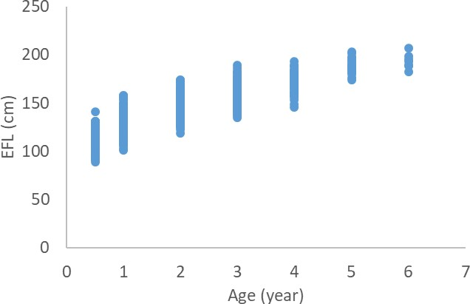

Figure 1. Assumed age-at-length growth data available from Sun *et al.* (2011) used to estimate the 2023 growth curve.

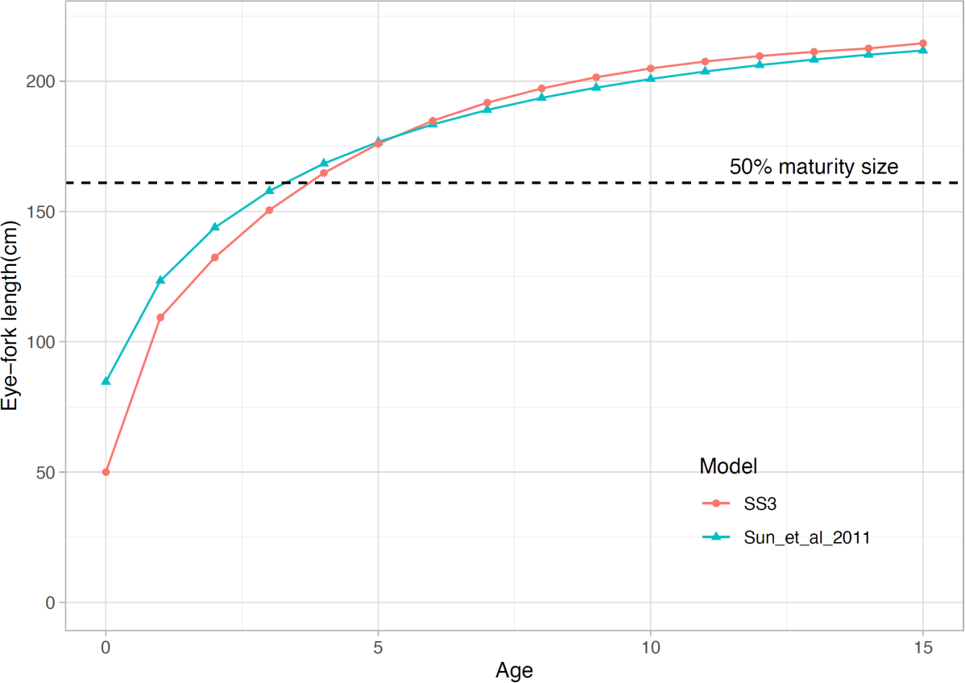

Figure 2. Output of the r4ss package age-at-length estimates (SS3, red circles) and the Sun *et al.*

(2011) growth curve (blue triangles). Figure 5 from Ijima (2021a).

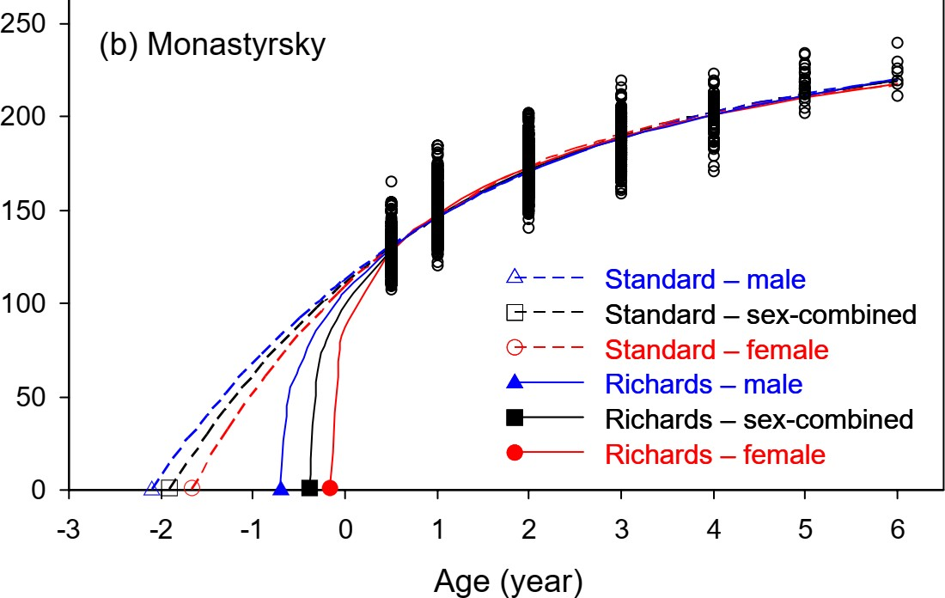

Figure 3. Estimated Von Bertalanffy (Standard) and Richards growth curves from the Sun *et al.*, 2011 growth paper used in the 2011, 2014, 2019, and 2022/2023 assessments.

Figure 4. A Comparison of the two growth curves used in the 2019 assessment and the 2022 assessment, and the best fit Richards curve from Sun *et al.* (2011).

Figure 5. Estimated growth curves from each growth model (Richards and Von Bertalanffy) for each of the three priors on maximum size-at-age.

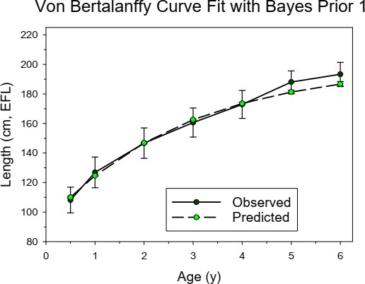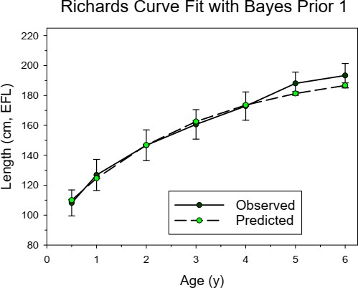

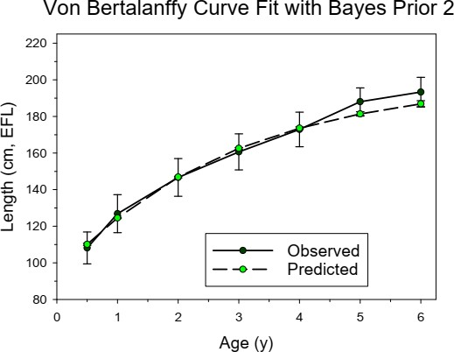 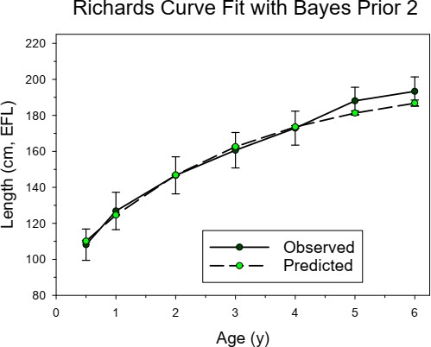

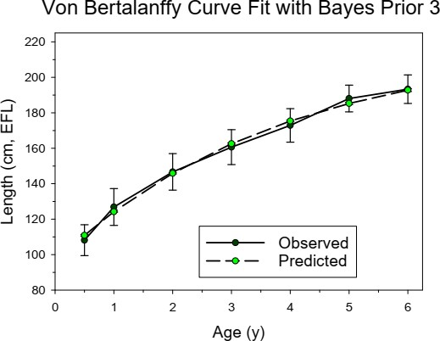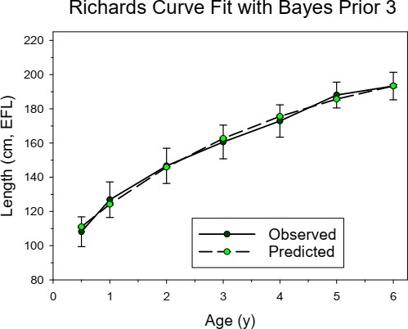

Figure 6. Comparison of the observed vs expected mean length-at-age for each of the six Bayesian growth models for ages 0.5 through 6.

Figure 7. A summary of the growth curves discussed during the development of the 2023 WCNPO MLS assessment model. Ultimately VB (Prior 3) was chosen as it reflected the best growth curve given the information available at this time.

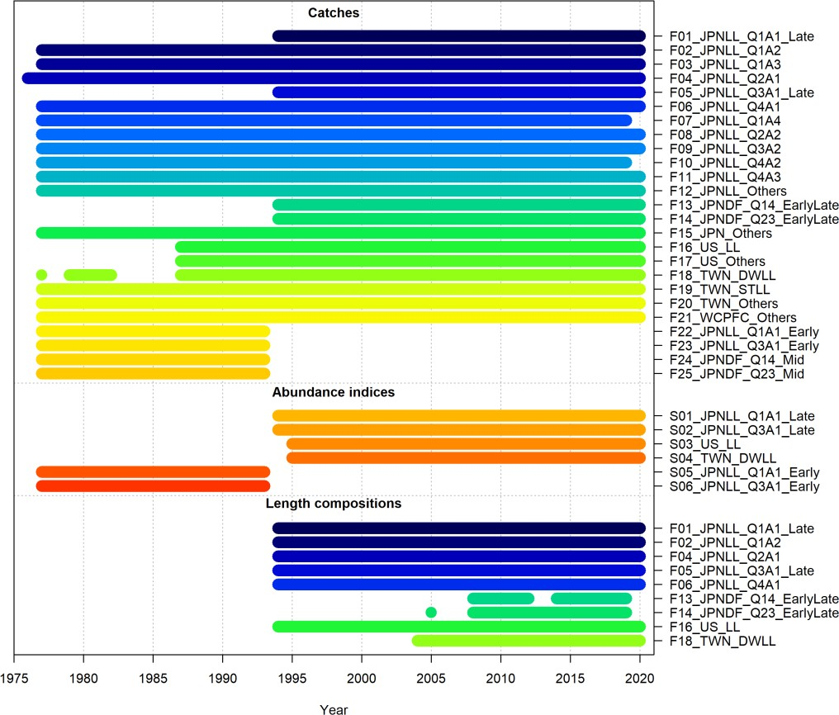

Figure 8. Available temporal coverage and sources of catch, CPUE (abundance indices), and length and size composition for the 2023 stock assessment of the Western and Central North Pacific striped marlin.

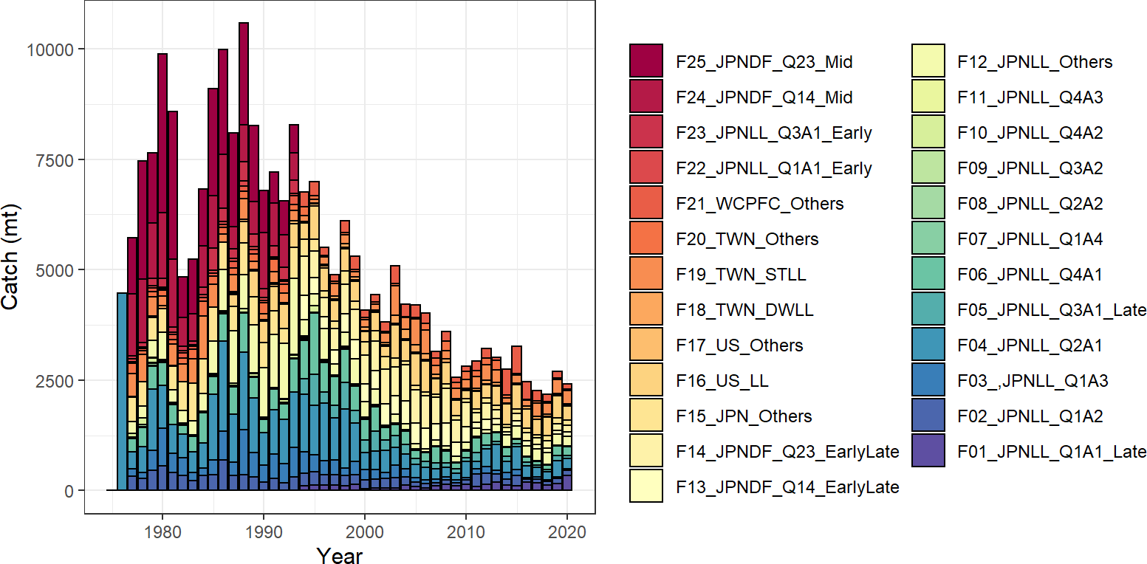

Figure 9. Total annual catch of the Western and Central North Pacific striped marlin by all fisheries harvesting the stock during 1977-2020. See Table 1 for the reference code for each fishery.

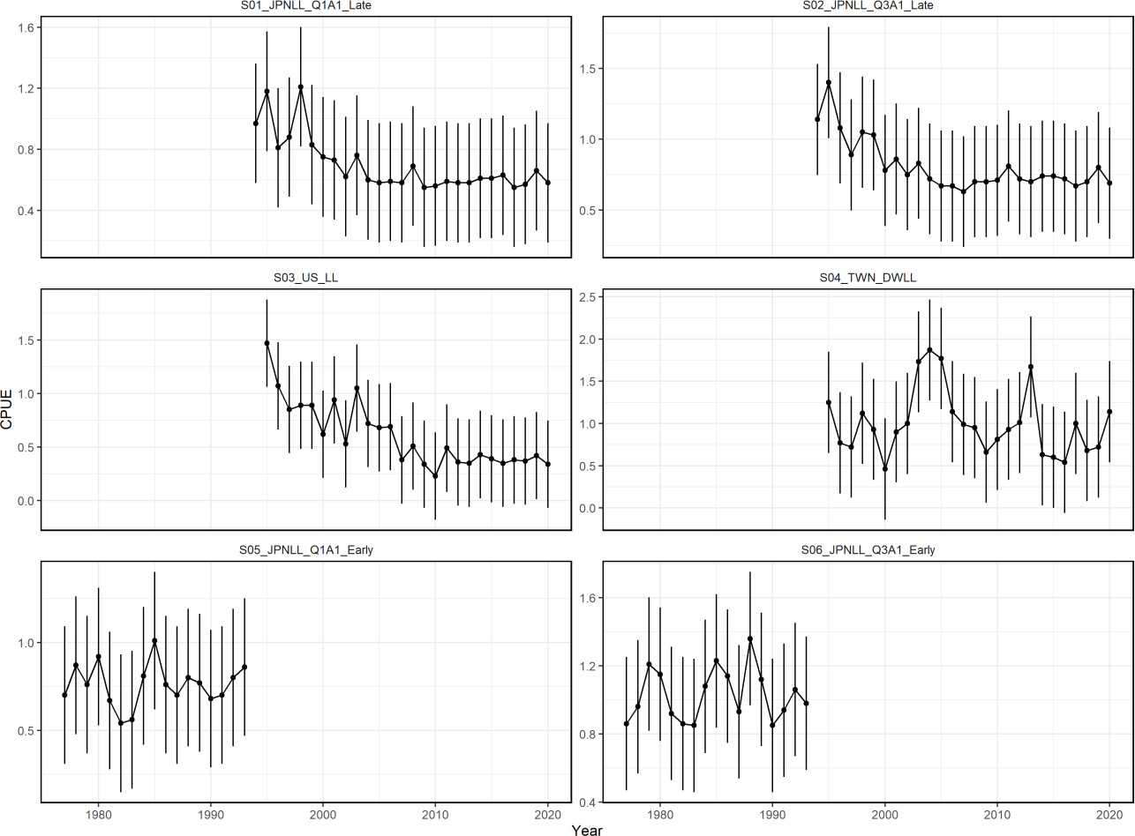

Figure 10. Time series of annual standardized indices of catch-per-unit-effort (CPUE) for the for each fleet in the base-case assessment model for the Western and Central North Pacific striped marlin as described in Table 1. Index values were rescaled by the mean of each index for comparison purposes.

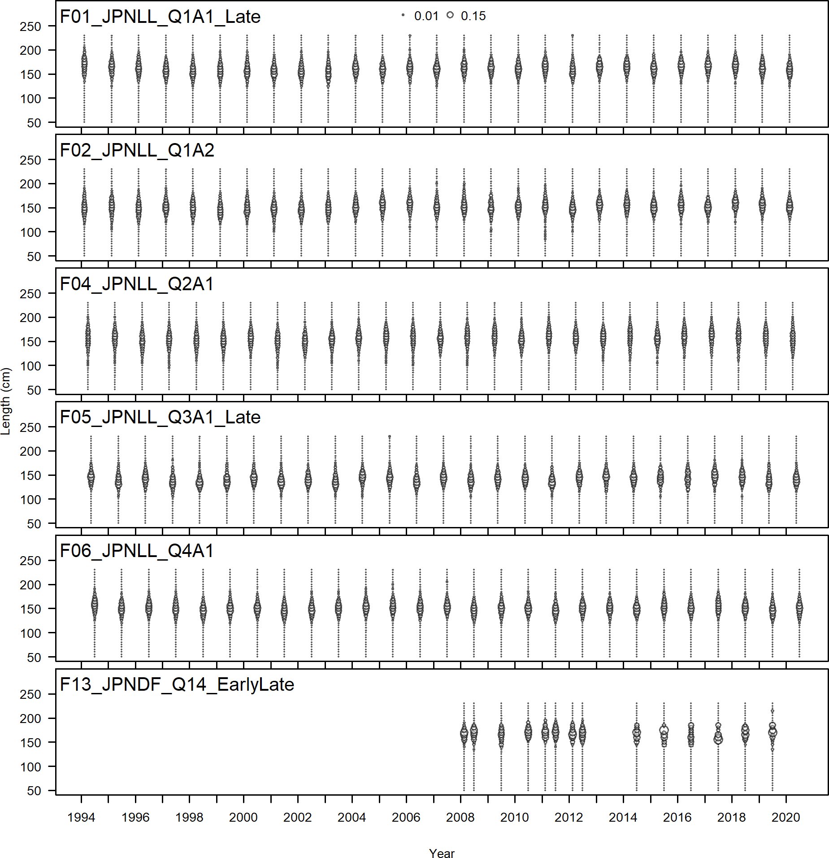

Figure 11. Quarterly length and size composition data by fishery used in the stock assessment (see Table 3). The sizes of the circles are proportional to the number of observations. All measurements were eye- fork lengths (EFL, cm).

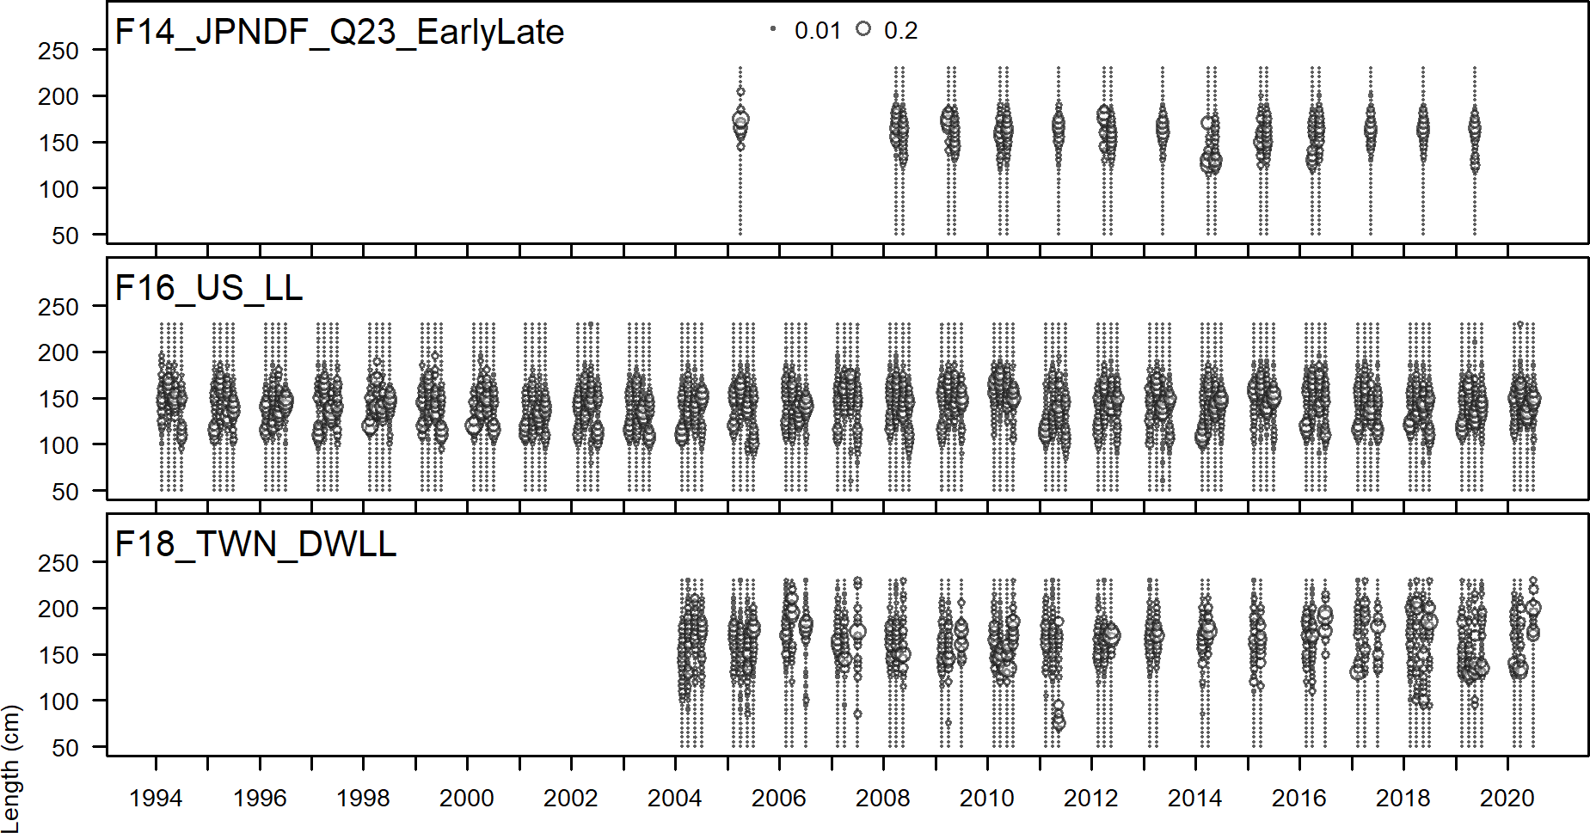

Figure 11. (Continued)

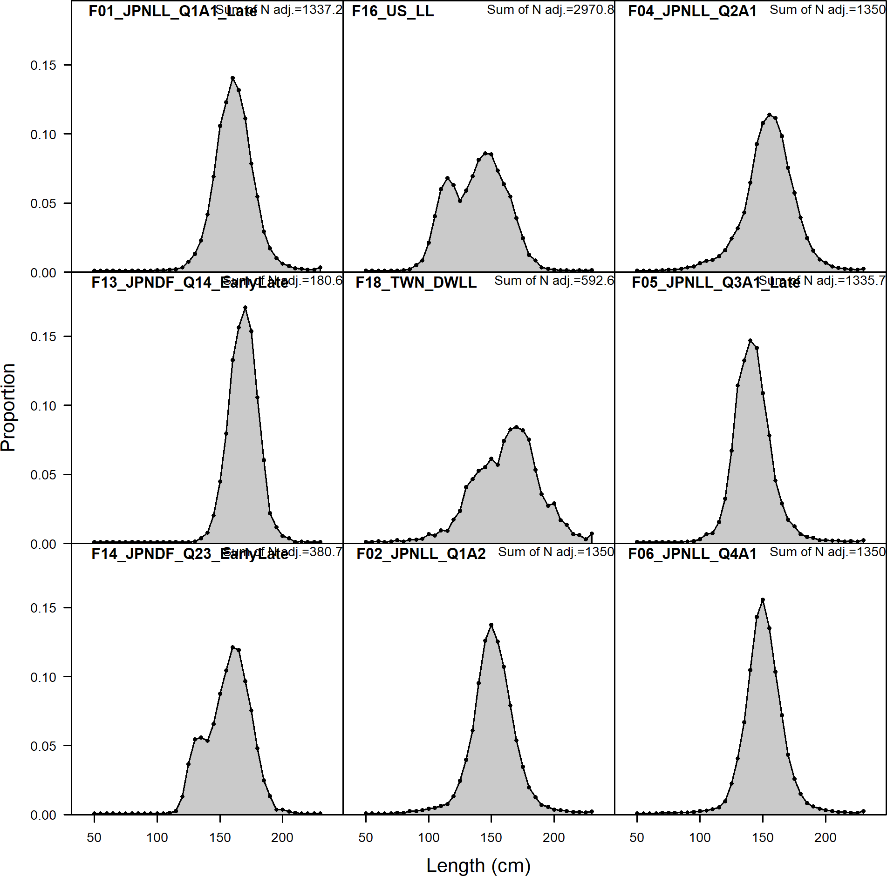

Figure 12. Aggregated length and size compositions used in the stock assessment (see Table 3 for descriptions of the composition data). All measurements were eye-fork lengths (EFL, cm).

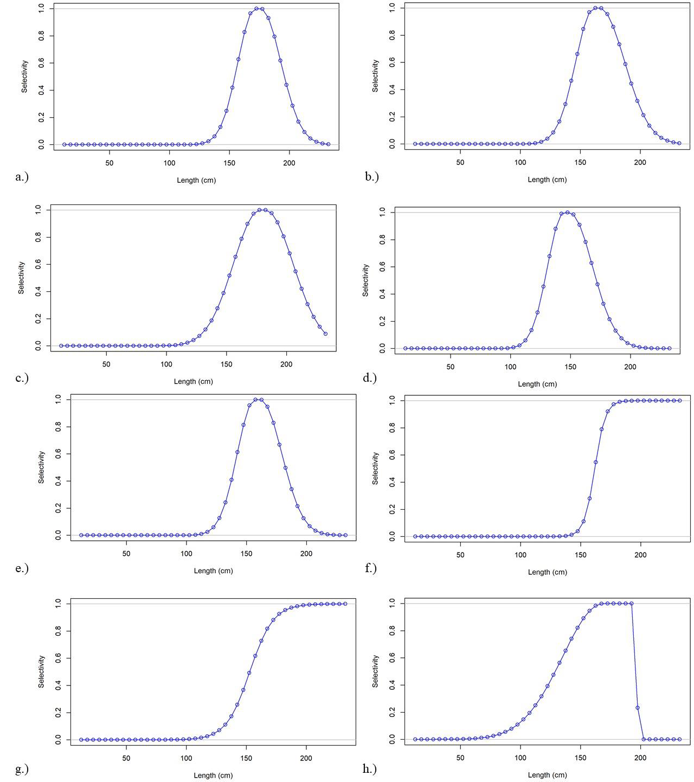

Figure 13. Final year length-based selectivity of fisheries for Western and Central North Pacific striped marlin estimated for the 2023 assessment: a.) F01_JPNLL_Q1A1_Late; b.) F02_JPNLL_Q1A2; c.) F04_JPNLL_Q2A1; d.) F05_JPNLL_Q3A1_Late; e.)

F06_JPNLL_Q4A1; f.) F13_JPNDF_Q14_EarlyLate; g.) F14_JPNDF_Q23_EarlyLate; h.) F16_US_LL; i.) F18_TWN_DWLL.

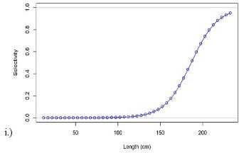

Figure 13. (Continued.)

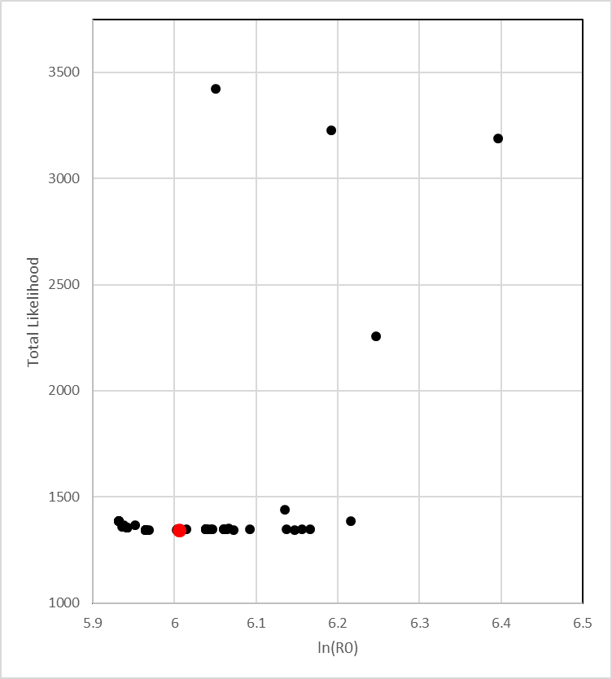

Figure 14. Results of a randomized initial parameter value diagnostic for the base case model where 100 randomized initial conditions were used with a CV of 10% assigned to each parameter. Results are shown for the base case model (MLE, solid red circle) and for the base case model with randomized initial parameter values (Jitter runs, solid black circles).

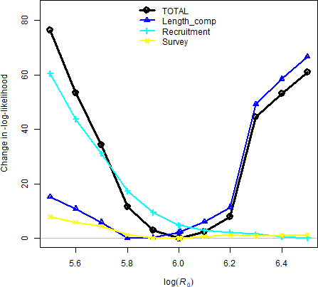

Figure 15. Profiles of the negative log-likelihoods relative to the minimum value of each component for the different likelihood components affecting the unfished recruitment parameter R0 in log-scale (i.e., the x-axis is log(R0)) ranging from 5.5 to 6.5 for the base case model, where recruitment represents the likelihood component based on the deviations from the stock- recruitment curve and length data represents the joint likelihood component for combined fleets based on the fish length composition data.

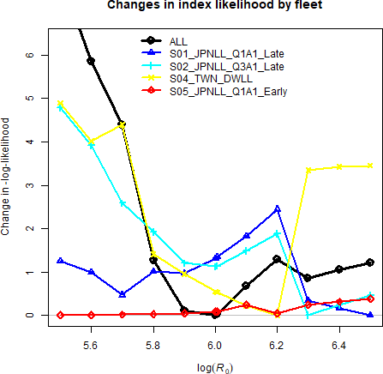

Figure 16. Profiles of the relative negative log-likelihoods by fleet-specific index likelihood components for the virgin recruitment in log-scale (log(R0)) ranged from 5.5 to 6.5 of the base case scenario. See Table 1 for descriptions of the index data. S3 and S6 were not included in the total likelihood.

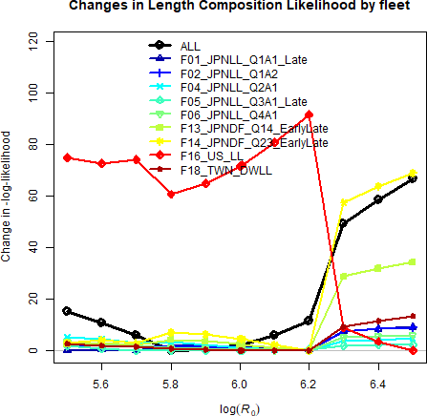

Figure 17. Profiles of the relative negative log-likelihoods by fleet-specific length composition likelihood components for the virgin recruitment in log-scale (log(R0)) ranged from 5.5 to 6.5 of the base case scenario. See Table 3 for descriptions of the length composition data.

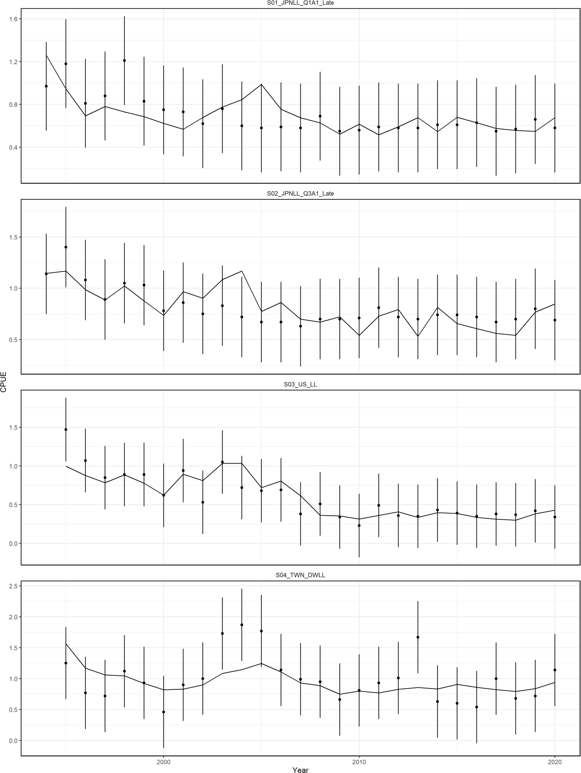

Figure 18. Model fits to the standardized catch-per-unit-effort (CPUE) data sets from different fisheries for the base case scenario. The line is the model predicted value and the points are observed (data) values. The vertical lines represent the estimated confidence intervals (± 1.96 standard deviations) around the CPUE values. S2, S3, and S4 were not included in the total likelihood.

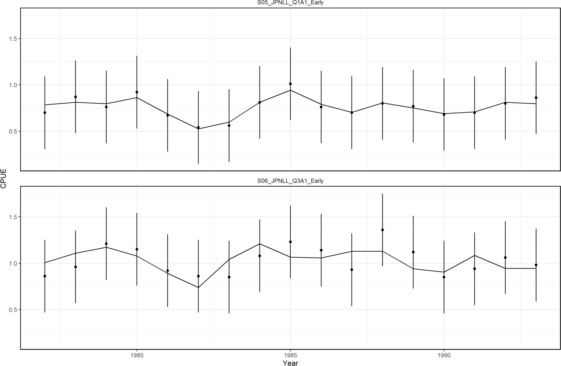

Figure 18. Continued

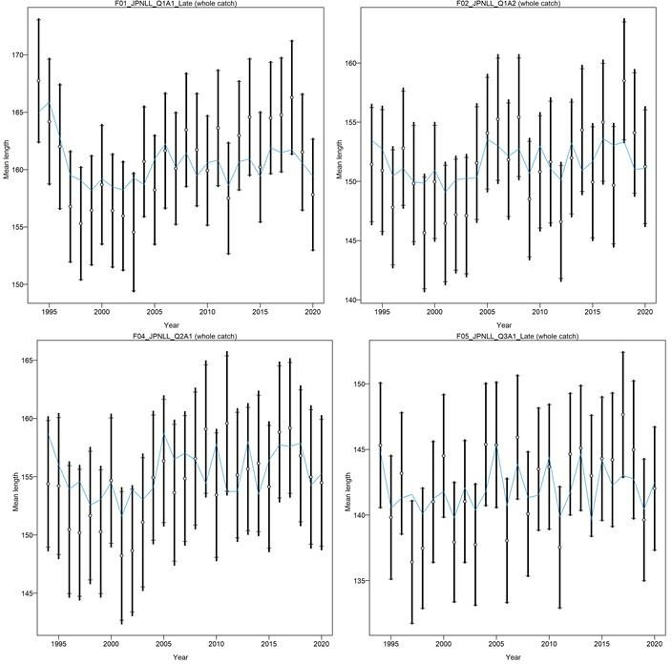

Figure 19. Model fit (lines) to mean length of the composition data (points, showing the observed mean age and 95% credible limits around mean age (vertical lines)). See Table 3 for descriptions of the data. All measurements were eye-fork lengths (EFL, cm).

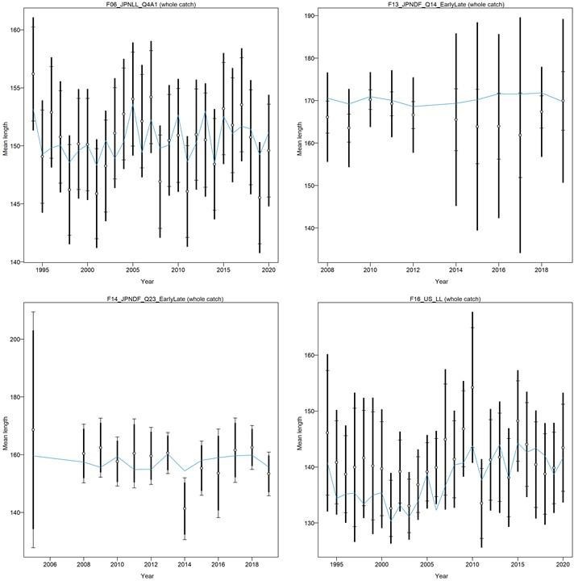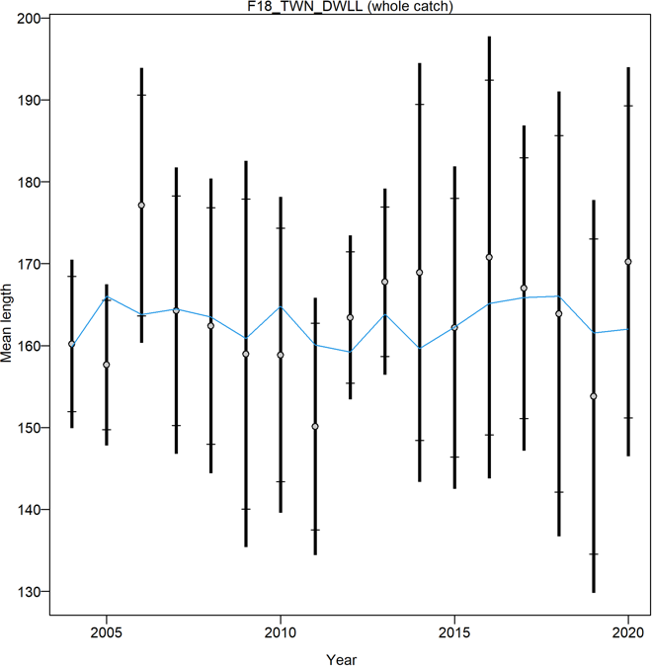

Figure 19. Continued.

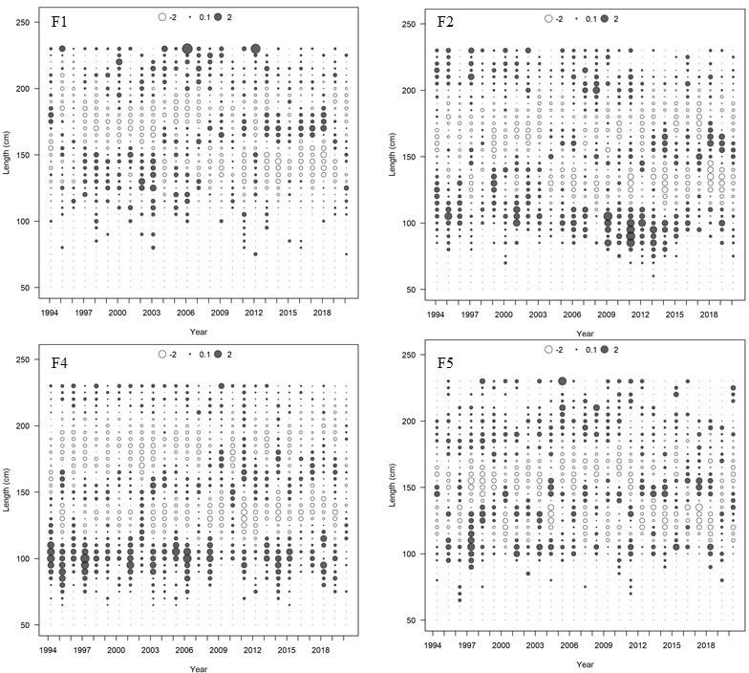

Figure 20. Pearson residual plots of model fits to the various length-composition data for the Western and Central North Pacific striped marlin fisheries used in the assessment model.

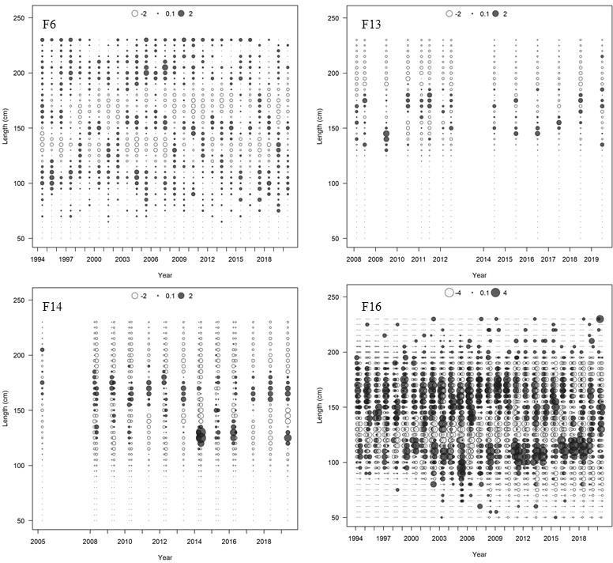

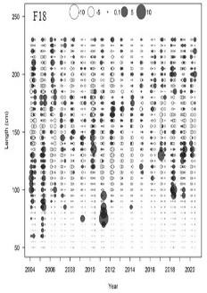

Figure 20. Continued

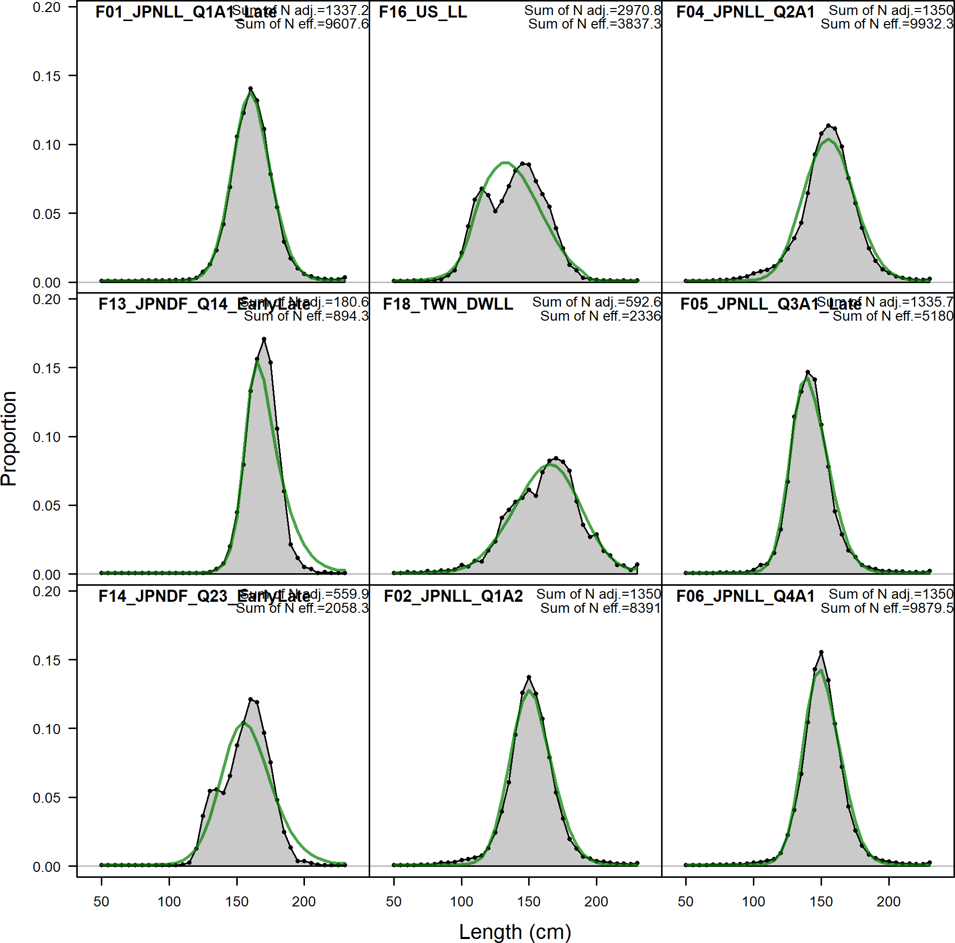

Figure 21. Comparison of observed (gray shaded area and blue dots) and model predicted (blue solid line) length compositions for fisheries used in the stock assessment for the Western and Central North Pacific striped marlin. Observed (black circles) and predicted (green line) length compositions. All measurements were eye-to-fork lengths (EFL, cm).

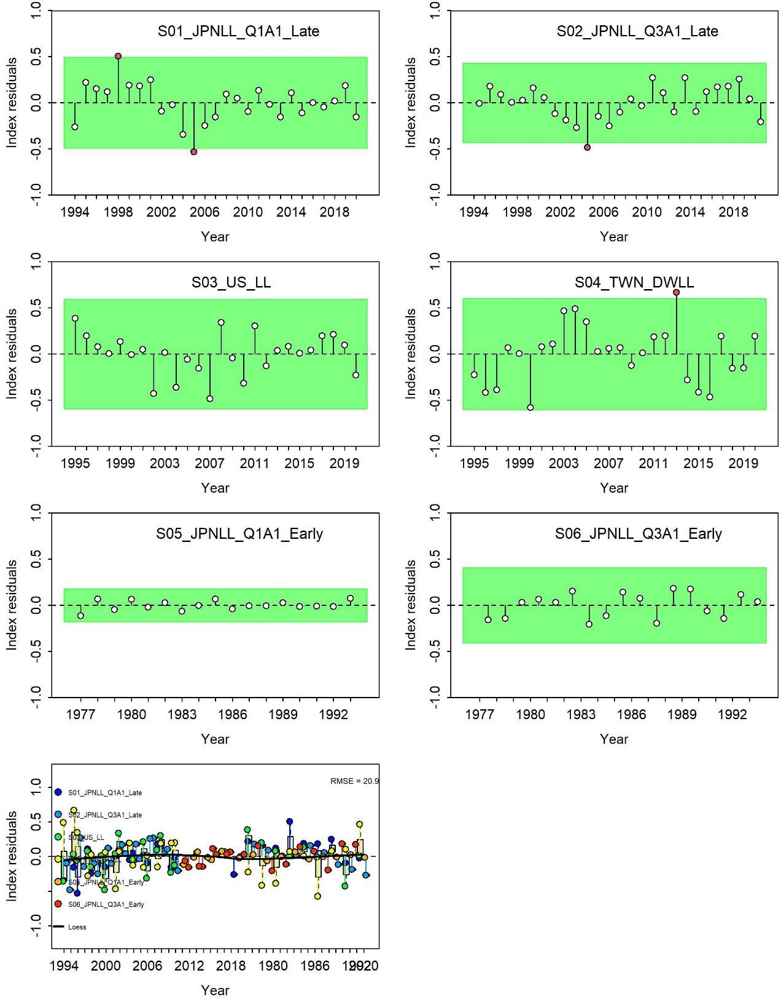

Figure 22. Runs test results for the CPUE fits. Green shading indicates no evidence (p≥0.05) and red shading indicates evidence (p<0.05) to reject the hypothesis of a randomly distributed time- series of residuals. The red/green shaded areas span three residual standard deviations to either side from zero, the red points outside of the shading violate the “three-sigma limits” for that series. Note that S3 and S6 were not included in the assessment likelihood.

## FINAL

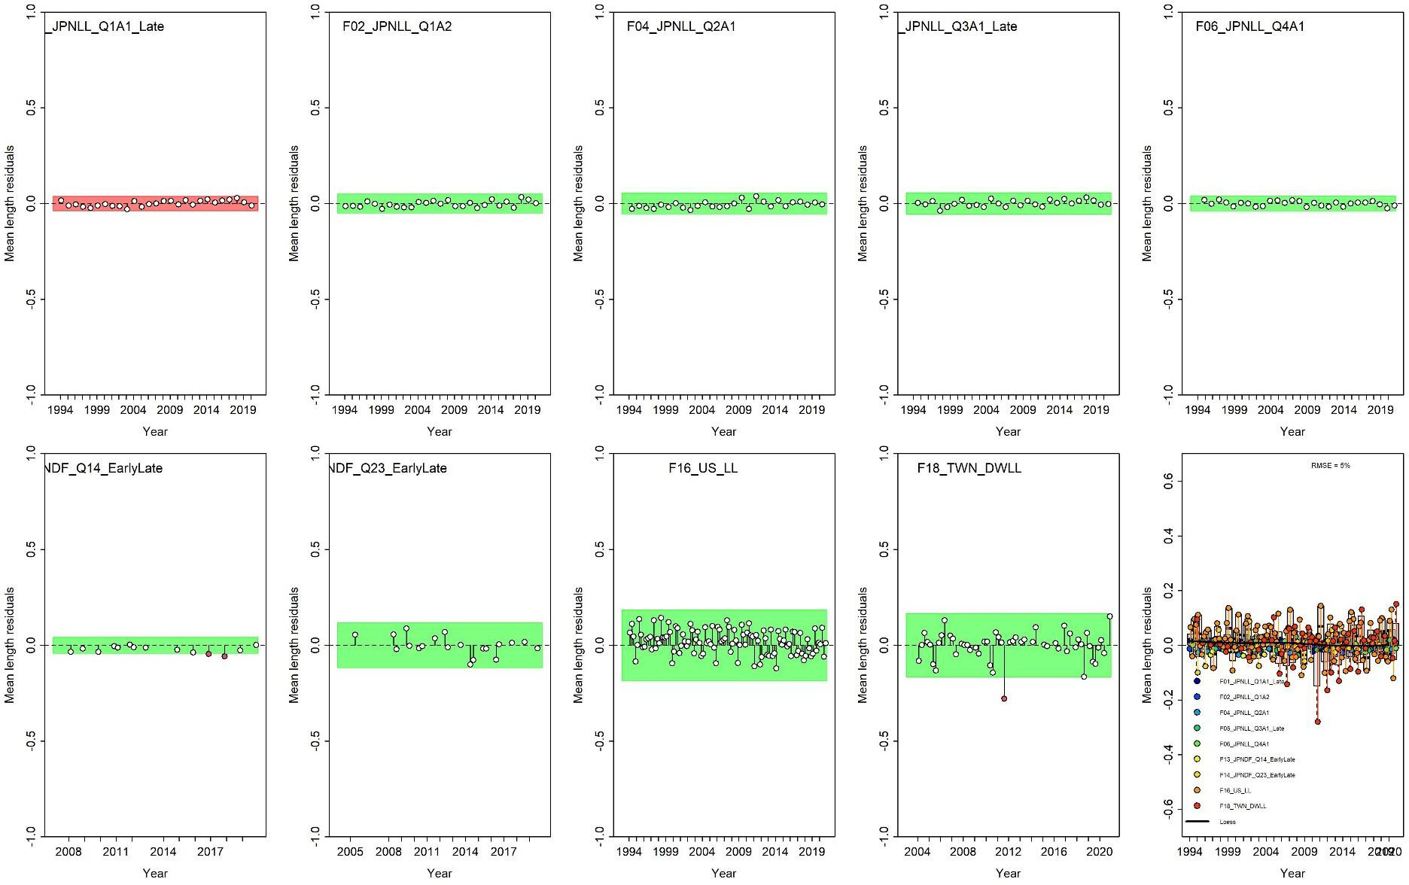

Figure 23. Runs test results for the mean lengths of size composition data. Green shading indicates no evidence (p≥0.05) and red shading indicates evidence (p<0.05) to reject the hypothesis of a randomly distributed time-series of residuals. The red/green shaded areas span three residual standard deviations to either side from zero, the red points outside of the shading violate the “three-sigma limits” for that series.

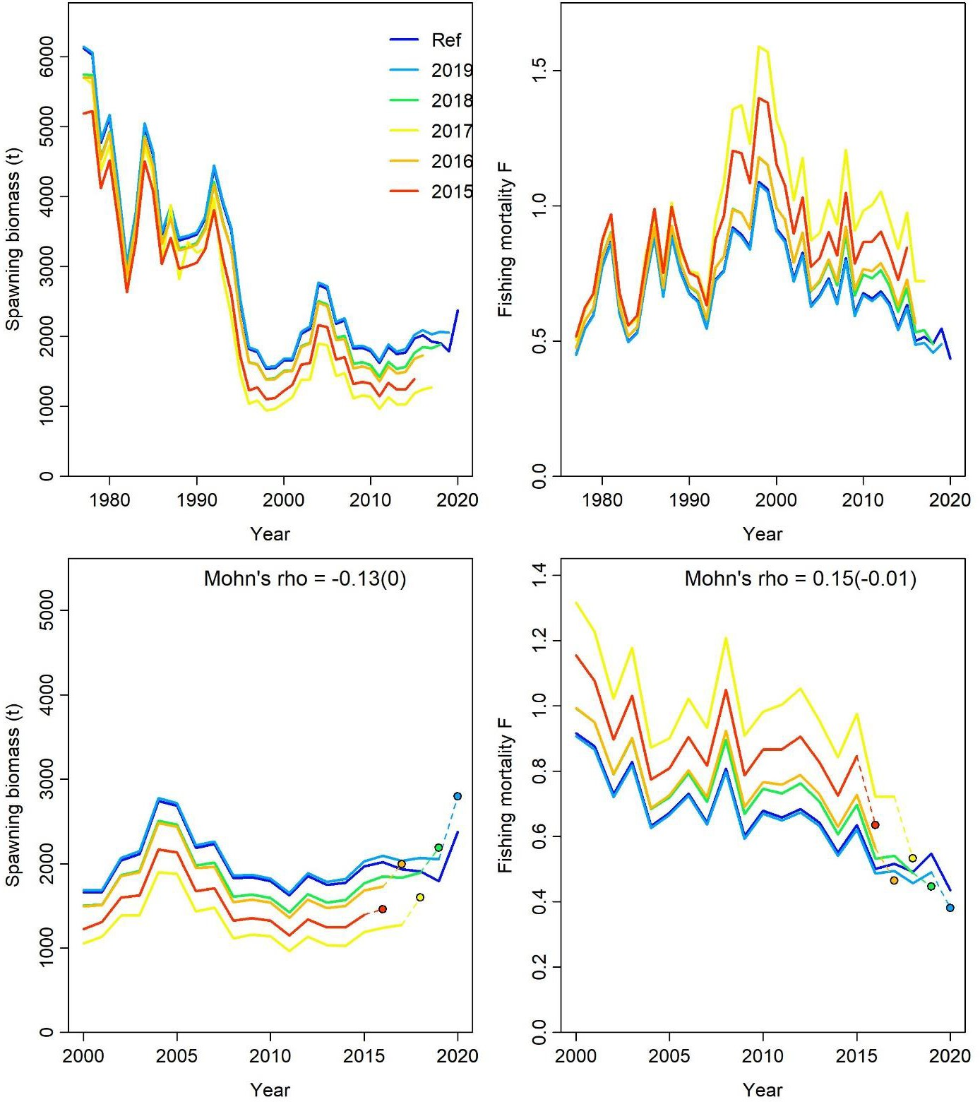

Figure 24. Retrospective analysis of spawning biomass (left) and fishing mortality (right) for the whole time series (top) and the last 20 years (bottom) consisting of 5 reruns of the base case model each fitted with one more year of data removed from the base case model (blue line, 1977- 2020).

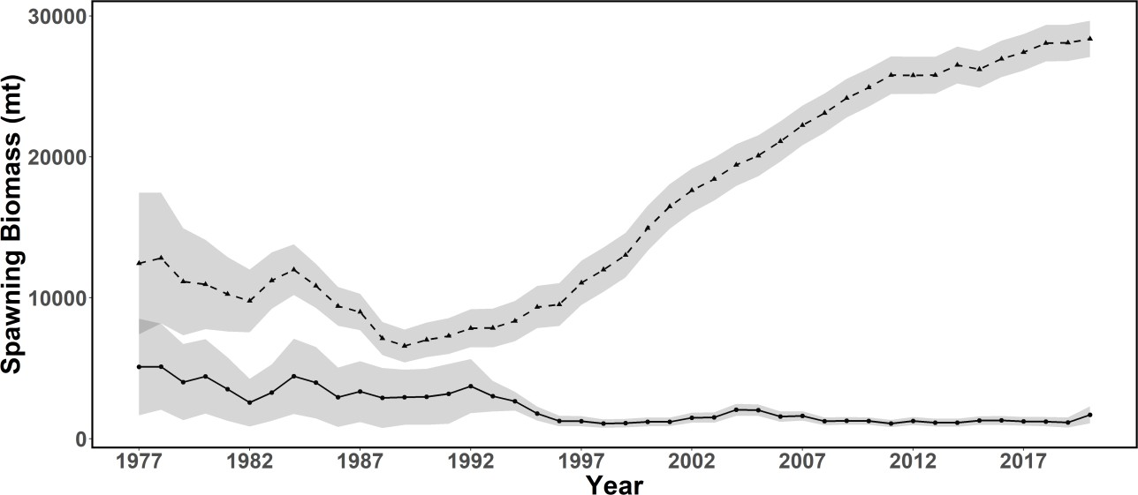

Figure 25. Age structured production model (ASPM) diagnostic for Stock Synthesis base case model. Spawning stock biomass estimates from the base-case model (circles, solid line; grey shading indicates 95% confidence interval) and ASPM model diagnostic (triangles, dashed line).

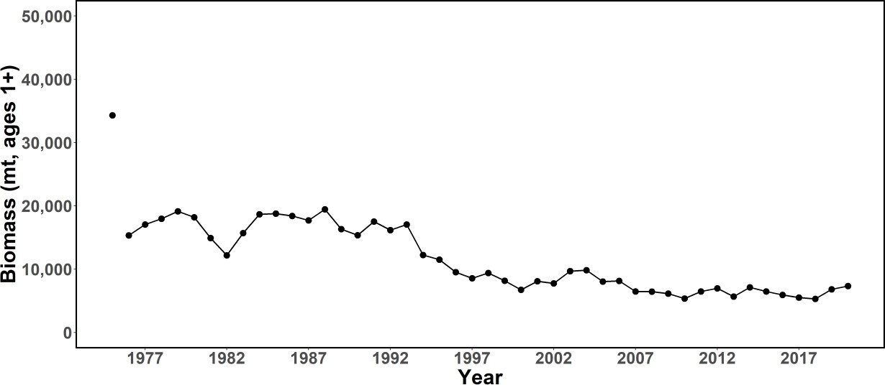

Figure 26. Time series of total biomass (age 1 and older, metric ton) for the Western and Central North Pacific striped marlin estimated in the base-case model. The first year indicates virgin biomass levels.

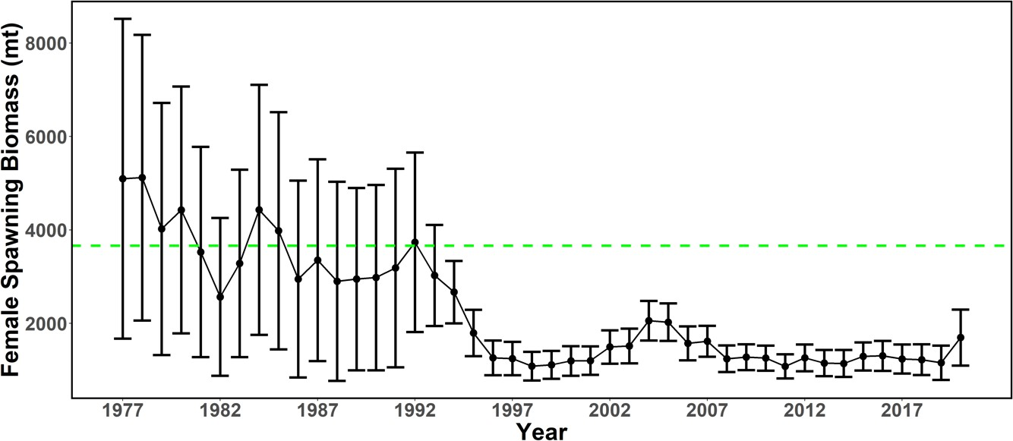

Figure 27. Time series of spawning biomass (metric ton) for the Western and Central North Pacific striped marlin estimated in the base-case model. The solid line with circles represents the maximum likelihood estimates and the error bars represent the uncertainty of the estimates (95% confidence intervals). The dashed horizontal line shows the spawning biomass to produce 20% SSBF=0 reference point.

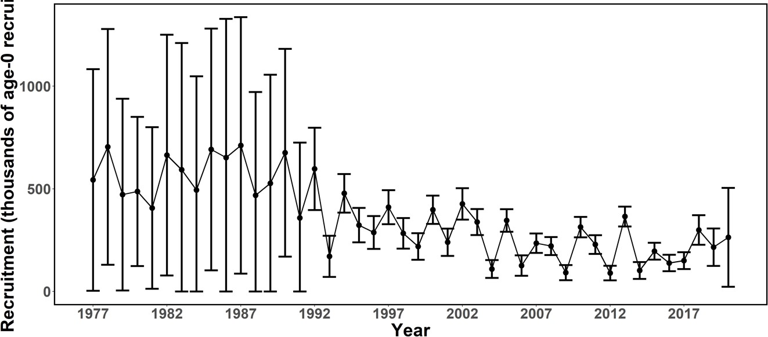

Figure 28. Time series of recruitment (thousands of age-0 fish) for Western and Central North Pacific striped marlin estimated in the base-case model. The solid line with circles represents the maximum likelihood estimates and the error bars represent the uncertainty of the estimates (95% confidence intervals).

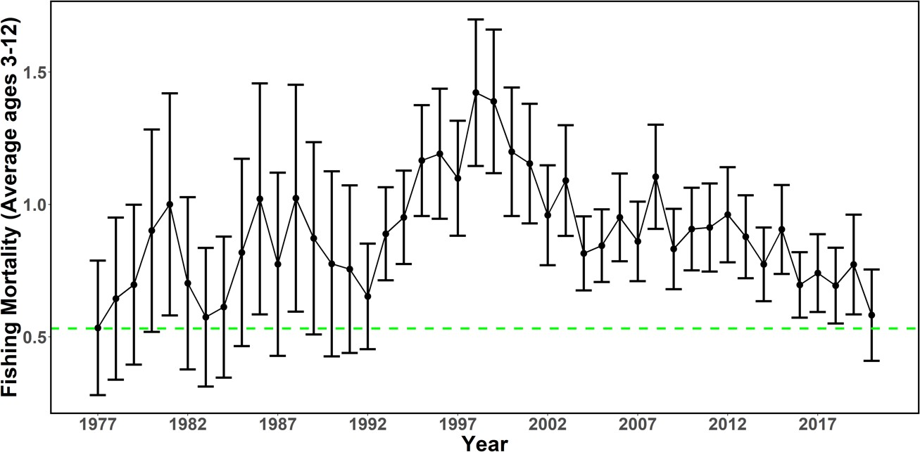

Figure 29. Time series of instantaneous fishing mortality (average for age 3-12) for the Western and Central North Pacific striped marlin estimated in the base-case model. The solid line with circles represents the maximum likelihood estimates and the error bars represent the uncertainty of the estimates (95% confidence interval). The dashed horizontal line shows the fishing mortality to produce 20%SSBF=0 (btgt) reference point.

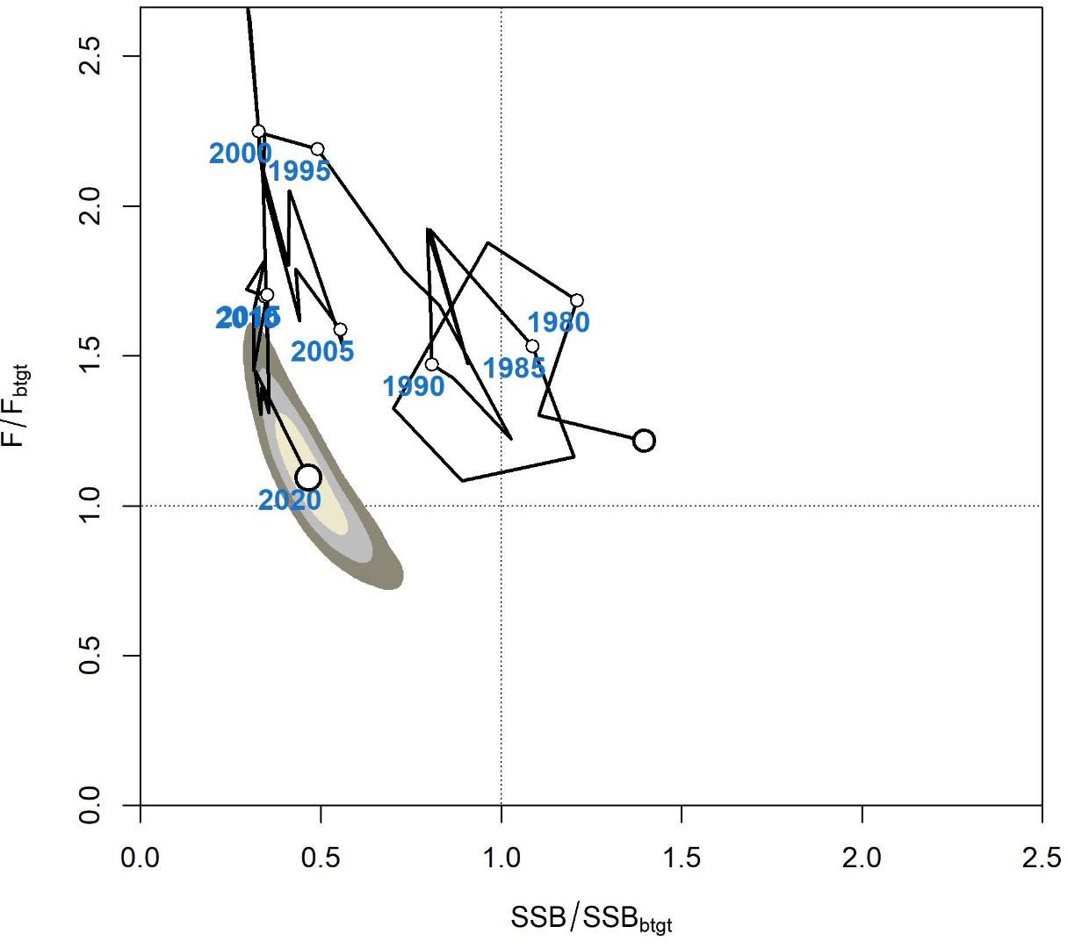

Figure 30. Majuro plot of the trends in estimates of relative fishing mortality (average of age 3- 12) and spawning stock biomass based upon 20%SSBF=0 reference points (btgt) of Western and Central North Pacific striped marlin (*Kajikia audax)* during 1977-2020. Shaded areas indicate 50%, 80% and 95% percent confidence intervals, respectively.

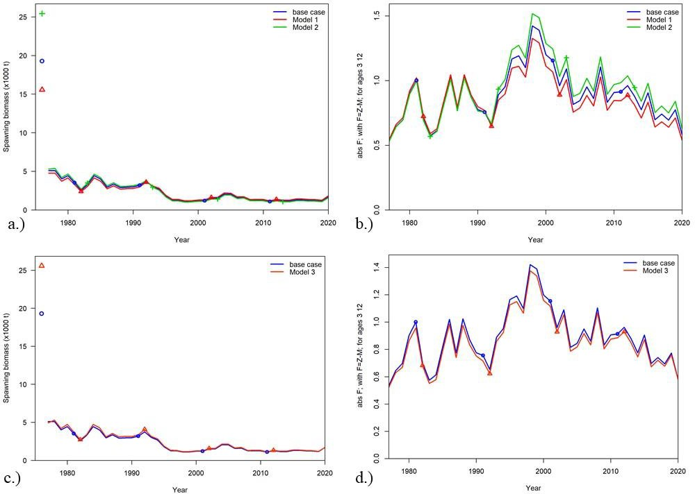

Figure 31. Trajectories of spawning stock biomass and fishing mortality from 14 sensitivity analyses listed in Table 12, compared to the base case model: (a-b) Runs 1 and 2 use alternative natural mortality parameters; (c-d) Run 3 uses alternative recruitment variability; (e-f) Runs 4, 5, and 6 use alternative steepness parameters; (g-h) Runs 7 and 8 use alternative maturity ogives; (i- j) Runs 9 and 10 use alternative model start years; (k-l) Runs 11, 13, and 14 use alternative model configurations and (m-n) Run 12 uses SWPO growth parameters.

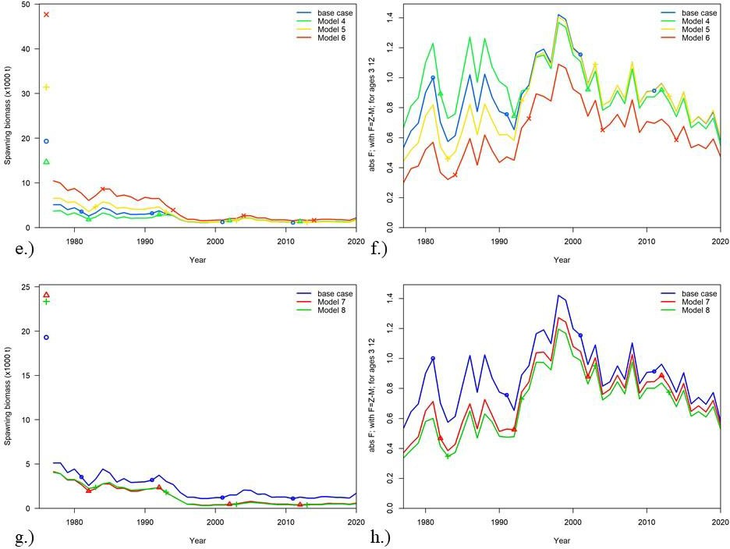

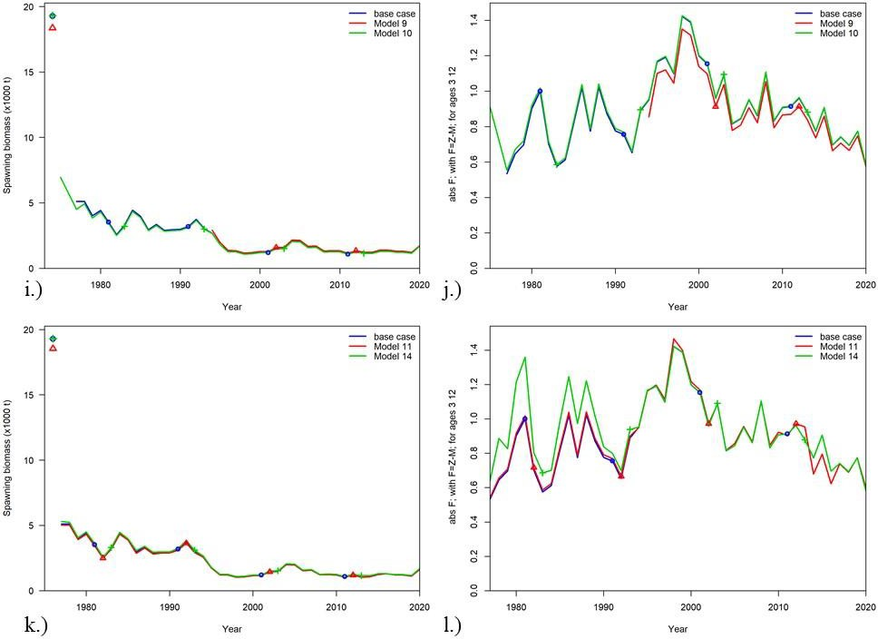

Figure 31. Continued

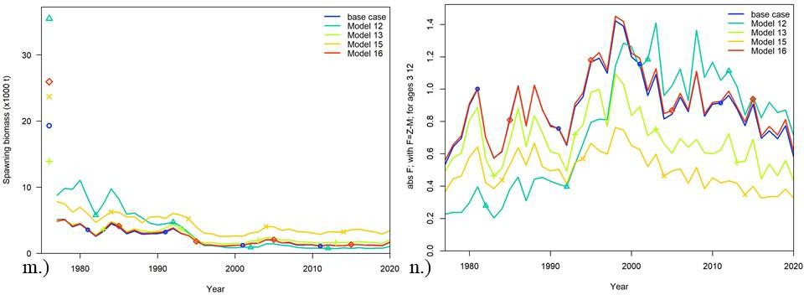c

Figure 31. Continued



Figure 32. Majuro plot showing the terminal-year stock status for the base case model (grey B) and the sensitivity analyses as indicated by the run numbers. For the list of sensitivity runs, please see Table 12. Reference points are in terms of Btgt which represents 20%SSBF=0.

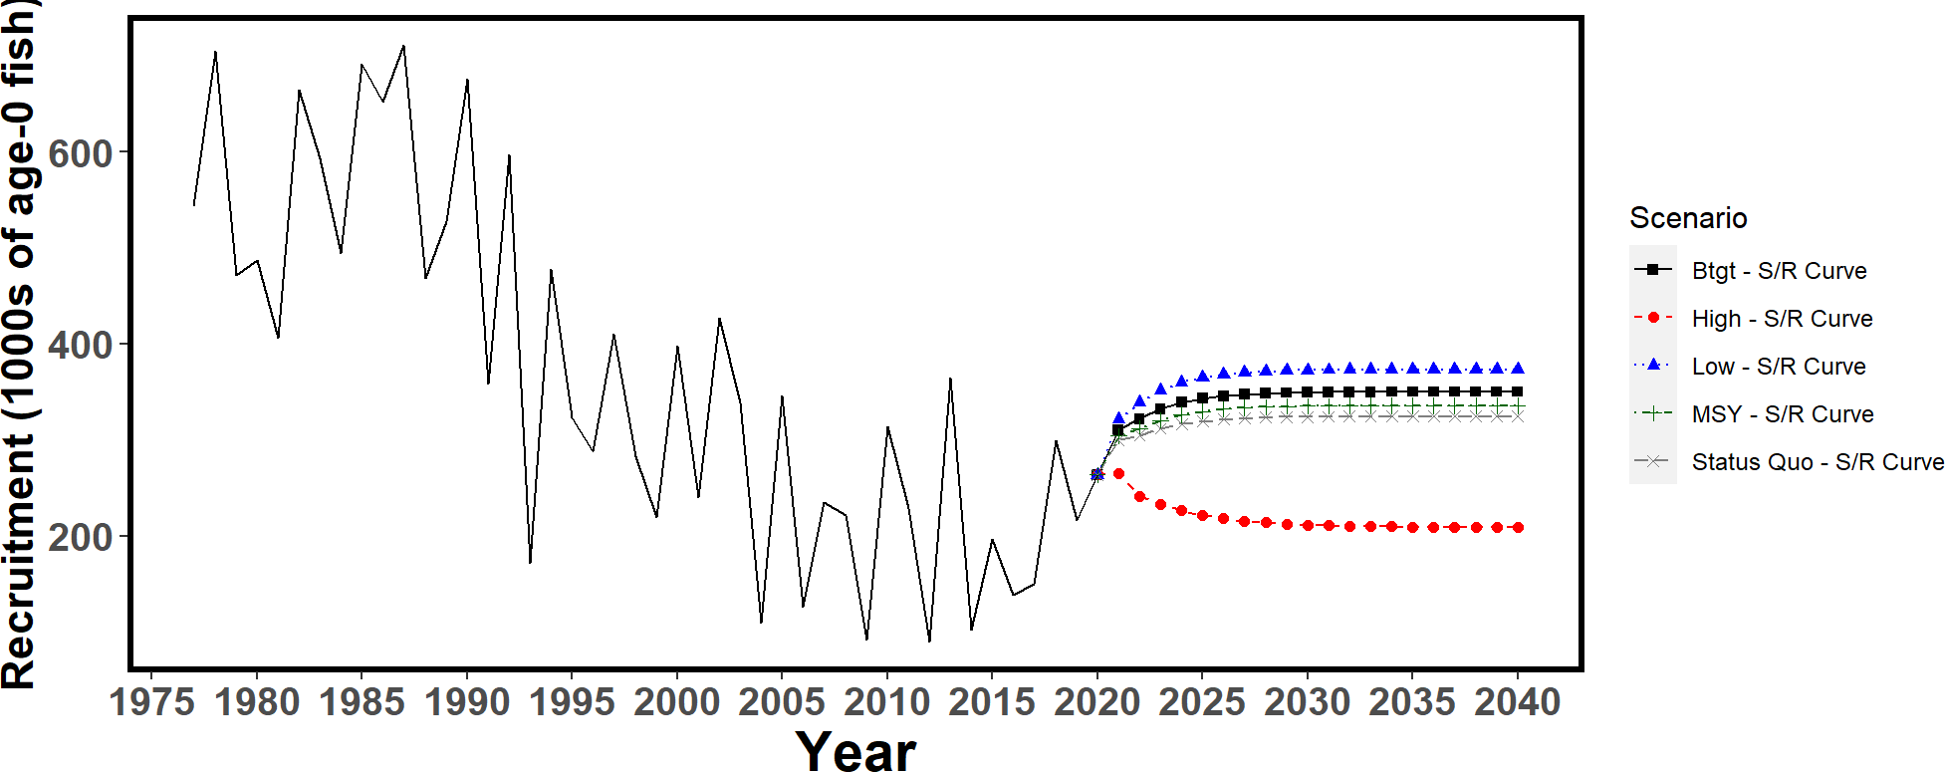

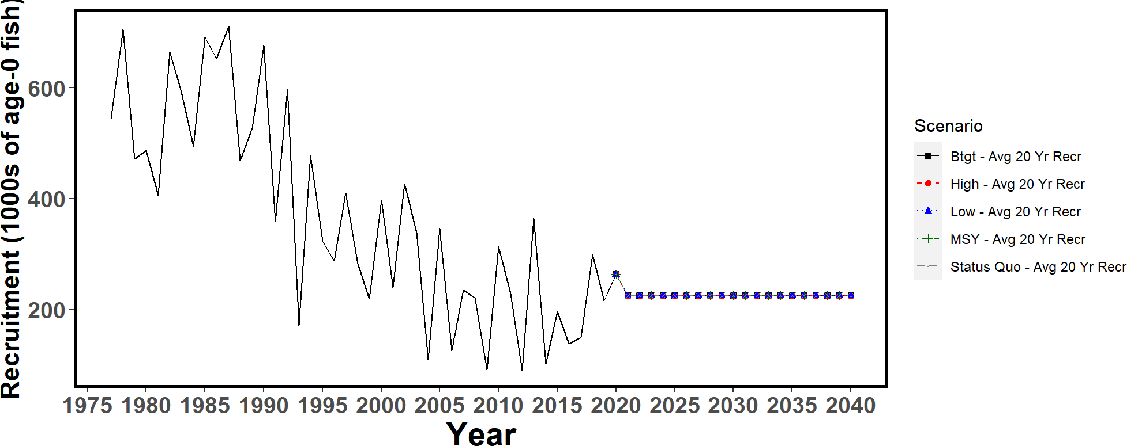

Figure 33. Recruitment trajectories used in the projections: estimated recruitment from the stock recruitment curve (top); estimated recruitment for the 20 year average recruitment runs (black); and base-case model estimated recruitment (black solid line)

a.)

b.)



c.)

Figure 34. Historical and projected trajectories of spawning biomass from the Western and Central North Pacific striped marlin base case model based upon F scenarios: (a) F scenarios projected spawning biomass using recruitment estimated from the stock-recruitment curve; (b) F scenarios projected spawning biomass using average recruitment from 2001-2020. (c) Catch scenarios projected spawning biomass using average recruitment from 2001-2020. Dashed line indicates the spawning stock biomass at the dynamic 20%SSBF=0 reference point. Solid line indicates the spawning stock biomass at SSBMSY. The list of projection scenarios can be found in Table 13 and 14.

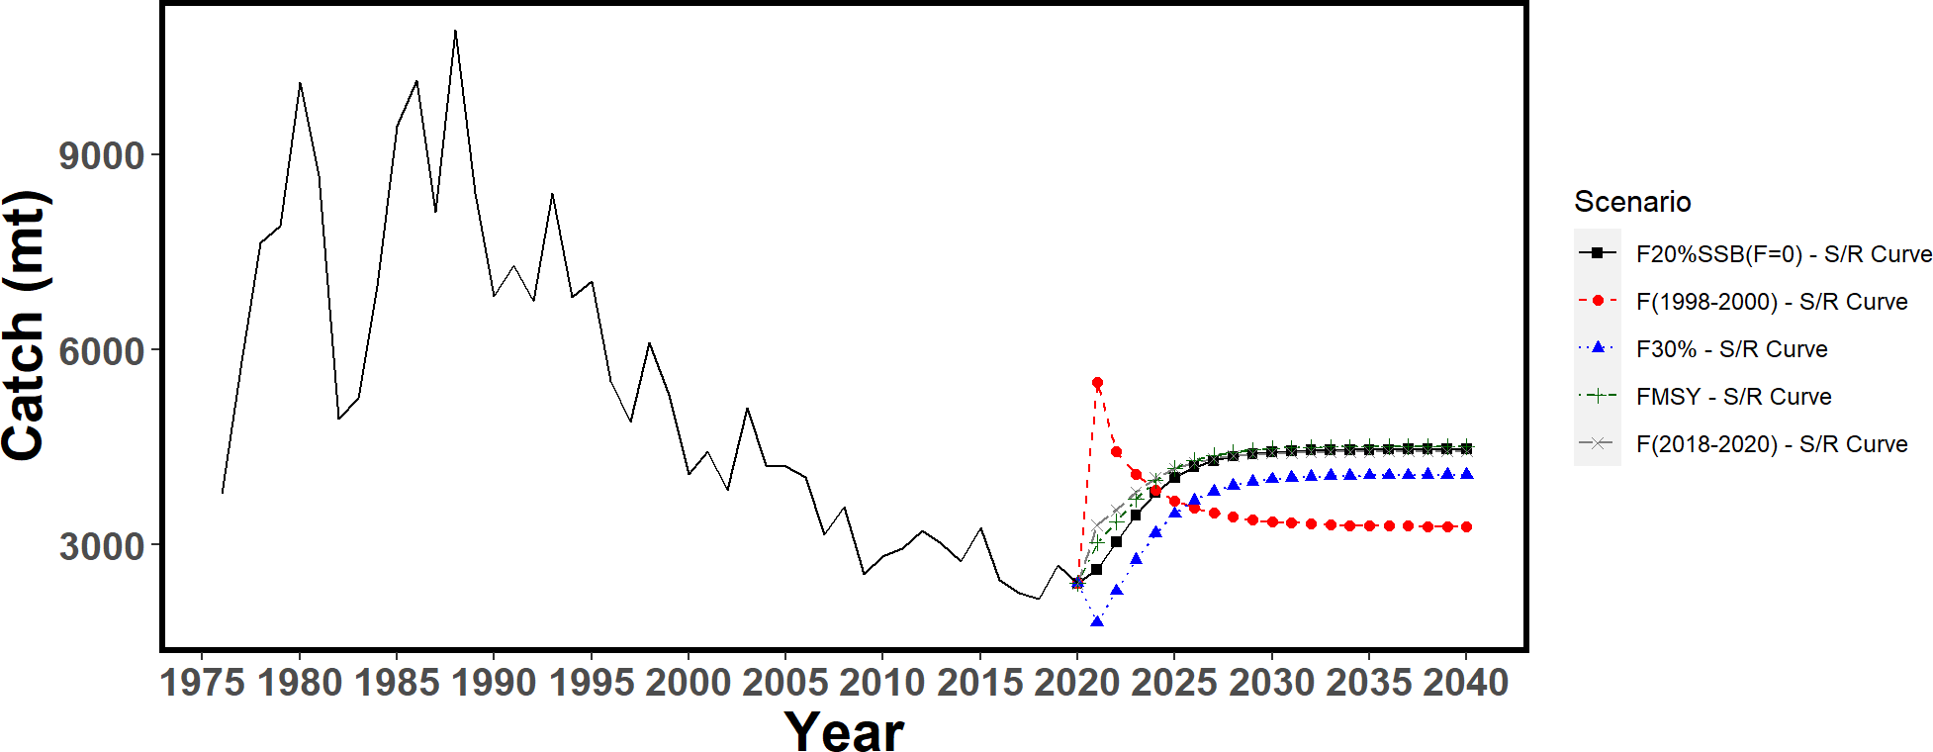

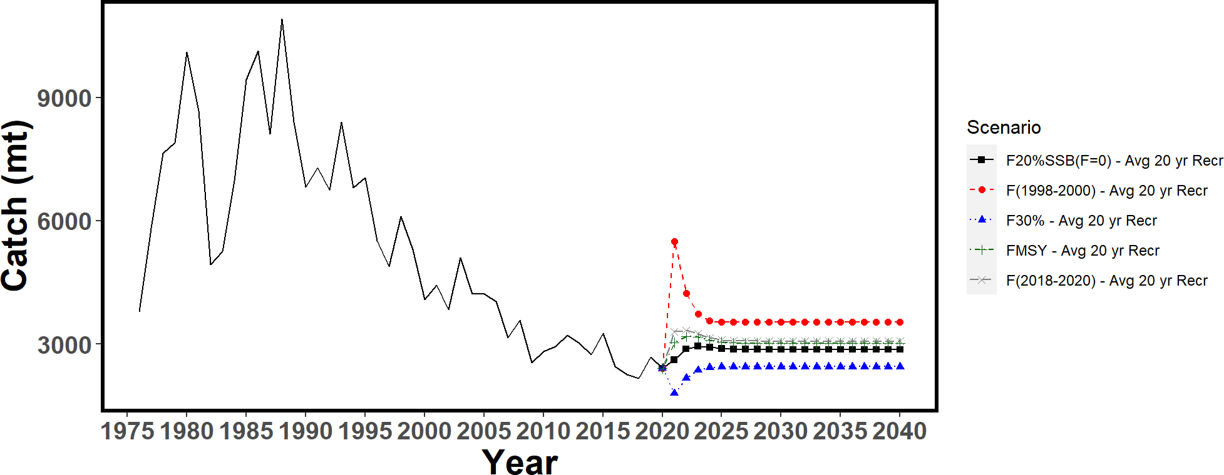

Figure 35. Historical and projected trajectories of catch from the Western and Central North Pacific striped marlin base case model based upon F scenarios using the stock recruitment curve scenarios (top) and the 20-year average recruitment scenarios (bottom). Dashed line indicates the spawning stock biomass at 20%SSBF=0. Solid line indicates the spawning stock biomass at MSY. The list of projection scenarios can be found in Table 13.

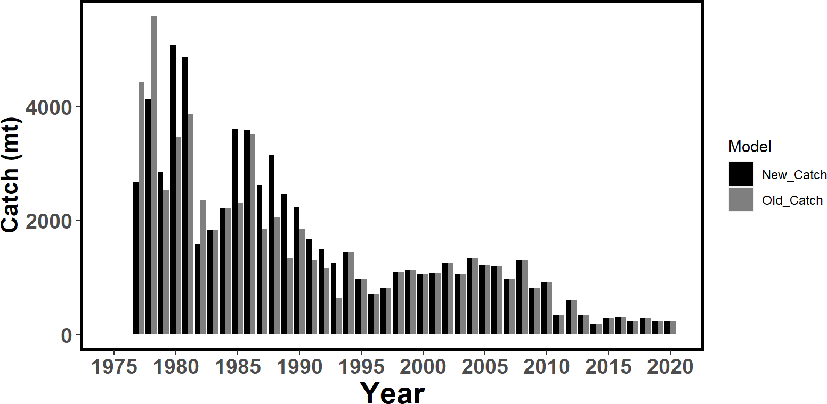

Figure 36. Comparison of Japanese driftnet catch in the 2019 (old) base-case model and the 2023 (new) base-case model. Catch was revised from 1977-1993 and input as numbers of fish for the 2023 model, therefore catch is estimated for this fleet internally in the model.

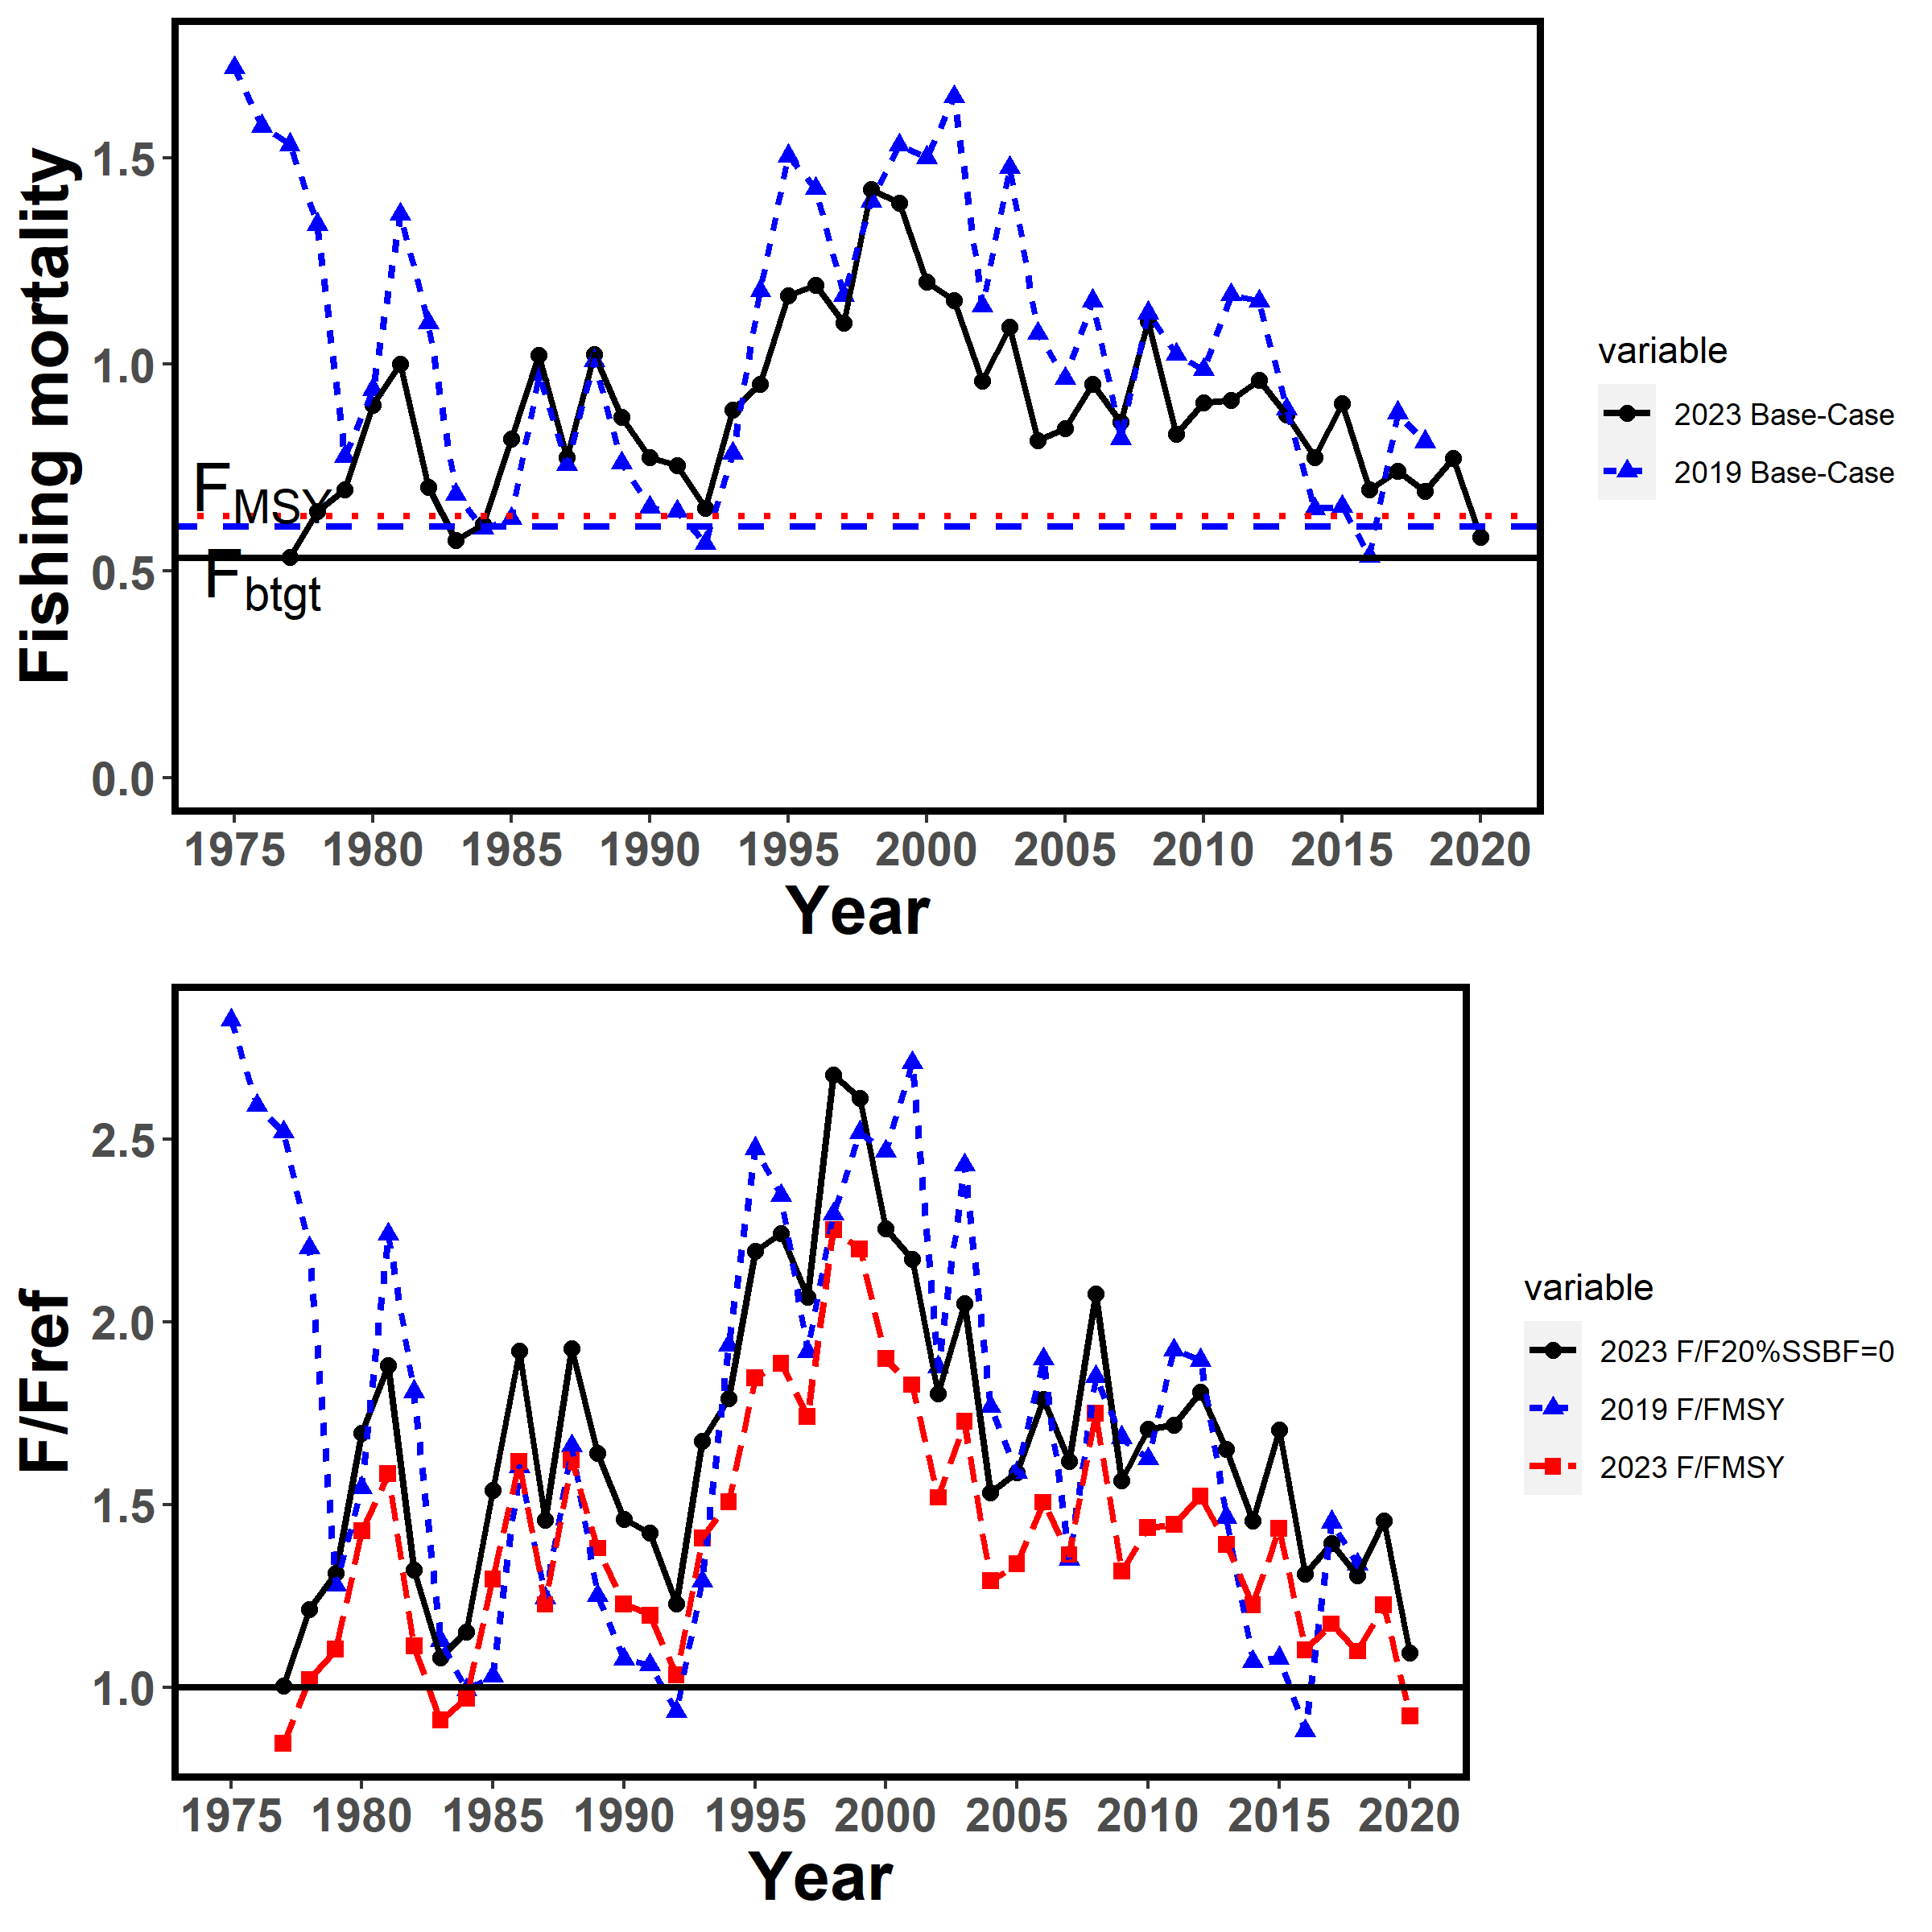

Figure 37. Comparison of the annual fishing mortality (top) and relative fishing mortality (bottom) for the 2019 and 2023 WCNPO striped marlin base-case models. Black solid is the 2023 base-case F20%SSB(F=0) values, blue short-dashed is the 2019 base-case FMSY values, and red long-dashed is the 2023 base-case FMSY values.

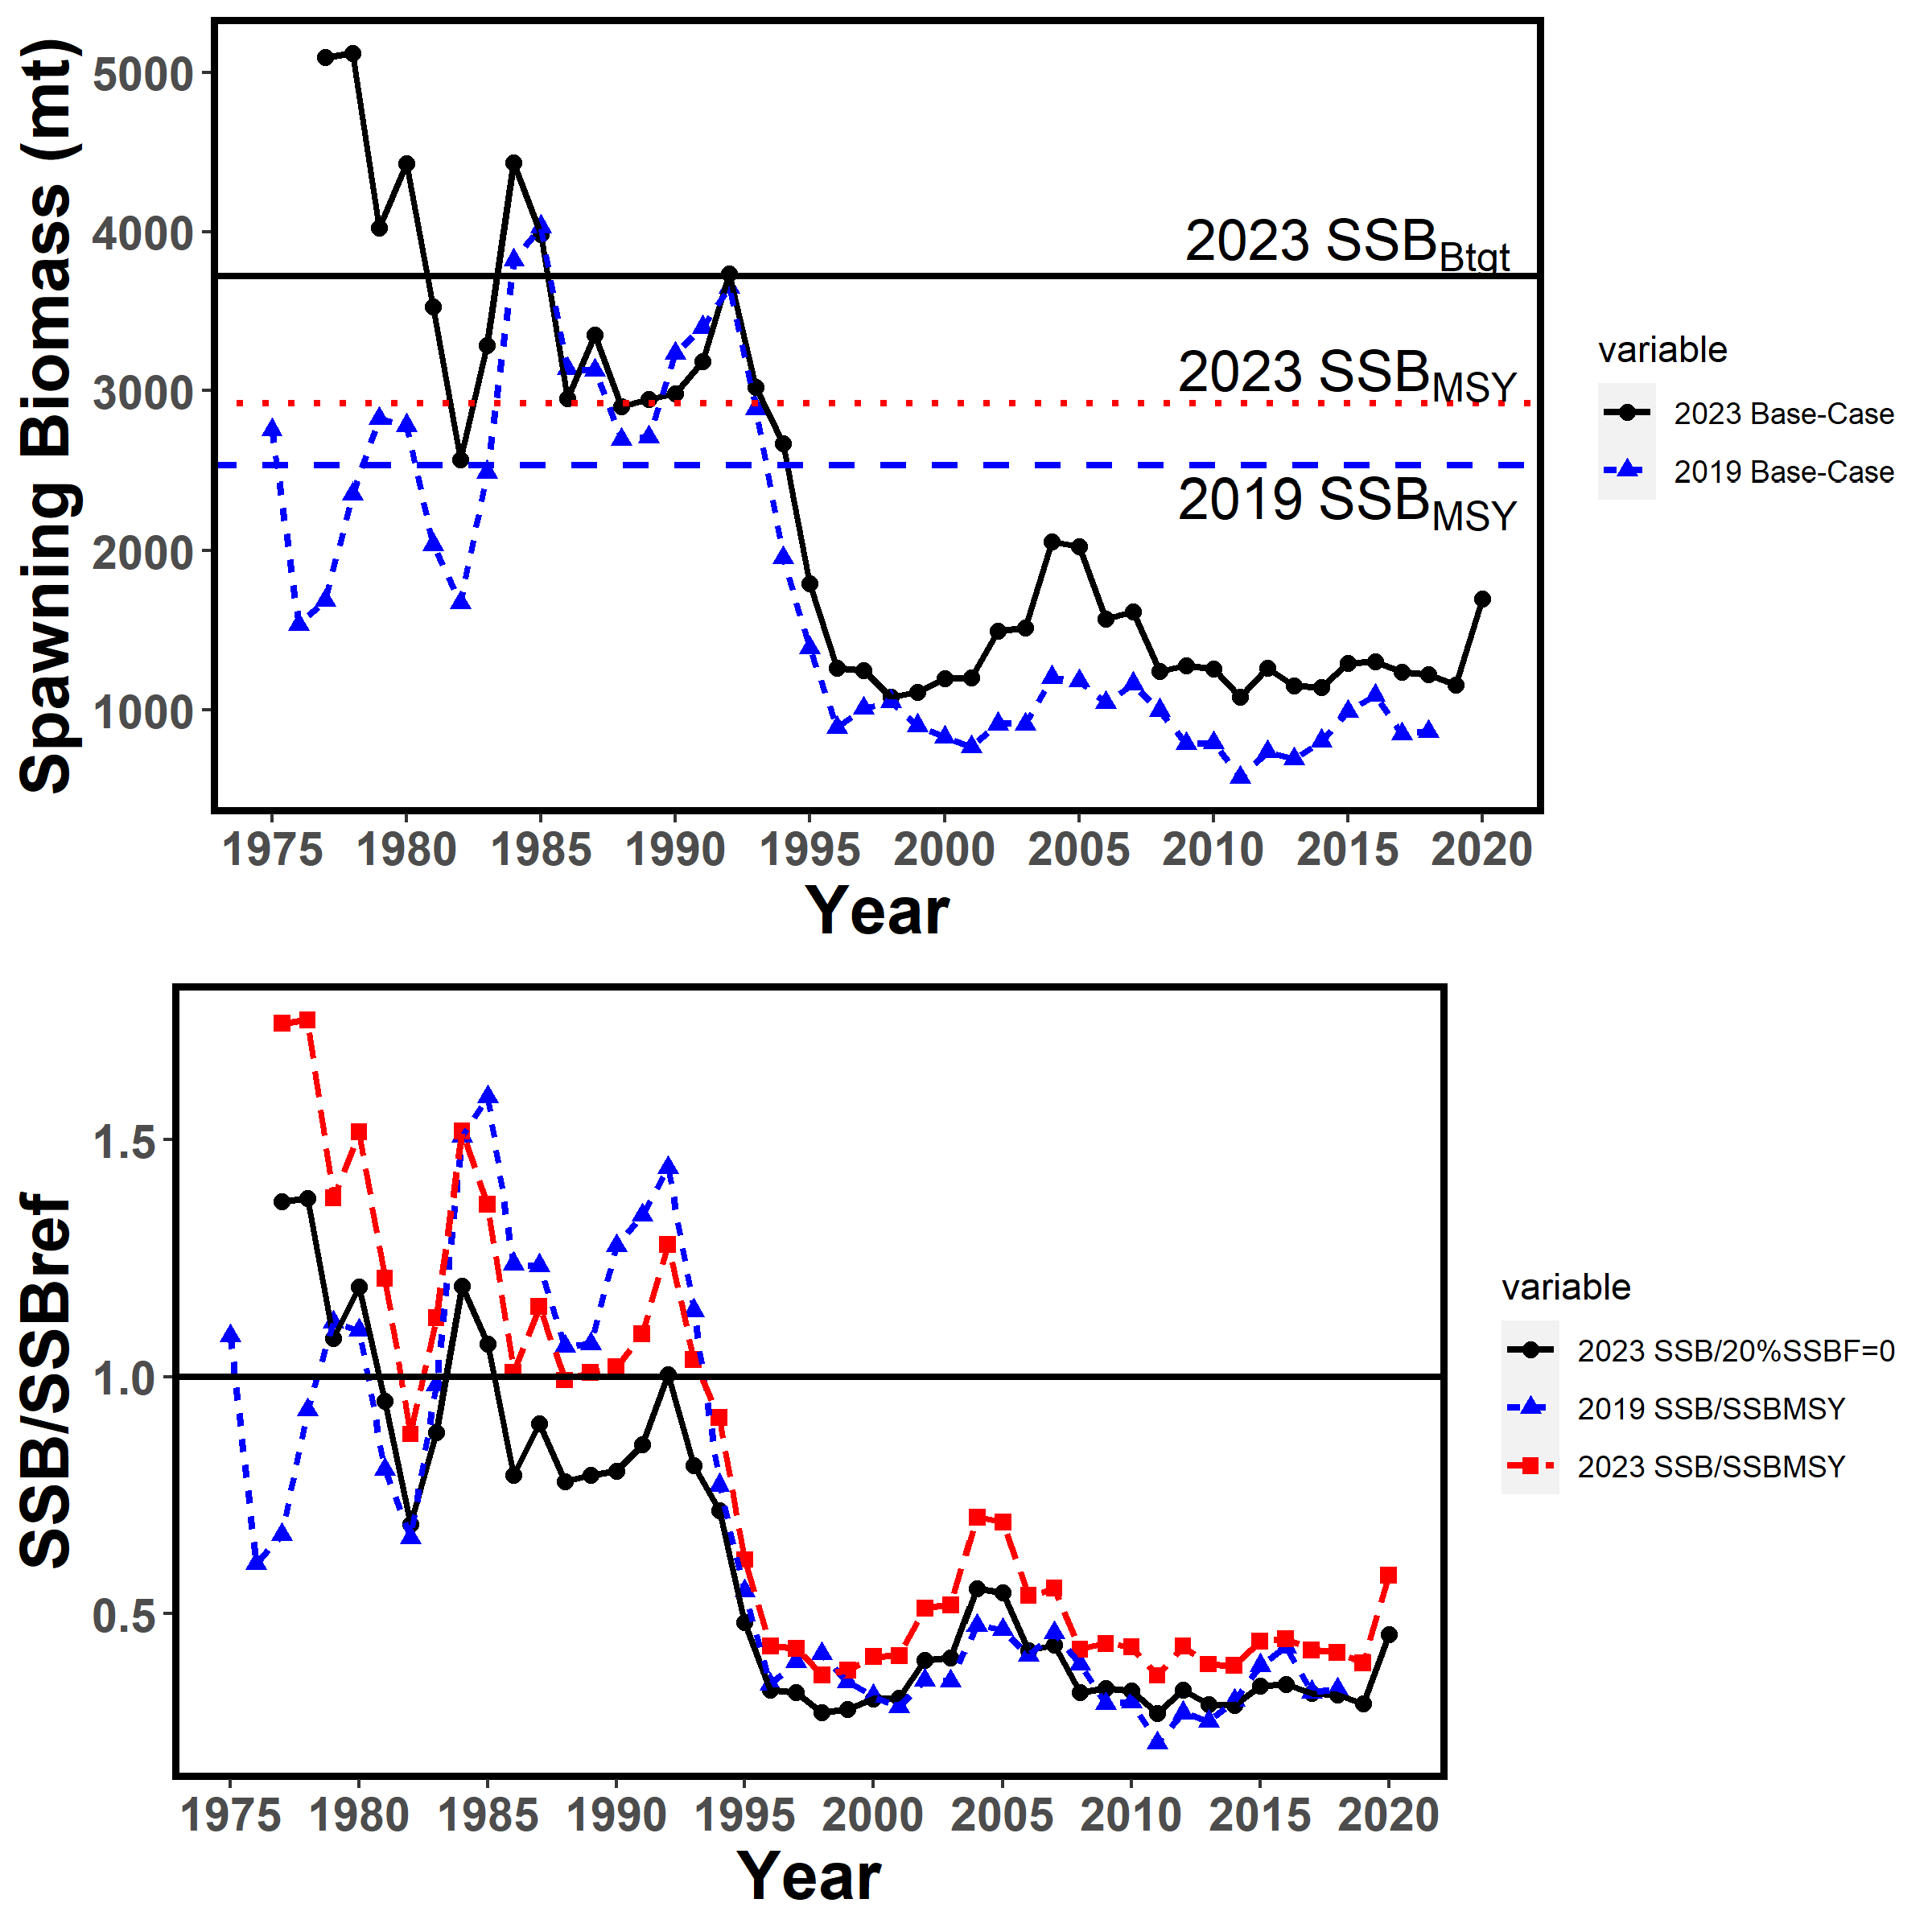

Figure 38. Comparison of the annual spawning stock biomass (SSB, top) and relative SSB (bottom) for the 2019 and 2023 WCNPO striped marlin base-case models. Black solid is the 2023 base-case F20%SSB(F=0) values, blue short-dashed is the 2019 base-case FMSY values, and red long-dashed is the 2023 base-case FMSY values.

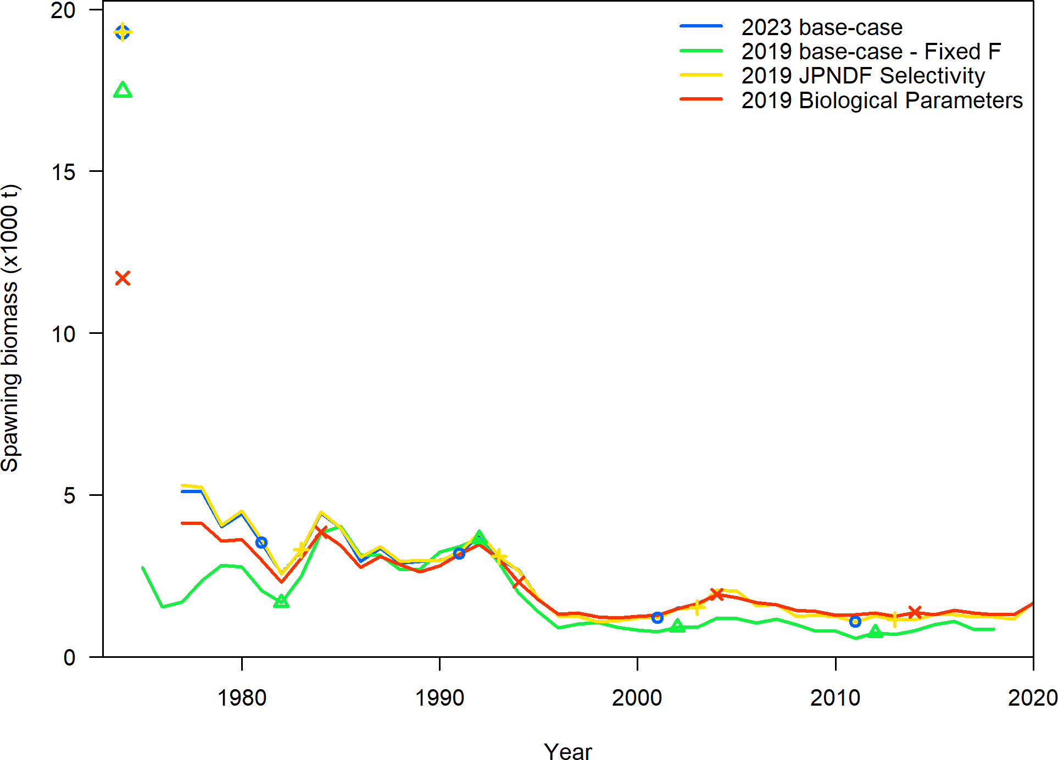

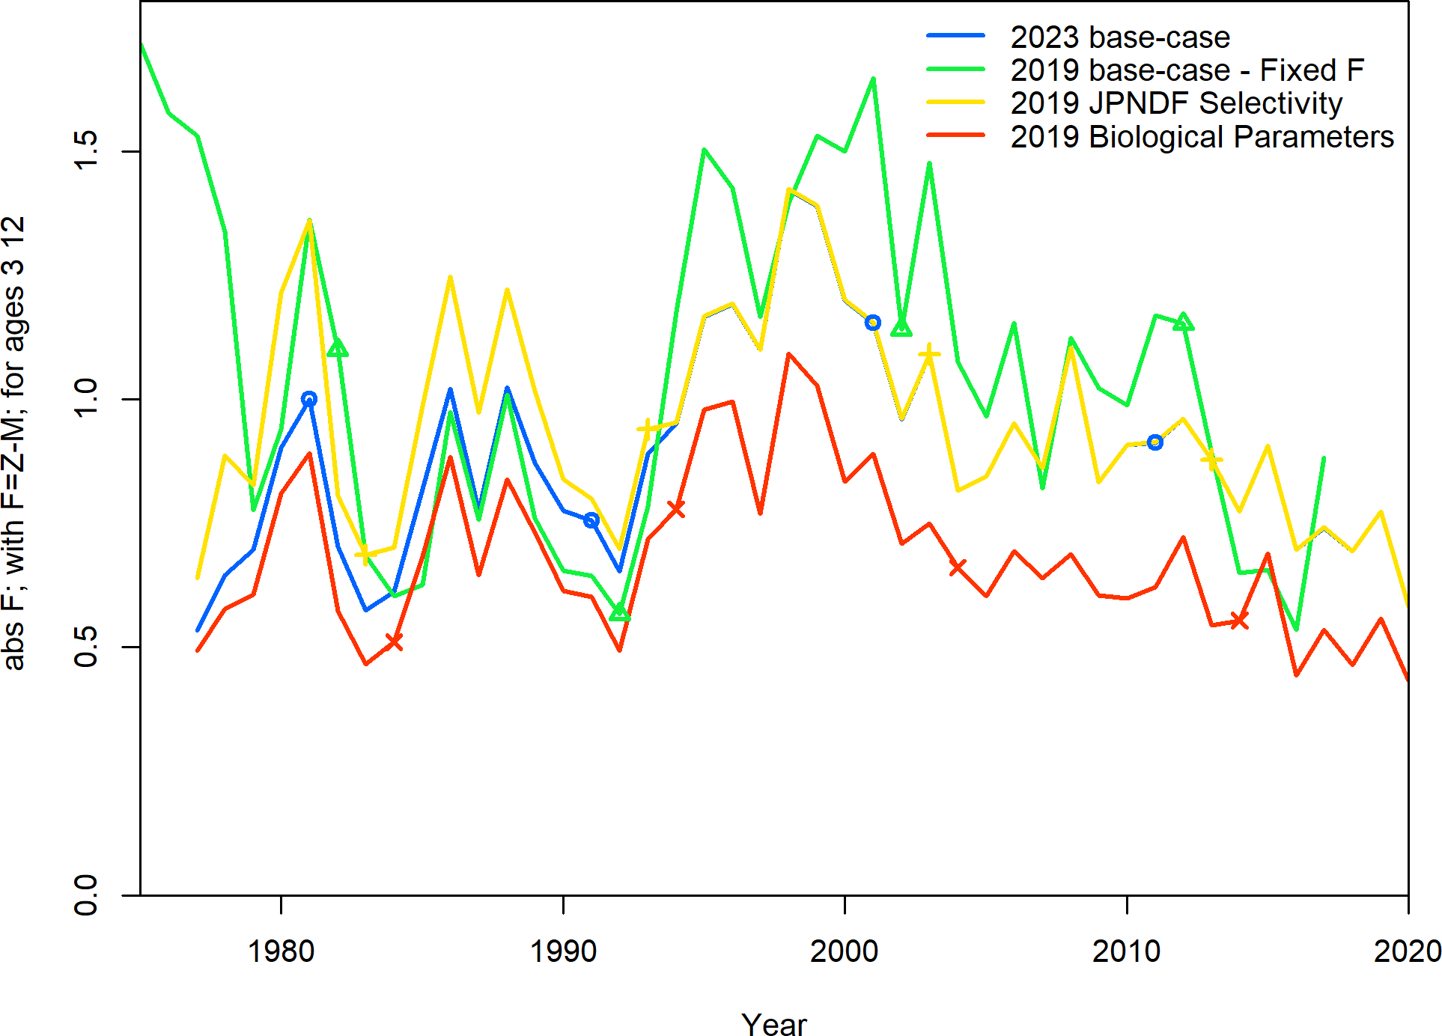

Figure 39. Comparison of the three major changes between the 2019 base-case assessment model and the 2022 base-case assessment model for spawning biomass (top) and fishing mortality (bottom).